Spatial Analysis and Policy Study of Food Crop Areas Realization in Denpasar City

Aldea Noor Alina¹, Galih Wahyu Pradana², Dionysius Bryan Sencaki³ , Bambang Hariyanto⁴ , Insan Wastuwidya Mahardiani⁵ , Annisa Ridhatul Khatimah⁶

¹Geography Education Department, FISIPOL, State University of Surabaya, Indonesia
²Public Administration Departement, FISIPOL, State University of Surabaya, Indonesia
³The Australian National University, Australia
⁴Geography Education Department, FISIPOL, State University of Surabaya, Indonesia
⁵Public Administration Departement, FISIPOL, State University of Surabaya, Indonesia
⁶Department of International Relations, FISIPOL, State University of Surabaya, Indonesia
Badan Riset dan Inovasi Nasional, Indonesia
*Corresponding Author: aldeaalina@unesa.ac.id

ABSTRACT
In practice, the utilization of urban spaces was often not in accordance with the planned spatial layout. Food crop areas in urban areas often undergo land-use changes to accommodate massive urban development. The purpose of this study is to evaluate the current use of rice fields and food crop areas using a spatial approach to determine the distribution of rice fields and the implementation of spatial plans for food crop areas. This study also aims to identify policies to protect food crop areas and to provide policy recommendations for controlling the conversion of rice fields in Denpasar City. This study employs a spatial approach using Remote Sensing and Geographic Information Systems (GIS) to update land cover, analyze the implementation of sustainable food crop land (LP2B), and assess the implementation of food crop areas in the Denpasar City spatial plan. This study also uses an analytical approach to analyze the policy of protecting rice field conversion. It is concluded that area in Denpasar City was experiencing land conversion from food crops to built-up area, with 205.63 hectares and 380.16, respectively, according to two policies
Keywords: Food Crop Area, GIS, LP2B, Spatial Plan Article
Article history
Received:  date | Revised:  date | Accepted:  date | Published:  date
How to Cite:Alina, A. N., Pradana, G. W., Senkaji, D. B., Hariyanto, B., Maharani, I. W., & Khatimah, A. R.. (2025). Spatial analysis and policy study of food crop areas realization in Denpasar City. Journal of Social Dynamics and Governance (JSDG), Vol 2 (No. 2): pp.73-94
This is an open access article under the CC–BY- SA license
INTRODUCTION
Control over the use of urban spaces is an integral part of the spatial planning process. In practice, the utilization of urban spaces often did not align with the spatial plan that has been designed (Asyita Rahmawaty et al., 2024). Various factors, such as the need for spaces with specific uses and suboptimal laws and control mechanisms, cause these inconsistencies. This situation underscores the importance of controlling the use of urban spaces to foster orderly, directed development. Deviations can occur because spatial planning is not implemented, or, conversely, the use of existing space is carried out without regard to the spatial plan. Therefore, an evaluation of the use of urban spaces is needed so that spatial planning is implemented in accordance with the established regional land uses.
Food crop areas in urban areas often undergo changes in land use to accommodate massive urban development. Those factors include population growth, advances in science and technology, dynamics of economic activities, development/expansion of communication and transportation networks, and so on (Alina, 2020). Agricultural land is generally considered to have lower economic value than residential or industrial areas, so it is often targeted for land-use conversion. In fact, in the long term, this agricultural land has excellent benefits, not only in terms of providing food security, but also has functions for the environment, including helping climate regulation and water purification (Zhuang et al., 2020)
Efforts to control the conversion of rice fields through policy have been carried out by the Government, including through Law Number 41 of 2009 (UU Nomor 41 Tahun 2009), n.d., concerning the Protection of Sustainable Food Agricultural Land (LP2B in Bahasa Indonesia). The law divides aspects of control into three categories: incentives, disincentives, and conversion. The Government provides incentives to farmers whose land falls into the LP2B category, including assistance with issuing land certificates and tax relief on land and buildings. Disincentives are given if there is a conversion of LP2B. Other efforts to control the conversion of rice fields are also carried out through the issuance and implementation of additional instruments, including Presidential Regulation Number 59 of 2019 concerning the Control of Conversion of Rice Fields.
Denpasar City is the capital of Bali Province and also the core urban area of the Sarbagita (Denpasar, Badung, Gianyar, and Tabanan) Urban Area. Denpasar City Spatial Planning aims to generate a productive, safe, comfortable, and sustainable Denpasar City as a National Activity Center, based on culture and a creative city concept rooted in Tri Hita Karana. As a National Activity Center, Denpasar City encourages the development of activities and improvements, while also being determined to control urban development in accordance with its carrying capacity and environmental capacity. (Denpasar City RTRW Regional Regulation).
According to the Decree of the Minister of Agrarian Affairs and Spatial Planning Number 1589/SK HK.02.01/XII/2021, the area of protected rice fields in Bali Province is 67,679.01 Ha with the most significant percentage of rice fields in Tabanan Regency, namely 28.6%, while the smallest area of rice fields is in Denpasar City, namely 2.37% (Ramadhan S, 2024). Uncontrolled conversion of agricultural land threatens food crop production and impacts food sovereignty (Ramadhan & Murti, 2024). In line with efforts to develop the Denpasar City and Sarbagita areas, it is important to control the conversion of rice fields to ensure their sustainability in the future.
The purpose of this study is to evaluate the existing use of rice fields and food crop areas using a spatial approach to determine the distribution of rice fields and the realization of spatial plans for food crop areas. This study also aims to identify policies to protect food crop areas and to provide policy recommendations for controlling the conversion of rice fields in Denpasar City.
This study is expected to complement previous research by Made et al. (2023), which analyzed the suitability of protected rice fields for the Denpasar City spatial plan. However, it can be supplemented with a comparison of the suitability of updated land cover for sustainable food cropland and policy directions to protect existing rice fields. This substance highlights the existence of sustainable food cropland that is no longer relevant to current land cover, and the implementation steps for protecting rice fields considered vulnerable to conversion.
Updating land cover using a remote sensing method based on satellite imagery was chosen to update existing land cover data in Denpasar City. It is helpful to provide more detailed information on the distribution and extent of food crop areas and built-up areas in Denpasar City, which were the primary focus of the research. There are numerous land cover Classification methods that can be applied to satellite images, such as pixel-based, object-based, and machine learning algorithms (Alina et al., 2024). In the context of land cover classification, machine learning-based classification utilizes algorithms that can be formed from training data to understand an object and is expected to produce a better classification of an object (Manakitsa et al., 2024)
METHOD
This study was conducted in Denpasar City, covering a total area of 12589 hectares, according to Peta Rupa Bumi Indonesia 1:25,000 for Denpasar City, obtained from https://tanahair.indonesia.go.id/portal-web/ of Badan Informasi Geospasial. Denpasar City consisted of four sub-districts, with each area as follows:

Table 1. Denpasar City Sub-districts area
Sub-district | Area total (hectares)
Denpasar Selatan | 4944.48
Denpasar Timur | 2625.75
Denpasar Barat | 2358.40
Denpasar Utara | 2660.41
Total Area (hectares) | 12589.04
Peta Rupa Bumi Indonesia 1:25,000 for Denpasar City

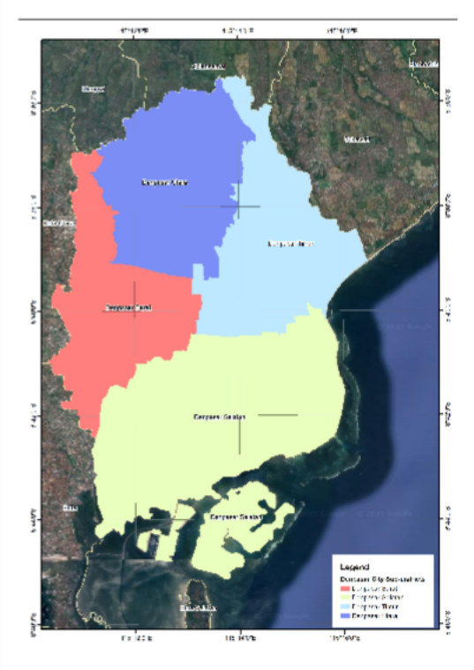

Figure 1. Denpasar City Sub-district (Area of Interest)

This study uses a spatial approach, employing Remote Sensing and Geographic Information Systems (GIS) methods, to update land cover, analyze the realization of sustainable food crop land (LP2B), and analyze the realization of food.Crop areas in the Denpasar City spatial plan. This study also uses an analytical approach to analyze the policy of protecting rice field conversion.
The data used in the land-use updating process is 2024 Sentinel-2 satellite imagery of Denpasar City, obtained through Google Earth Engine, with cloud cover less than 10% to maximize land-cover classification using the maximum likelihood machine-learning method. Maximum Likelihood (ML) is a classification method that selects training data for objects and is still commonly used in Geographic Information Systems (GIS) applications (Jech et al., 2023).
Supervised classification begins with a set of known classes, learns the statistical properties of each class, and then assigns pixels based on those properties (Ahmad & Quegan, 2012). The land use data generated from the maximum-likelihood machine learning classification results are then used to update the existing land cover data for Denpasar City at a scale of 1:25,000, obtained from https://tanahair.indonesia.go.id/portal-web/. The updates are primarily for rice field land cover and built-up areas, which are the focus of the research. The objective of this stage is to obtain the most up-to-date land cover, which will later serve as a basis for comparison with sustainable food crop land (LP2B) and food crop areas in the Denpasar City spatial plan.
At the stage of analyzing the realization of sustainable food agricultural land (LP2B), LP2B data were obtained from the Denpasar City Agriculture Service via the link https://satudata.denpasarkota.go.id/dataset/lp2b-kota-denpasar with an update year of 2023. This LP2B data was then analyzed by overlapping it with the updated existing land cover data to determine whether its distribution and area remained relevant to the current land cover. Determining the relevance of sustainable food agricultural land (LP2B) was based on land cover conditions: whether it is still a food crop/rice field area or has been converted to another land cover, especially to built-up areas. LP2B needs to be recognized for its relevance because it is one of the foundations for the Denpasar City Regional Government in determining incentives, disincentives, and other measures deemed necessary to prevent rice fields from changing.
For the analysis of the realization of the food crop area of the Denpasar City Spatial Plan, the spatial plan data were obtained based on the spatial plan direction of Denpasar City Regional Regulation Number 8 of 2021 concerning the Denpasar City Spatial Plan for 2021-2041(Peraturan Daerah Kota Denpasar Nomor 8 Tahun 2021 RTRW Kota Denpasar, N.D.). This spatial plan data was then overlaid with the updated existing land cover data to determine the distribution and area of spatial plan data that remain in accordance with, and no longer in accordance with, the current existing land cover, as part of the spatial plan implementation analysis steps. Land cover that no longer aligns with the spatial plan direction can then be submitted for revision in the Denpasar City Spatial Plan.
The analytical approach to examine policies aimed at safeguarding the conversion of agricultural land, particularly rice fields, is anchored in Law No. 41 of 2009 and Denpasar City Regulation No. 8 of 2021 concerning the Spatial Plan of Denpasar City. These legal frameworks are evaluated to determine their effectiveness and coherence in protecting agricultural land from unwarranted conversion. The implementation of sustainable agricultural land policies is crucial for preserving food security and environmental sustainability (2021-09-23Bappenas-PengembanganPengelolaanRawa Kompres.Pdf, n.d.). This involves a combination of legal frameworks, economic incentives, and community participation to ensure the long-term viability of agricultural land (Sutrisno S Setiawan, 2018). Land use planning should be integrated with environmental conservation efforts to promote sustainable practices that protect biodiversity and ecosystem services. (Hadiwinata et al., 2021)
Law No. 41 of 2009 provides the legal basis for protecting sustainable agricultural land, emphasizing the importance of maintaining agricultural productivity and preventing.
Land conversion (Ariani S Susilo, 2022). Denpasar City Regulation No. 8 of 2021 further elaborates on these principles, outlining specific measures to control land conversion and promote sustainable development within the city. These regulations serve as critical tools for managing land use and guiding urban development to minimize the loss of agricultural land. To analyze the policy, the author uses the Policy Cycle Model (Brewer S. de Leon), which divides the policy process into six stages: Problem Identification, Agenda Setting, Formulation, Implementation, Evaluation, and Termination (Yar et al., 2024).

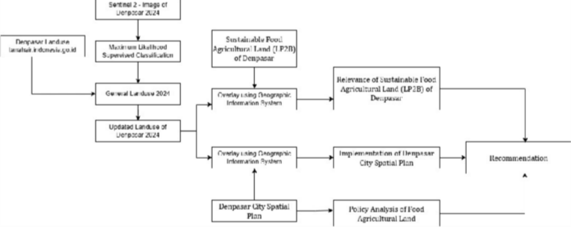

Figure 2. Processing Workflow

FINDINGS AND DISCUSSION

Land use updating
Sentinel – 2 used for this study was filtered between June and December 2024 and clipped to the area of interest (Aoi). Google Earth Engine of the Sentinel – 2 image for area study is shown below :
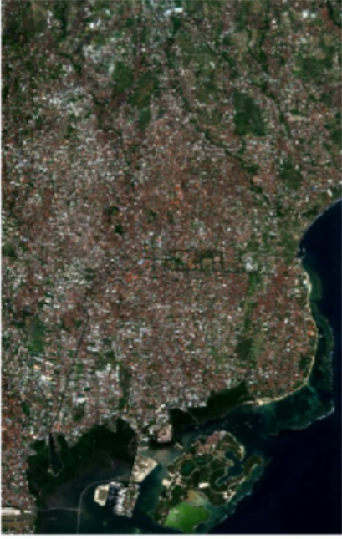

Figure 3. Sentinel -2 Imagery of Denpasar City https://code.earthengine.google.com/f98fc869465fa38ab6d0e0b2b5c635eb
Subsequently, the downloaded Sentinel 2 imagery was classified using the Maximum Likelihood algorithm. The classification process was trained on polygon samples for each land use class. The polygon training samples were collected based on visual interpretation of high-resolution satellite imagery and later enhanced with secondary data from tanahair.indonesia.go.id as a reference. Training samples distribution and total for each class are shown below in Table 1:

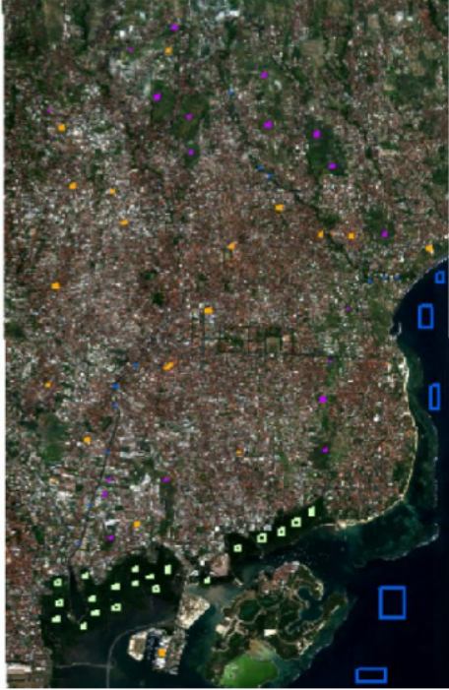

Figure 4. Training Samples Distribution

Table 2. Training Samples for Supervised Classification

Land use class | Total Samples | Pixel Count
Agricultural Area | 20 | 498
Built-Up Area | 20 | 841
Mangrove | 20 | 2636
Water bodies | 20 | 10608
Data Analysis, 2025
Each land use class has an equal number of polygons in the training sample. Equal random sampling was proposed to address class imbalance. In model evaluation, this method can be applied to ensure fair analysis of model performance and to prevent accuracy metrics from being biased towards the majority class (Buda et al., 2018). The generated land uses map was then used as input data to update the existing land cover data on a scale of 1:25,000 for Denpasar City, obtained from https://tanahair.indonesia.go.id/portal-web/. The updating is mainly carried out for rice field, land cover, and built-up areas.

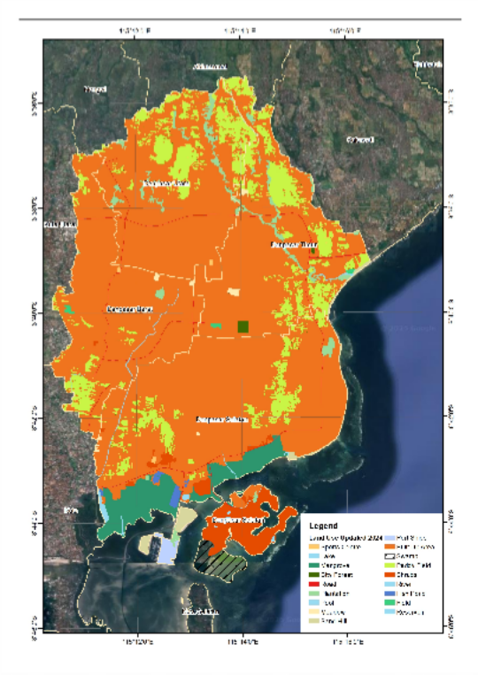

Figure 5. Land use

Table 3. Landuse Result Updated
Land Use Updated 2024 | Area (Ha)
Sports Centre | 7
Lake | 2
Mangrove | 546
City Forest | 18
Artery Road | 5
Collector Road | 44
Local Road | 26
Mix Plantation | 234
Pool | 10
Meadow | 27
Sand Hill | 93
Port Ships | 51
Plantation | 29
Built Up Area | 9302
Swamp | 149
Paddy Field | 1487
Shrubs | 452

River | 41
Fish Pond | 33
Field | 16
Reservoir | 17
Total | 12589
Data Analysis, 2025

Sustainable Food Agricultural Land (LP2B) of Denpasar City
At the stage of analyzing the realization of sustainable food agricultural land (LP2B), LP2B data were obtained from the Denpasar City Agriculture Service via the link https://satudata.denpasarkota.go.id/dataset/lp2b-kota-denpasar with an update year of 2023. The map of sustainable food agricultural land (LP2B) is shown below :
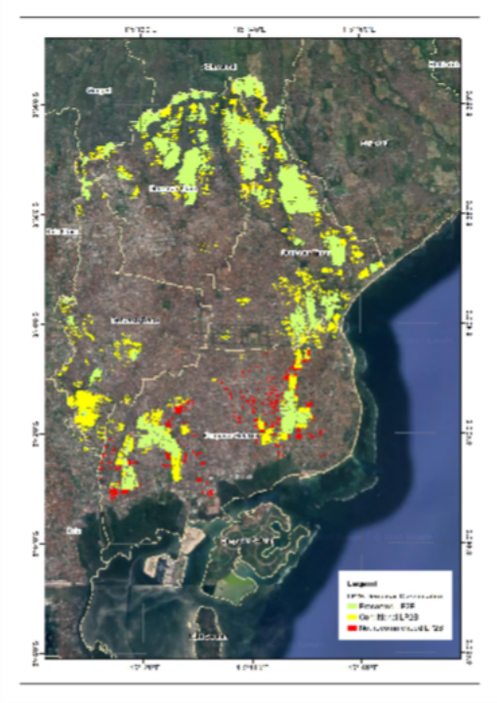

Figure 6. Sustainable food agricultural land (LP2B) updated result

Sustainable food agricultural land (LP2B) data in Denpasar city were classified into three categories: preserved LP2B, conditional LP2B, and not recommended LP2B. Preserved Sustainable Food Crop Land (LP2B) is a land that has the capacity to produce staple foods sustainably and is prohibited from being converted into another land use. This recommendation is generally based on the analysis and evaluation of the area's land characteristics, potential, and needs. Conditional LP2B means LP2B status can still be developed or utilized, provided certain conditions are met. These conditions may include restrictions on land use, the types of crops allowed, or mandatory agricultural techniques. Not recommended. LP2B generally refers to sustainable food cropland that is not considered suitable for use as an area requiring protection and consistent development for staple food production. Land is usually considered to have the potential to be developed, industrialized, or settled.
This LP2B data were then analyzed by overlapping them with updated existing land cover data to determine the distribution and area of LP2B data that are still relevant and those that are no longer relevant to the current land cover.

Denpasar City Spatial Plan for 2021-2041
For the analysis of the implementation of the food crop area in the Denpasar City Spatial Plan, the spatial plan data were obtained from the spatial plan direction of Denpasar City Regional Regulation Number 8 of 2021 concerning the Denpasar City Spatial Plan for 2021-2041. This spatial plan data was then overlaid with the updated existing land cover data to determine the distribution and area of spatial plan data that remain in accordance with, and no longer in accordance with, the current existing land cover, as part of the spatial plan implementation analysis steps.
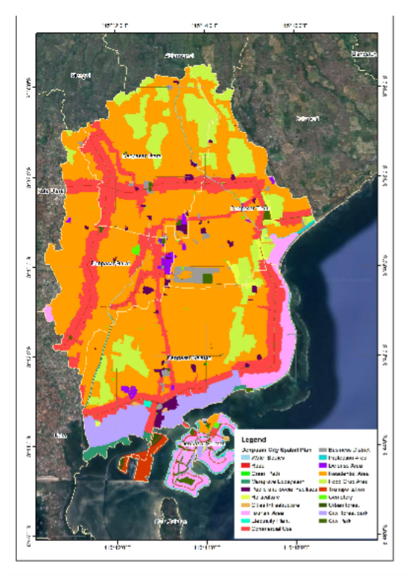
Figure 7. Spatial Plan of Denpasar City

Discussion
Realization of Sustainable Food Agricultural Land (LP2B) Analysis
As stated in the previous section, the sustainable food agricultural land (LP2B) of Denpasar city was classified into three categories: preserved LP2B, conditional LP2B, and not recommended LP2B. This analysis will focus on the realization of LP2B that should be preserved, since conditional LP2B that were not recommended were allowed to convert to another land use. The LP2B analysis was conducted using the overlay method in a geographic information system (GIS). LP2B data were overlaid with updated land-use data. The result of the overlay process is shown as follows:

Table 4. Overlay LP2B and Landuse
LP2B Category | Landuse | Area (Ha) | Overlay Analysis
preserved LP2B | Mix plantation | 2.11 | Preserved
preserved LP2B | Meadow | 0.17 | Allowed

preserved LP2B | Built-Up | 205.63 | Prohibited
preserved LP2B | Paddy Field | 836.03 | Preserved
preserved LP2B | Field | 5.47 | Preserved
Data Analysis, 2025

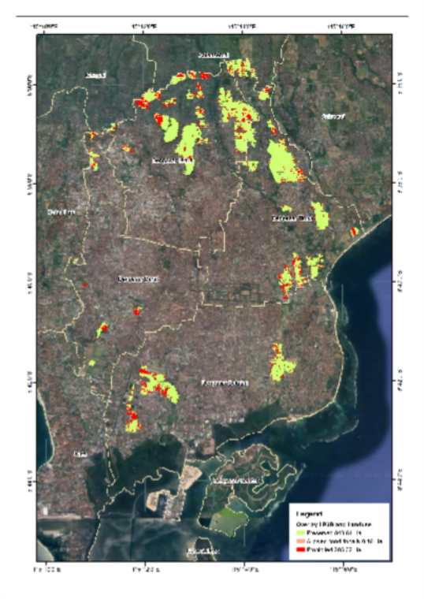
Figure 8. LP2B and Landuse Analysis
According to the overlay result, the prohibited land use within the preserved LP2B was a residential area of 205.63 hectares. Preserved LP2B, according to the law, were prohibited from converting to another land use, particularly permanent building. Two general measures can be taken to overcome this issue. Firstly, re-examining the LP2B area and disclosing the built-up area within the preserved LP2B. Secondly, to keep the amount of preserved LP2B, another potential area should be confirmed as preserved LP2B. This potential area for preserved LP2B should be confirmed as LP2B only after ownership of the land parcel is established.
Land use and land cover are in constant flux, with these changes carrying profound implications for environmental sustainability and urban growth (Widiawaty et al., 2020). Over the past 30 years, there has been a marked shift—urban areas have been spreading, often at the expense of agricultural land and natural habitats (Zhang S Zhang, 2020). This is not just about more buildings; we are seeing ecosystems pushed aside, raising real concerns about ecological stability and food security (Martinuzzi et al., 2015). It is critical to factor in ecological considerations when making land use decisions. Otherwise, we risk degrading the land's natural capacity and making choices that are not sustainable in the long run (Syafiq et al., 2021).
Land use, the way humans use land for various activities, plays a pivotal role in shaping the environment (Sharma et al., 2019). This includes a wide array of modifications to natural landscapes—agriculture, urban development, infrastructure—all of which dramatically transform land cover (Bikis et al., 2025).

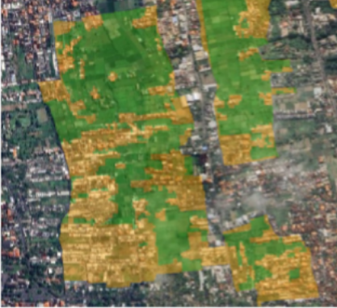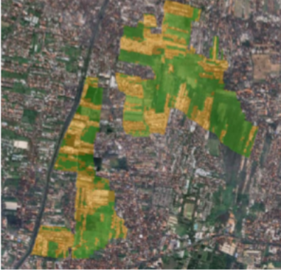

Figure 9. Samples Location of Food Crop Area that turns into a Built Up Area

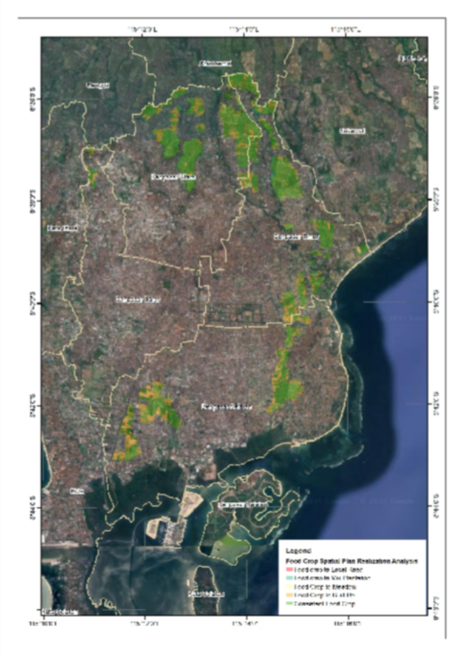
Figure 10. Realization of Food Crop Area Plan Analysis in Denpasar City

Policy Analysis of Food Agricultural Land in Denpasar Protecting Rice Field Conversion Based on Law No. 41 of 2009 S Regulation of The City of Denpasar Number 8 Of 2021 RTRW City of Denpasar
The author applies the Policy Cycle Model to analyse in detail the policy issue under consideration—decomposing it into discrete key stages: problem definition, scanning the agenda, formulating the strategy or plan, operating and evaluation and if applicable dissolution. The one provided by Turnbull and Stowe presents a coherent framework to explore how policy goes from concept to evaluation, and occasionally, discontinuation (Stowe & Turnbull, 2001). But policy-making is seldom so tidy a process, done in stages. As Exworthy observes, such a process is likely to be more cyclical in nature with stages not necessarily proceeding in tandem and feedback loop mechanisms stimulating iterative recalibration and adaptation (Exworthy, 2008). Put another way, policy is at least as much about revisiting and tweaking as it is about hitting the gas. Further, Policy Equilibrium Theory argues that policies generally persist for long periods as public opinion steadies them. When external pressures do emerge, the reform process does become possiblepresumably only when there is enough pressure on elites and significant actors against whom reformers can mobilize. Otherwise, most policy shifts are at best incremental.
The following analysis is based on Brewer and deLeon's Policy Cycle Model and is used to understand the policy journey.

Problem Identification
In recent years, Denpasar has been caught in a bind, balancing a growing, fast-paced city with its responsibility to preserve agricultural land. However, pressure to accommodate development demands constantly threaten rice field and have flow-on effects for food security and the environment (e.g. Wiraguna et al., 2019). If we see the historical data, there is a visible and worrying increase in the rate of rice field converted to housing after 2021. There are some signs of movement since the introduction of Regulation No. 8, but whether it is all smoke and mirrors still remains to be seen.
The pressure faced by farmers comes not only from economic aspects, but also from regulations, and this pressure is very intense. Surveys, as well as interviews with local farmers, show that there is a main problem, which is that rice farming is currently unprofitable. About 70% of farmers told participants of the study that, due to diminishing rice yields, they were compelled to consider, while some others were even more initiated, to actively pursuing the conversion of their land to other uses. Furthermore, as the land is being valued more for residential and commercial developments, the financial reasoning for conversion becomes even more compelling.
There are regulations, such as the Law No. 41 of 2009 and Denpasar City Regulation No. 8 of 2021 that should halt or slow down land conversion, but these laws have different competing power with economic pressure faced by farmers in places like Subak Kerdung (IKHSAN et al.,2019). The city’s own expansion is the prime cause of cropland loss more people, more economic activity and a burgeoning tourism sector have expanded demand for new hotels, restaurants and other infrastructure (Arnawa et al 2022; Agumagu et al., 2025).
And adding to these economic and social forces, climate change is making the situation worse. With sea levels rising and increasing saltwater intrusion, the quality of the remaining rice fields is being degraded more and more, thus lowering yields even more and making agriculture less attractive (Alam, 2014; Ashrafuzzaman et al., 2022). So, despite having regulations there is mounting pressure from the combination of economic, social and environmental forces to convert rice fields.
Finally, the concrete effectiveness of seemingly comprehensive legislation can be questioned in practice. This reality highlights the importance of research to uncover the specific factors and impacts of land conversion to rice fields in Denpasar, evaluate whether the policy has actually achieved positive results, and identify key practical areas that support the sustainable advancement of sustainable agriculture and the improvement of agricultural communities (Rajindra et al., 2021).

Agenda Setting
The paddy conversion in Denpasar is a perfect example of economic needs taking precedence over environmental and food security needs. One does not need to scratch the surface of policy documents to see the preponderance of tourism, not as an interpretive frame, but as a constant presence throughout the planning documents, meeting minutes, and public statements of the Spatial Planning Office from 2018 to 2021 (Ramadhan S Murti, 2024). The legacy of change is certain, even though there is a relative lack of visibility: the protective policies enacted in the 1990s to guard farmland are now being adapted, if not outright ignored, to accommodate tourism development. This is exactly what media and NGO reports do. It's a debate that often gets presented as a never-ending compromise: agriculture will just have to lose some land for the economy to grow. But in reality, the scales couldn't be further from even. Easy to organise and high-profile lobbying with large sums of money from tourism overrides public sentiment and also drives decisions (Wiraguna et al 2019). Even though agricultural NGOs and local farmer representatives are present, they are often sidelined and drowned out. The difference is glaringly evidenced by the mapping out of stakeholders, in which tourism developers, in contrast to others, find it easy to have access to the decision-makers, who were responsible for the 2021 RTRW and have been instrumental in leaving out some key ‘strategic projects’ (Wirata et al 2017). More often than not, these are the exceptions that are abused as backdoors to permanently cover even more important cropland.
The current economy prioritises tourism, and the municipality is therefore compelled to keep tourism-friendliness as the first and foremost focus. The economy is such that in Denpasar, the most recent tourism satellite accounts report that tourism contributes around 80% of the GDP (Hasibuan et al, 2019; Sunarta et al, 2021). Policies to protect the agricultural land are warranted; however, in practice, the policies are rarely implemented. The data on food security is concerning, and the data on the ecological costs in the coming decades is even more concerning. Traditional rice farming landscapes continue to silo and supply important ecosystem services. The remaining landscapes of this nature will be disproportionately more to non-rice farming, and the repercussions on these landscapes will be permanent. The most adverse of such repercussions will be the protracted destabilisation of these historically critical ecosystems.
Local authorities facing such challenges have never been idle. Attention is being paid to food security within a development agenda. The preservation of agricultural land is being promoted through educational campaigns and public awareness programmes. The theoretically intended land use planning and zoning controls are aimed at trying to control the rate and extent of land conversion. Meanwhile, new assistance measures to local farmers, such as subsidies, technical assistance, as well as production increasing programmes, are seen as making the agriculture sector socially sustainable.
However, sustained tourism development economically and socially has great potential to undermine any such interventions. The reality is that while tourism is the most economically beneficial sector in Denpasar, perpetuating
agricultural preservation policies will be unfeasible. The agricultural preservation policies will be unfeasible. Denpasar’s food sovereignty, environmental sustainability, and agricultural preservation policies are in a trade-off situation. It is a fine trade-off that will need to be sustained economically and socially for Denpasar to achieve sustainable urban development, and for Denpasar to avoid economically and socially unsustainable urban development. This is a fine trade-off situation that will need to be sustained for Denpasar to avoid breaking the longer-term prosperity.

Policy Formulation
In protecting Denpasar's rice fields, policymakers face obstacles arising from the services these rice fields provide, in their noted form, and their condition which is beyond the scope of this paper. When examining Law No. 41/2009 and its LP2B (Protection of Sustainable Food Agricultural Land) provisions, coupled with the 2021 spatial zoning regulations (RTRW 2021) amendments, there is a clear indication of spillovers of buffer zone effectiveness and ineffectiveness. Consequently, these buffer zone weaknesses are more pronounced in the Subaks - unprotected but ecologically sensitive, culturally significant, and rich zones of Bali. The lack of or inconsistent enforcement of buffer zones heightens the risk to these traditional irrigation systems, patchwork landscapes, and local agricultural systems. These weaknesses are further compounded by existing legal gaps. These shortcomings are worsened by the existing legal gaps. For instance, Article 15 RTRW 2021 has an ambiguous provision regarding the changing of land use to be '' for the public”. This passage has been applied to authorise the construction of rice field hotels, which are considered by law as tourist accommodation.
However, based on some arguments, these gaps in the rules could be seen as regulatory flexibility, which in turn some could interpret as “opening the door” to protection gaps to enhance economic growth. Some may try to compute the costs and benefits and find an institutional bias in favour of economic growth, particularly in tourism, to the detriment of other necessary value continua such as food security and sustainability of the underlying ecosystem. This is made worse by the light regulatory slaps on the wrist for land use violations. Hence, land use violation from the perspective of the developer is seen within the parameters of the developer's risk framework as controlled infractions, which results in no restraint on the use of the land in question. In the longer term these scenarios undermine the ability of Denpasar to deal with excessive climate variability, rapid growth in population and the volatile price of goods. Policymaking in this area requires an interdisciplinary approach. This joint effort would benefit from an understanding of the interconnectedness of the economic, socio-cultural, and environmental processes involved. Thirdly, policies should be and remain evidence-based, should be dynamic, and should adapt to changes in the environment. This is a call for the future sustainable management of rice fields in Denpasar that includes strong legal protection and transparent governance along with an understanding of the socio-cultural as well as the socio-ecological systems. Undoubtedly, without these building blocks, the policy levers will remain at the level of rhetoric, and the benefits of these investments will remain inaccessible for current and future generations, and out of reach for a long time.

Policy Implementation
For instance, in Denpasar, there is a gap in the protection of rice paddy fields, where there are written regulations, but local 'implementation' is a long way from policy purpose (Kanaha et al, 2020). The blueprint for the policy may look detailed and thorough. However, look closer and there will be a possible discrepancy; for instance, using satellite images over the years to assess how land conversion and preserved fields correlate, and it will be evident that there is a lack of communication of enforcement. The conversion of rice fields at an alarming rate is also an indication of the socio-economic issues. There is a lack of socio-economic regulations. Data and anecdotes point to the fact that there is an alarming rate of conversion of rice fields.
One of the major concerns with the capacity of the Deep Systems is the allotment of the budget. Policies that lower costs, such as cutting inspections, cross the politically ‘painless’ line. While more consumption may increase employment, cutting the budget makes enforcement of new policies unfeasible. The system is obviously stretched when, as is the case now, there are only two field inspectors for more than 1,300 hectares of land. The enforcement is of such dismal quality, directly leading to fewer major infringements, resulting in such limitations. More field unpaid land conversions remain unmonitored. Select iterations such as the conversion of the rice field in the Tukad Bindu region illustrate clearly the unregulated and unauthorized land conversion despite its LP2B status, which was still considered preserved (Ramadhan S Murti, 2024). These situations explain the gaps in the system and the misplaced expectations of the individuals within the system. These issues depend on more than the direction of the system. Poor regulatory coordination between government divisions weakens and confounds the system’s response. The silo operations of divisions leave land use and management in unregulated and often contradictory states. Lack of systemic consultation with local stakeholders, particularly farmers, exacerbates the problem.
Most farmers face significant economic challenges, which makes it impossible for them to comply with land use policies that require land to be kept idle. When policies, such as Law No. 41 of 2009, are top down and do not consider the significant socio-economic challenges faced by farming communities, the policies fail to be effective. The land use regulations do not work, as evidenced by the extent of land use change (5-10% p.a.), which has not changed despite the regulations (Wiraguna et al, 2019; Wirata et al, 2017).
The transformation of rice field defence has been needed for a long time. The order of policies has been followed; however, the actual challenges are the allocation of funds, cooperation between ministries, and engaging the community (IKHSAN et al, 2019). Policies should be designed and implemented with the agility to address local issues and other development challenges. Even though it aids in the understanding of a certain setting, the Sarbagita Metropolitan Area is transforming like other areas and facing extreme unplanned land alterations that impact land use and food security (Murti, 2024). The changing landscape, and growing population as a shifting economy, has dire consequences for the persistent sustenance of rice and food supply. Therefore, adjusting the strategy is beyond just preserving the upland rice fields. The socio-economic integrated agriculture, and its diversity, has also been reshaping agriculture (Murti, 2024).

Policy Evaluation
The conservation policies in Denpasar need to be applied with care and with several layers. One simply cannot look at production numbers or land conversions and assume the policy deserves bragging rights. A thorough evaluation must correlate complex and interwoven layers and policies to the realities of those most affected, the farmers. Starting with the numbers. Yes, comparing rice yield with and without protection is a basic starting point. If the answer is yes, and the protected area is sustainably producing or yielding more at least for some species, while the non-protected zone is declining, there is some indication the policy can achieve most of its objectives. But numbers can and do mislead. A twenty-five percent less conversion of land in protected zones is, say, something that looks good on paper. But if those fields are sustained by long-term drought issues, as recent research suggests, their apparent success is more likely due to the presence of deeper geographies. Drought: the long-term viability of these "protected" fields is highly vulnerable under climate change and the unpredictable long-term ones. This leads us to the most current and appropriate issues in agricultural policy: climate resilience. Sustaining the land in growing rice is not the same as growing rice while also enduring droughts, floods, and variable levels of rainfall. In the absence of appropriate policies to mitigate these issues, the decline in the future will worsen. It requires appropriate water management policies. Proper management of water resources involves the local communities, who are custodians of the resources, and the socio-economic effects should also be of concern. An economically insecure farmer represents a policy failure. Since the implementation of policies, qualitative data should be collected through engagement with the farmers to ascertain their concerns regarding the subsidies and technical assistance received.
The presence of poor technical support does not indicate dissatisfaction with the funding. Imbalanced technical assistance can lead to reduced motivation within the community and ultimately affect the policy’s intended positive outcomes. It can also be the case that a higher level of dissatisfaction with policies can be a positive sign that the policy is well designed. It shows that policy support is available and of good quality. Farmers expect and desire policy support, and younger farmers are more engaged. The inefficiencies and complexities of how policy allows land conversion and how land use irrigation is converted slowly show how land and policy work together. This is the basis of a policy challenge that is visible and yet not really able to be captured by a static unchanging policy model. Policies that do not grapple with the underlying issues such as the economic incentives that drive land use conversion and the institutional deficiencies of our water allocation policies tend toward less of a proactive model and more of a reactive model.
“The other important piece is community,” he emphasises. There would be no loss of policy credibility and effectiveness if there were improved systems to enable farmers and local stakeholders to participate in land use decisions. When communities are given a genuine voice, they are more likely to support and comply with protective measures, rather than resent them as externally imposed restrictions.
Overall, assessment of rice field protection policies needs to be complete and adaptable. To assess net effectiveness, both quantitative and qualitative metrics at different levels need to be combined, such as farm yield and land use change for quantitative metrics, and farmer satisfaction and institutional performance for qualitative metrics. This ensures that policy outcomes are fully captured and provides evidence for additional policy granularity. The ultimate objective of such an evaluative scheme is to assess current policy implementation and outcomes, for the purpose of enabling policies to be reformed in an equitable, sustainable and socially acceptable manner as socio-economic and environmental conditions of a society change.

Termination
The removal of rice field protection policies in Denpasar cannot be considered merely bureaucratic processes. It must be approached very cautiously and gradually, incorporating aspects such as policy amendments, changes to the spatial plan, and actions deeply rooted in reflections on previous policy failures. When we refer to the removal of policies, we do not mean it in the literal sense of abruptly stopping policies, but rather reaching a point where we feel the policies are due for amendments, not based on what policies are currently in place, but on what has been achieved and what the current scenario is.
Analyzing data and making policy decisions based on the information available is essential. For example, the changes made to the RTRW in 2021 and the pending 2023 proposals for policy changes reflect a never-ending cycle of policy proposals that need to include proper consideration of stakeholders and, more importantly, evidence. It is a system that attempts to bring together the coordination of spatial and licensing administrative functions to attain a more efficient and less opaque bureaucratic system (Ramadhan S Murti, 2024). This is important in the context of the conversion of land, which has a lot of underlying issues (Andita et al., 2019).
The need for enforcement and proactive action is illuminated by the financial and legal complications involving the reversal of illegal land conversion. There is poor control mainly because of costly buybacks of Sanur villas. These examples reveal the need for the orderly delineation of protected area boundaries, proper enforcement, and rapid response patrols. One such example is the guarantee of the government of special ownership and protective covenants over paddy fields, which can serve as a deterrent to land conversion (Firmansyah et al., 2019).
Facilitating the political closure of those gaps is the absence of exceptions for what are termed “strategic” projects, especially when there is strong opposing lobbying from the industry, including tourism and others. These exceptions are precisely those that can frustrate our policy aims and lead to undesirable development. Closing those gaps demands political commitment and open governance, where stakeholders can participate as necessary. This does not mean that government involvement will suffice, particularly when farmers have little to no financial means and are under pressure to convert land due to poor policy. Effective policy implementation, therefore, is not merely a matter of having good policy and accompanying funds, but also the active systematisation of various government tiers to minimise counterproductive synergies, and the community's ability to protect land from cultivation.

CONCLUSION
Based on the study's analysis, it is concluded that a particular area in Denpasar City underwent land conversion from what was expected to be a food crop area to another land use, mainly a built-up area. Based on two policies, Sustainable Food Agricultural Land (LP2B) and the Spatial Plan of Denpasar City, land conversion is mainly to built-up areas, totaling 205.63 hectares and 380.16 hectares, respectively. The Food crop area in the Spatial Plan is larger than in LP2B, as it uses a different technical standard for Food Crop (Kawasan Tanaman Pangan) in Bahasa. Food Crop in Spatial Plan refers to Sustainable Food Crop Land Area (KP2B) or Kawasan Lahan Pertanian Pangan Berkelanjutan (KP2B), whilst LP2B refers to Sustainable Food Agricultural Land (LP2B), whose land use must be ideal agricultural land. KP2B, in the other hand is wider in both aspect of coverage than LP2B. It should be noted also that LP2B is an integral part of KP2B.
Protection of agricultural areas from land conversion must be encouraged in Denpasar City. Even though Denpasar serves as an urban area with main focus in development of culture and creative city planning, wetland agricultural areas can still function as ecotourism areas, maintain the city's microclimate, and provide limited recreational facilities for urban communities.
Denpasar’s struggle to preserve its rice fields amidst rapid urbanization and tourism-driven development highlights a critical tension between economic growth and sustainability. While policies like Law No. 41/2009 and RTRW 2021 exist to protect agricultural land, weak enforcement, legal loopholes, and overwhelming economic pressures continue to drive land conversion. The lack of adequate monitoring, disincentives for farmers, and climate vulnerabilities further undermine the policy's effectiveness. To sustainably preserve rice fields, Denpasar must strengthen institutional capacity, close regulatory gaps, and integrate farmers' livelihoods into policy frameworks. Balancing tourism's economic benefits with long-term food security and ecological resilience will require adaptive governance, transparent decision-making, and meaningful community engagement. Without these reforms, unchecked land conversion risks irreversible damage to Bali’s agricultural heritage and food sovereignty

ACKNOWLEDGMENT
Authors would like to thank Fakultas Ilmu Sosial dan Ilmu Politik Unesa for its support to write this study.
REFERENCES
Agumagu, O. O., Marchant, R., S Stringer, L. C. (2025). Land Use and Land Cover Change Dynamics in the Niger Delta Region of Nigeria from 1986 to 2024. Land, 14(4), 765. https://doi.org/10.3390/land14040765
Ahmad, A., S Quegan, S. (2012). Analysis of Maximum Likelihood classification technique on Landsat 5 TM satellite data of tropical land covers. 2012 IEEE International Conference on Control System, Computing and Engineering, 280–285. https://doi.org/10.1109/ICCSCE.2012.6487156
Alam, M. S. (2014). Climate Change and Land Use Change in the Eastern Coastal Belt of Bangladesh, Elucidated by Analyzing Rice Production Area in the Past and Future. Journal of Life and Earth Science, 8, 83. https://doi.org/10.3329/jles.v8i0.20151
Alina, A. N. (2020). ANALISIS FISIK DAN LINGKUNGAN KESESUAIAN LAHAN UNTUK
REKOMENDASI ARAHAN TATA RUANG KOTA MADIUN. Elipsoida : Jurnal Geodesi Dan Geomatika, 3(02), 198–205. https://doi.org/10.14710/elipsoida.2020.9202
Alina, A. N., Jaelani, L. M., Hayati, N., S Syariz, M. A. (2024). Accuracy Results Comparison of Machine Learning Classification for Mangroves on Worldview-2 Satellite Imagery. 2024 IEEE Asia-Pacific Conference on Geoscience, Electronics and Remote Sensing Technology (AGERS), 24–31. https://doi.org/10.1109/AGERS65212.2024.10932968
Andita, W. A. N., Rahmah, I. M., S Anggraeni, F. N. (2019). Analisis Perubahan Lahan pada Wilayah Inti Ibu Kota Negara (IKN) di Kabupaten Penajam Paser Utara, Provinsi Kalimantan Timur Tahun 2019 dan Tahun 2023 Menggunakan Sistem Informasi Geografis (SIG).
Ariani, R. D., S Susilo, B. (2022). Population Pressure on Agricultural Land due to Land Conversion in the Suburbs of Yogyakarta. IOP Conference Series Earth and Environmental Science, 1039(1), 12039. https://doi.org/10.1088/1755-1315/1039/1/012039
Arnawa, I. K., Columna, N. T., S Tariningsih, D. (2022). Functional Shifting From Agricultural Land Into Non-Agriculture. SOCA Jurnal Sosial Ekonomi Pertanian, 16(1), 109. https://doi.org/10.24843/soca.2022.v16.i01.p10
Ashrafuzzaman, Md., Cerdà, A., Santos, F. D., S Schmidt, L. (2022). Current and Future Salinity Intrusion in the South-Western Coastal Region of Bangladesh. Spanish Journal of Soil Science, 12. https://doi.org/10.3389/sjss.2022.10017
Asyita Rahmawaty, M., Firdaus Wibowo, J., Noor Alina, A., Gustin, O., S Warasambi Mispaki, S. (2024). Mapping LSD Locations by Integrating Land Documents and Spatial Planning in Cepu District. IOP Conference Series: Earth and Environmental Science, 1418(1), 012017. https://doi.org/10.1088/1755-1315/1418/1/012017
Bikis, A., Engdaw, M. M., Pandey, D., S Pandey, B. K. (2025). The impact of urbanization on land use land cover change using geographic information system and remote sensing: a case of Mizan Aman City Southwest Ethiopia. Scientific Reports, 15(1). https://doi.org/10.1038/s41598-025-94189-6
Buda, M., Maki, A., S Mazurowski, M. A. (2018). A systematic study of the class imbalance problem in convolutional neural networks. Neural Networks, 106, 249–259. https://doi.org/10.1016/j.neunet.2018.07.011
Exworthy, M. (2008). Policy to tackle the social determinants of health: Using conceptual models to understand the policy process. Health Policy and Planning, 23(5), 318–327. https://doi.org/10.1093/heapol/czn022
Firmansyah, I., Widiatmaka, W., Pramudya, B., S Budiharsono, S. (2019). The dynamic model of
paddy field conversion control in Citarum watershed. IOP Conference Series Earth and Environmental Science, 399(1), 12009.
https://doi.org/10.1088/1755- 1315/399/1/012009
Hadiwinata, K., Muslim, S., S Mundzir, H. (2021). Reformulation of Local Government Policy Regarding Agricultural Land Transfer Permits to Building Food Security in the Era of the Covid-19 Pandemic. Journal of Law Policy and Globalization. https://doi.org/10.7176/jlpg/114-04
Hasibuan, B., Gusdini, N., Ratnasari, L., S Widaningsih, T. (2019). The Economic Potential of Tourist Destinations of Pangandaran Beach, West Java Indonesia. KnE Social Sciences, 3(14), 20. https://doi.org/10.18502/kss.v3i14.4295
IKHSAN, L., Windia, W., S Astiti, N. W. S. (2019). Strategi Pengendalian Alih Fungsi Lahan Pertanian di Subak Kerdung, Kelurahan Pedungan, Kecamatan Denpasar Selatan, Kota Denpasar. Jurnal Agribisnis Dan Agrowisata (Journal of Agribusiness and Agritourism),
205. https://doi.org/10.24843/jaa.2019.v08.i02.p09
Jech, J., Komárková, J., S Bhattacharya, D. (2023). Comparison of Automatic Classification Methods for Identification of Ice Surfaces from Unmanned-Aerial-Vehicle-Borne RGB Imagery. Applied Sciences, 13(20), 11400. https://doi.org/10.3390/app132011400
Kanaha, I., Darmawan, A., S Novaria, R. (2020). Regional Government Public Policy Implementation in Tourism Development. Science Technology S Public Policy, 4(2), 76. https://doi.org/10.11648/j.stpp.20200402.15
Khan, A. A., Arshad, S., S Mohsin, M. (2014). Population Growth and Its Impact on Urban Expansion: A Case Study of Bahawalpur, Pakistan. Universal Journal of Geoscience, 2(8),
229. https://doi.org/10.13189/ujg.2014.020801
Made, I., Graha, S., Indah, P., Putri, D., Ngurah, G., S Dharmayasa, P. (2023). KESESUAIAN LAHAN SAWAH DILINDUNGI (LSD) TERHADAP RENCANA TATA RUANG WILAYAH (RTRW) KOTA
DENPASAR. http://journal.unnes.ac.id/sju/index.php/geoimage
Manakitsa, N., Maraslidis, G. S., Moysis, L., S Fragulis, G. F. (2024). A Review of Machine Learning and Deep Learning for Object Detection, Semantic Segmentation, and Human Action Recognition in Machine and Robotic Vision. Technologies, 12(2), 15. https://doi.org/10.3390/technologies12020015
Martinuzzi, S., Radeloff, V. C., Joppa, L., Hamilton, C. M., Helmers, D. P., Plantinga, A. J., S Lewis, D.
J. (2015). Scenarios of future land use change around United States’ protected areas. Biological Conservation, 184, 446. https://doi.org/10.1016/j.biocon.2015.02.015
Matu, J., Kyalo, D. N., Mbugua, J., S Mulwa, A. S. (2020). Stakeholder Participation in Project Initiation: A Foundation to Completion of Urban Road Transport Infrastructure Projects, Kenya. Journal of Civil Construction and Environmental Engineering, 5(1), 11. https://doi.org/10.11648/j.jccee.20200501.12
Novira, N., Dalimunthe, S. A., Pinem, M., Elfayetti, S Pinem, K. (2019). Rice field conversion and urban agglomeration in Indonesia: between power and options. Journal of Physics Conference Series, 1175, 12184. https://doi.org/10.1088/1742-6596/1175/1/012184
PERATURAN DAERAH KOTA DENPASAR NOMOR 8 TAHUN 2021 RTRW KOTA DENPASAR.
Rajindra, R., Jumiyati, S., S Irmawati, I. (2021). Increasing production and income of rice farming: Keywords of food security and poverty alleviation. IOP Conference Series Earth and Environmental Science, 870(1), 12021. https://doi.org/10.1088/1755- 1315/870/1/012021
Ramadhan, S., S Murti, R. P. W. (2024). Dinamika Alih Fungsi Lahan Sawah dan Upaya Perlindungan Lahan Pertanian Pangan Berkelanjutan di Wilayah Metropolitan Sarbagita. Tunas Agraria, 7(3), 303–325. https://doi.org/10.31292/jta.v7i3.357
RENCANA TATA RUANG WILAYAH KOTA DENPASAR TAHUN 2021-2041. (2021)
Sadsoeitoeboen, B. M. G., Aipassa, M. I., Sumaryono, M., S Sulistioadi, Y. B. (2021). SWOT Analysis in Determining the Management Strategy of Rendani River Catchment Area in Manokwari District. Advances in Biological Sciences Research/Advances in Biological Sciences Research. https://doi.org/10.2991/absr.k.210408.012

Sharma, S., Bista, M., S Li, M. (2019). Characterizing changes in land cover and forest fragmentation in Dhorpatan Hunting Reserve of Nepal from multi-temporal Landsat observations (1993-2018). bioRxiv (Cold Spring Harbor Laboratory). https://doi.org/10.1101/846741
Stowe, M. J., & Turnbull, H. R. (2001). Tools for Analyzing Policy “on the Books” and Policy “on the Streets.” Journal of Disability Policy Studies, 12(3), 206–216. https://doi.org/10.1177/104420730101200306
Sunarta, I. N., Nugroho, S., S Adikampana, I. M. (2021). Spatial Transformation of Subak in Northern Kuta Tourism Area, Bali: From Agricultural to Cultural-Service. South Asian Journal of Social Studies and Economics, 26.
https://doi.org/10.9734/sajsse/2021/v9i130229
Sutrisno, F. A., S Setiawan, B. (2018). Sustainable Urban Agricultural Land Protection Policy: The Case of Surakarta City, Central Java Province, Indonesia. Jurnal Perencanaan Pembangunan The Indonesian Journal of Development Planning, 2(3). https://doi.org/10.36574/jpp.v2i3.48
Syafiq, Muh., Arsyad, U., Bachtiar, B., Soma, A. S., Wahyuni, W., S Amaliah, R. (2021). Suitability of land use with spacial plan in Lisu watershed. IOP Conference Series Earth and Environmental Science, 870(1), 12042. https://doi.org/10.1088/1755- 1315/870/1/012042
UU Nomor 41 Tahun 2009.
Widiawaty, M. A., Ismail, A., Dede, Moh., S Nurhanifah, N. (2020). Modeling Land Use and Land Cover Dynamic Using Geographic Information System and Markov-CA. Geosfera Indonesia, 5(2), 210. https://doi.org/10.19184/geosi.v5i2.17596
Wigunawan, H., Noor, I., S Wanto, A. H. (2016). Performance Appraisal in Indonesian Local Government. Jurnal Ilmiah Administrasi Publik, 2(4), 198.
https://doi.org/10.21776/ub.jiap.2016.002.04.12
Wiraguna, I. G. A. A., Sueca, N. P., S Adhika, I. M. (2019). Pengendalian Alih Fungsi Lahan Sawah sebagai Upaya Pemenuhan Ruang Terbuka Hijau Kota (RTHK) di Kota Denpasar. RUANG- SPACE Jurnal Lingkungan Binaan (Space Journal of the Built Environment), 6(1), 85. https://doi.org/10.24843/jrs.2019.v06.i01.p07
Wirata, G., Merta, I., Kumbara, A. A. N. A., S Sukardja, P. (2017). THE PRACTICE OF FUNCTIONALLY CONVERTING THE IRRIGATED RICE FIELDS IN SOUTH DENPASAR
DISTRICT. E-Journal of Cultural Studies, 24.
https://doi.org/10.24843/cs.2017.v10.i01.p05
Yar, M. A., Hamdan, M., Anshari, M., Fitriyani, N. L., S Syafrudin, M. (2024). Governing with Intelligence: The Impact of Artificial Intelligence on Policy Development. Information, 15(9), 556. https://doi.org/10.3390/info15090556
Zhang, D., S Zhang, L. (2020). Land Cover Change in the Central Region of the Lower Yangtze River Based on Landsat Imagery and the Google Earth Engine: A Case Study in Nanjing, China. Sensors, 20(7), 2091. https://doi.org/10.3390/s20072091
Zhuang, Y., Liu, H., Zhang, L., S Li, S. (2020). Research perspectives on paddy field systems: ecological functions and environmental impacts. International Journal of Agricultural Sustainability, 18(6), 505–520. https://doi.org/10.1080/14735903.2020.1793652

