EFL STUDENTS’ METACOGNITIVE STRATEGIES IN ONLINE-BASED LEARNING: IN RELATION TO THEIR WRITING QUALITY
Nur Ania Fitrianti¹, Arik Susanti²
¹Universitas Negeri Surabaya, nur.17020084004@mhs.unesa.ac.id
²¹Universitas Negeri Surabaya, ariksusanti@unesa.ac.id

ABSTRACT

This study aimed to investigate the correlation between students’ metacognitive strategies and their writing quality in an online learning context. It involved 35 English-major students at one of the state universities in East Java, Indonesia. A metacognitive strategies questionnaire and a writing rubric were used as the instruments of this study. Then, the data obtained were analyzed by using a descriptive statistic and a Spearman rho correlation analysis with SPSS 21 program. The results reported that the participants applied metacognitive strategies at high frequency. Among the three kinds of metacognitive strategies, evaluating strategies (M=4.17) are the most strategy used by students, followed by monitoring strategies (M=3.98) and planning strategies (M=3.92) sequentially. The overall mean of the students’ essay scores (M=76.10) reported that the students’ writing quality was a good level. The highest to the lowest quality was obtained by the organization aspect, mechanics, language use, vocabulary, and content respectively. Further, there was a moderate positive correlation between students’ metacognitive strategies and their writing quality in online learning. In sum up, the more students apply metacognitive strategies, the better writing quality they have. It is suggested to conduct with larger participants to make the results more generalizable

Key Words: metacognitive strategies; online learning; students’ writing quality.

INTRODUCTION
Being familiar with technology is one of the keys to survival in the 21st century era. Mastering technology has been regarded as an important thing that play role in all aspects of life, including the educational aspect. Along with the development of technology, the term online learning is becoming more common. This condition is further influenced by the existence of the pandemic of Covid-19. Around a year ago, Indonesia’s government announced a new policy to reduce the spread of the disease. Almost all the activities in primary, secondary, and tertiary schools should be done from home by implementing online learning. Both synchronous and asynchronous as two online education systems are applied by educators. Synchronous learning allows students to involve in a face-to-face meeting by utilizing virtual media (Bower et al., 2015). Before conducting the lesson, educators usually set up a schedule, make a room conference, and send the link to their students. Meanwhile, asynchronous learning involves both students-students and students-instructor communication through the use of chats or recorded lectures (Wu et al., 2019). In this learning system, educators should set the assignments in a particular asynchronous tool and ask students to accomplish those assignments within a period. This condition brings a new challenge for EFL students. During online learning, educators unable to control their learning process all the time. The materials they got were also not as clear as to when they were explained directly in a real class. Consequently, students are fostered to be more independent. They have to be able to regulate their learning process to achieve optimal learning quality. Thus, students are required to utilize a particular strategy that helps them manage their learning process by themselves (Goulão & Menedez, 2015).
Related to this issue, metacognitive strategies can be applied as a solution. These strategies are believed to play significant roles in language learning (Al-jarrah et al., 2018; Alamri, 2019; Cer, 2019; Fiani, 2020; Goctu, 2017; Pitenoee et al., 2017; Teng, 2019). Metacognitive strategies are defined as techniques to organize and monitor students’ learning process (Ma and Oxford, 2014; Goctu, 2017). This definition implies that by utilizing those strategies, students can be more self-directed and responsible for their learning. It is further supported by the three categories of metacognitive strategies which cover planning, monitoring, and evaluating (Ma and Oxford, 2014). Planning strategies are usually used to prepare some elements of language learning that can help students during the learning process. These strategies are crucial to be applied as they enable students to focus on what they want to achieve (Al-jarrah et al., 2018). Monitoring strategies, as the second category of metacognitive strategies, can be used by students to observe and control their learning process. These strategies are useful to enhance the efficacy and effectiveness of learning (Ahmadi et al., 2013). Meanwhile, evaluating strategies can be applied to recheck and evaluate students’ learning activities that have been accomplished (Ahmadi et al., 2013). Those are beneficial to know students’ progress in the learning process. These explanations indicate that by applying the three sets of metacognitive strategies, students can prepare for their own learning, keep on track, and try to assess their performance by themselves. As the result, they can regulate their learning and complete their tasks easily.
The roles of metacognitive strategies in language learning also crucial for English as a foreign language (EFL) students (Al Moqbali et al., 2020; Hartina et al., 2018; Mansor et al., 2018; Qin and Zhang, 2019) in which they have to master four main skills when learning English. One of these skills is writing which is increasingly regarded as an important skill that must be possessed by students. By being proficient in writing, students can communicate their feelings and ideas in a written form (Kassem, 2017; Yulianti, 2018). It simply implies that mastering writing abilities can help students increase their communication skills as one of the crucial skills in the twenty-first century. Further, this is also true in the academic aspect. At every level, EFL students’ abilities are usually assessed through writing (Al-jarrah et al., 2018). It can be in the form of assignments, exams, or various tests. This notion indicates that having a good quality of writing can help students to improve their achievement. Thus, writing is often considered a survival skill (Kassem, 2017).
However, EFL students often consider that mastering writing abilities are not an easy process. The major difficulties found by students are in terms of selecting vocabulary, mastering grammar, finding ideas, also composing their essays with coherence and cohesion devices (Fareed et al., 2016). One of the reasons for these problems is that they are usually not aware enough of appropriate writing strategies that can help them regulate their writing process. Those can lead students to have a high level of anxiety when they are asked to write. Consequently, their writing performance is usually not optimal. Concerning these problems, metacognitive strategies offer a solution to help students manage their learning. During writing their essays, students usually need to provide evidence to support their ideas. It indicates that the reluctance to read many books is the main reason for their difficulties in finding ideas (Belkhir and Benyelles, 2017). This problem can be solved by reading many references as it can help them to get more information related to their topic. The more they read, the more they can develop their ideas. Moreover, in solving problems related to coherence and cohesion devices, students are required to outline their ideas before they start to write and reread their essays to ensure that the organization is easy to read. They can also learn materials that are relevant to their essay, continuously monitor their writing process, and recheck after they finish writing their essays. It can help them to enhance the writing aspects’ quality which includes content, organization, language use, vocabulary, and mechanics (Dabbagh, 2017). These explanations imply that students who utilize metacognitive strategies tend to be able to deal with their writing problems. Furthermore, another reason that hinders a good writing quality is that writing is not a simple process (Cer, 2019). Four steps should be done by students in the writing process which comprises a pre-writing activity, arrangement, drafting and revising, also editing and proofreading (Kirszner and Mandell, 2015). Those steps indicate that students need to spend a long time in writing. This idea increases the consideration that writing is a workload of other subjects (Fareed et al., 2016). Therefore, students are required to utilize metacognitive strategies to help them organize their writing process.
In literature, studies related to metacognitive strategies and writing skills have been done by some researchers. Firstly, Al-jarrah et al. (2018) investigated students’ attitudes on metacognitive strategies applied in the writing process. They involved ten secondary students in Jordan. The data of this study were obtained from an in-depth interview. It includes nine questions related to the writing process and the students’ views on the implementation of metacognitive strategies. This study found that the students have positive attitudes toward metacognitive strategies. They know and use metacognitive strategies in their learning process. Furthermore, they believe that those strategies help them in organizing their composition.
Secondly, Qin and Zhang (2019) conducted a study of metacognitive strategies and their relation to the students’ writing performance. They involved 126 non-English major undergraduate students in China. They are around 21 years old. In collecting the data, they administered a questionnaire and writing tests as the instrument of this study. During the test, all the participants were asked to write an essay on a writing platform that is most commonly used in China, named Pigaiwang. The results showed that metacognitive knowledge is related to the participants’ writing performance. Further, another result showed that students who have a high level of proficiency apply more metacognitive strategies and more aware to regulate their writing process than the low proficiency students.
Thirdly, a study conducted by Fiani (2020) investigated students’ views on the implementation of metacognitive instruction in a writing class. This study involved thirty-three undergraduate students in Indonesia. They get metacognitive instructions in their writing class during a semester. Then, a questionnaire and journals were used as the instruments to obtain the data. This study discovered that students have positive responses toward the use of metacognitive writing instructions. By applying metacognitive strategies in their writing class, students can learn writing materials and write their compositions easily. Further, they can also organize their learning by themselves and be more independent.
Since the implementation of online learning is getting more concerned nowadays, the importance of metacognitive strategies to help students organize an online-based writing learning process is needed to be further explored. Nevertheless, the major previous studies have focused on the traditional learning context, except the study conducted by (Qin and Zhang, 2019). The roles of metacognitive strategies in online-based learning are still rarely examined as well as the relationship between those strategies and English major students’ writing qualities. Based on this issue, to fill the gap, the present study attempted to investigate the correlation between students’ metacognitive strategies and their writing qualities in online-based learning.
Particularly, this study aimed to answer the following research questions:
- What are metacognitive strategies applied by students in online-based writing learning?
- How are the students’ writing qualities in online-based learning?
- How is the correlation between students’ metacognitive strategies and their writing quality in online-based learning?
The two hypotheses of this study are:
H₀: | There is no correlation between students’ metacognitive strategies and their writing quality in online-based learning.
H₁: | There is a correlation between students’ metacognitive strategies and their writing quality in online-based learning.

RESEARCH METHODOLOGY
Research Design
The main purpose of this study was to investigate whether students’ metacognitive strategies correlate with their writing qualities, particularly in an online-based learning setting. Therefore, a correlational research design was applied by the researcher. Based on Ary et al. (2010), correlational research is a kind of research design that is applied to investigate a prediction, consistency, and the relationship between variables involved in a study. In this present study, the researcher attempted to know whether the more students apply metacognitive strategies in online-based learning, the better writing qualities they have.

Population and Sample
The population of this study was eighty-nine male and female English Education students at one of the state universities in Surabaya. They were in the third semester and taking an Argumentative Writing course. Then, the sample of this study was selected randomly. A total of 35 students who were selected to participate consist of 4 (11.4%) male and 31 (88.6%) female. Besides, 35 argumentative essays of the students were also analyzed to know their writing quality. During the teaching-learning process, the lecturer utilized two online learning platforms, namely zoom and WhatsApp. The zoom platform was used to explain and discuss writing materials, while WhatsApp was used to compile the students’ assignments.

Research Instruments
Two instruments were used in this study, namely a questionnaire and a writing rubric. The questionnaire is an instrument to answer the first and third research questions that were adapted from the existed questionnaire of some researchers (Bailey, 2019; Oxford, 1990; Qin and Zhang, 2019) consisted 22-items. It comprises 5 point scale ranging from never to always. Before it was administered to the respondents, the questionnaire was checked by an expert to ensure validity. The result of the validity test suggested some modifications to avoid redundant items. Moreover, the reliability was confirmed by conducting a pilot study. The questionnaire was administered to 13 English major students who are not the sample of this study. The reliability test shows that all of the questionnaire’s items were reliable and the Cronbach’s alpha results were .64, .83, and .85 for planning, monitoring, and evaluating strategies respectively.
A writing rubric was used to answer the second research question about students’ argumentative essay results. It was adjusted the modification rubric of Connor-Linton and Polio (2014) and Winke and Lim (2015) which comprise five writing aspects such as content, organization, language use, vocabulary, and mechanics.

Data Collection Techniques
Some ways to collect data were before delivering the questionnaire, it was asked permission to conduct this study. Then, the questionnaire was administered in English to all participants through google forms. The researcher asked help from a student of each class to deliver the link of the questionnaire through the WhatsApp groups. All the participants were given 3 days to accomplish the questionnaire. After that, students’ argumentative essay writing were collected to be analyzed using writing rubrics. Further, the students’ writing were also scored by the lecturer to ensure that the scores were valid. Then, both the scores from the researcher and the lecturer were calculated to obtain the average scores. It aimed to find out the students’ essay qualities in an online-based writing learning setting.

Data Analysis Techniques
Both the data from the questionnaire and writing rubric that have been collected were then analyzed by using SPSS 21. The data from the questionnaire were analyzed by using descriptive statistics to calculate the mean and standard deviations of the students’ choices in using each type of metacognitive strategy. Then, the mean scores of the strategies used by students were interpreted based on Oxford (1990) who categorized the mean level into low, moderate, and high. The mean of 1.0 to 2.4 indicates low use, the mean of 2.5 to 3.4 indicate moderate use and the mean of 3.5 to 5.0 indicates high use of metacognitive strategies.
Secondly, the data of the students’ argumentative essay scores were also analyzed by using descriptive statistics. Each aspect of writing quality, including content, organization, language use, vocabulary, and mechanics was analyzed first and categorized into very good (ranging from 20 to 16), average (ranging from 15 to 11), fair (ranging from 10 to 6), and poor (ranging from 5 to 0). Then, the means of the overall students’ writing scores were categorized based on Hartina et al. (2018) into very good (ranging from 86 to 100), good (ranging from 71 to 85), moderate (ranging from 56 to 70), low (ranging from 41 to 55), and fail (ranging from 0-40). It aimed to reveal the students’ essay writing qualities.
Thirdly, to answer the third research question, a correlation analysis was also be conducted. It aimed to investigate the correlation between metacognitive strategies and the students’ writing qualities in online-based learning. Before doing a correlation analysis, a normality test was conducted to measure whether the data were normally distributed. Since the sample of this study was less than fifty students, a Shapiro-Wilk normality test was used to check the data.
Table 1
Tests of Normality
 | Shapiro-Wilk
 | Statistic | df | Sig.
Metacognitive Strategies | .965 | 35 | .315
Writing Scores | .899 | 35 | .004
a. Lilliefors Significance Correction

Table 1 showed, the result of the normality test reported that the significance value of metacognitive strategies was .315, while the significance value of writing scores was .004. Therefore, since the data of the students’ writing scores were not normally distributed (lower than .05), a Spearman’s rho was used in the correlation analysis. Then, to determine the strength of the correlation, table 2 presented the degree of coefficient correlation based on Creswell (2012).
Table 2
The Degree of Coefficient Correlation Based on Creswell (2012)
Correlation Coefficient Range | Degree of Correlation
0.20 - 0.35 | Weak correlation
0.35 - 0.65 | Moderate correlation
0.66 - 0.85 | High correlation
> 0.86 | Very high correlation
RESULTS

- Metacognitive Strategies Applied by Students in Online-Based Writing Learning
The results showed that students utilize three kinds of metacognitive strategies in the online-based writing learning process, including planning, monitoring, and evaluating strategies. Table 3 presented the mean scores and the standard deviations of planning strategies applied by students. The mean score of overall planning strategies as the first category of metacognitive strategies was 3.92. Thus, it indicated that students highly applied these strategies in an online-based writing process. The most planning strategy preferred by students was “I make an outline before writing” (M=4.77), while the least planning strategy used by students was “I arrange my schedule so I can finish my essay on time” (M=3.34). These findings imply that students prefer more to organize their ideas before starting to write their essays. However, they were not aware enough to set up their time management at the beginning of their writing process.

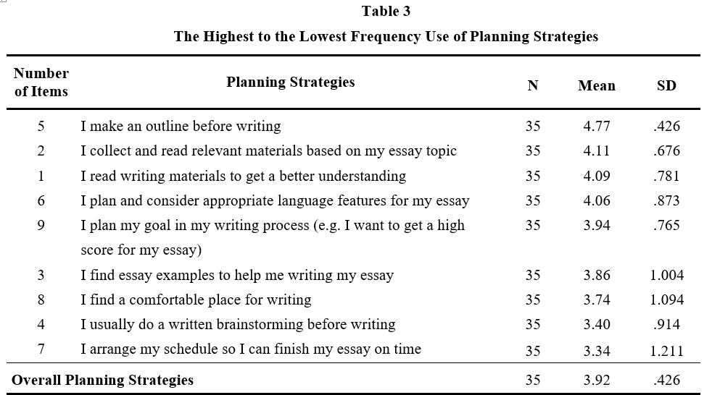
Furthermore, table 4 presented the analysis results of monitoring strategies used by students. The mean score of overall monitoring strategies as the second category of metacognitive strategies was 3.98. It reported that students also applied monitoring strategies at high frequency. Specifically, among the nine items of these strategies, “I try to think about how to connect each paragraph of my essay” (M=4.49) were reported as the most monitoring strategies applied by students. Meanwhile, “I try to mark some parts of my essay that are needed to revise with different colors or symbols on the computer screen” (M=3.34) were the least monitoring strategies used by students. This finding indicates that, during writing their essay, students utilize more strategies to be aware of the quality of their essay organization. Also, rather than the other monitoring strategies, they less apply a strategy of utilizing their computer’s tools to give signs on their draft.
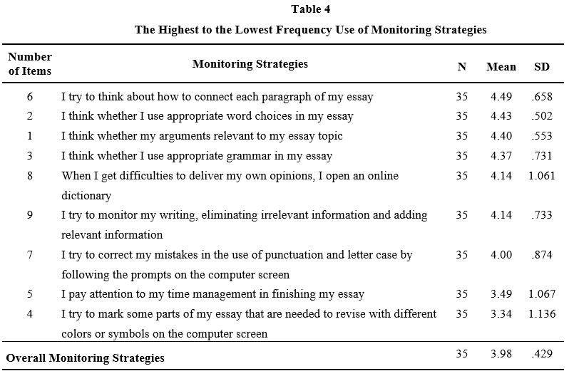
Moreover, table 5 presented the results of evaluating strategies utilized by students. The overall mean score showed that these strategies as the third category of metacognitive strategies have a mean score of 4.17. In line with the two kinds of metacognitive strategies above, it clearly showed that students also highly used evaluating strategies in online-based learning. “I reread my essay and make sure that I use clear language” (M=4.63) and “I assess my progress by comparing my essay with my peers (in terms of sentence length, the complexity of ideas, power of arguments, organization, or accuracy)” (M=3.09) were the most and the least evaluating strategies applied by students respectively. Based on the results, it was indicated that, after finishing their essays, students prefer more to reared and recheck their essays by themselves rather than compare them with their peers.
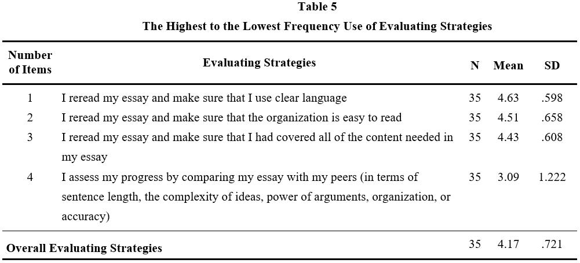

To sum up, the findings revealed that all of the mean scores of metacognitive strategies categories were above 3.5. It generally indicated that students highly apply all of the kinds of metacognitive strategies during the online-based writing learning process. Among the three kinds of metacognitive strategies, evaluating strategies (M=4.17) are the most strategy used by students, followed by monitoring strategies (M=3.98), and planning strategies (M=3.92) respectively. The results indicated that students preferred more to apply strategies that help them in the last step of the writing process. They tend to reread their essays and fix some awkwardness that they did not notice before. Thus, they could assure that their essay was well written before they submit it to their lecturer.

- Students’ writing qualities in online-based learning
As presented in table 6, the results of the analysis revealed that the quality of all writing aspects was ranged from average to very good. Among the five aspects, the organization (M=15.56) was reported as the writing aspect that has the highest quality. The students generally wrote their essays with a clear thesis statement and organizational structure. They also arrange their paragraph with a good enough coherent and cohesive device. Then, the organization was followed by mechanics (M=15.36), language use (M=15.34), and vocabulary (M=15.33) sequentially. In terms of mechanics, the result of the students’ essay showed that they majorly used an appropriate layout with few minor errors in spelling and punctuation. In terms of language use, the students generally wrote their essays with good sentence construction and clear meaning. Also, their essay generally only contained some grammatical errors. In terms of vocabulary, the students tend to use a good range of high-level vocabulary and effective words choice with some errors. Following the four aspects, the content (M=14.51) was reported as the writing aspect that obtains the lowest mean. However, the mean score still showed that the content quality of the students’ essays was at an average level. Their essays were generally written with clear main and supporting ideas also appropriate with the topic.
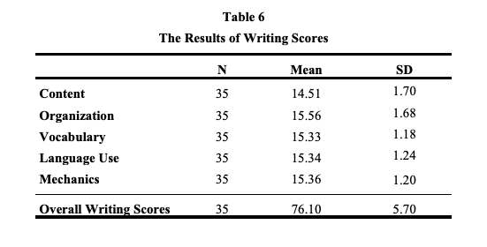
Furthermore, to determine the students’ writing quality, the students’ overall writing scores were also calculated. As table 6 showed, the mean of the students’ writing scores was 76.10. Thus, according to Hartina et al. (2018) categorization, it reported that the students’ writing quality was at a good level.

- Correlation between metacognitive strategies applied in online-based learning and students’ writing quality
A correlation analysis was done to find out the correlation between students’ metacognitive strategies and their writing quality in an online-based learning setting. As shown in table 7, the results of Spearman’s rho correlation analysis reported that the significance value of the two variables (.001) was lower than .05. It indicated that there was a correlation between students’ metacognitive strategies and their writing qualities in online-based learning. Therefore, the null hypothesis of this study was rejected and the relative hypothesis was accepted.
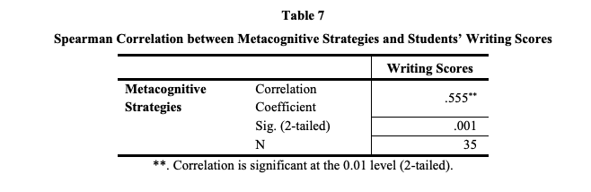
Based on table 7, the coefficient correlation (r= .555) of the metacognitive strategies and the students’ writing quality showed that there was a positive moderate correlation between the two variables. The results indicated that students with higher writing quality reported highly use of metacognitive strategies than those who have lower writing quality.

Discussion
Regarding the results of this study, three findings were reported. The first finding revealed that metacognitive strategies were highly applied by students in an online-based writing process. It supports the results of a previous study (Qin and Zhang, 2019) which also found that students highly applied metacognitive strategies in a multimedia learning setting, particularly in a writing process. More specifically, further results of the current study showed that students utilize all kinds of metacognitive strategies at high frequency, including planning, monitoring, and evaluating. Among these three kinds of metacognitive strategies, evaluating strategies were reported as the most strategy applied by students. This finding, however, contradicts a study conducted by Al Moqbali et al. (2020) which found that evaluating strategies were the least preferred metacognitive strategies. This difference might be affected by the different teachers’ teaching techniques and the way the students regulate their writing process. During online learning, students are required to be more responsible with their own learning. They have to reread and recheck their drafts continuously to enhance their writing quality. Thus, they tend to utilize evaluating strategies to help them ensure that their composition is written well. This idea corroborates with Qin and Zhang (2019) who revealed that high proficiency students prefer to review and edit their compositions by applying evaluating strategies in a multimedia learning setting. It implied that the more they utilize evaluating strategies in their writing process, the more they assure that their essay was written well. Therefore, it could increase their possibility to obtain a better writing score.
The second finding showed that the students’ writing quality was categorized at a good level. This finding was congruent with the results of studies conducted by some researchers (Hartina et al., 2018; Pitenoee et al., 2017; Qin and Zhang, 2019; Teng, 2019). They also found that students highly utilize metacognitive strategies in their writing process and they obtained a good writing performance. It shows that applying metacognitive strategies in the writing process has important roles for students. They could organize their writing process by themselves. Thus, they are able to be more independent and obtain a good achievement. Moreover, at each writing aspect level, the highest quality was obtained by the organization aspect, followed by mechanics, language use, vocabulary, and content respectively. The high quality of the organization might be influenced by metacognitive strategies applied by students. Among the 22 items of metacognitive strategies, outlining was mostly used by students. By making an outline, students could organize their ideas and list important points that they wrote from the introduction till the conclusion of their essay (Qin and Zhang, 2019). It is beneficial to guide them arrange the flow of their draft. Further, the most monitoring strategy applied by students was thinking about how to connect each paragraph of their essay. By utilizing the strategy, students were assisted to write their essays with a good coherent and cohesive device. Also, another strategy that was preferably applied by students was rereading their essays to ensure that the organization is easy to read. Those explanations simply indicated that most of the metacognitive strategies utilized by students were useful to help them improve the quality of their essay organization.
The third finding showed that there was a positive correlation between students’ metacognitive strategies and their writing quality in online-based learning. This finding was in line with some previous studies which were conducted either in online learning (Qin and Zhang, 2019) or a conventional learning setting (Hartina et al., 2018). Students with higher writing quality also reported high use of metacognitive strategies than the lower ones. It indicates that metacognitive strategies could help students organize their writing process and accomplish their writing tasks, particularly in an online learning setting. Thus, those who apply more metacognitive strategies could obtain a better score for their composition. This result, however, contradicts Al Moqbali et al. (2020) who found that metacognitive strategies were not significantly correlated to the students’ writing performance. This difference might be influenced by the teaching-learning system in which the studies were conducted. In online learning, students are less controlled by their lecturers. They are required to regulate their writing process by themselves. It suggests students utilize metacognitive strategies by carefully planning and arranging their process. Also, they could reread and revise their draft if they find awkwardness in terms of content, organization, language use, vocabulary choice, and mechanics. Therefore, their essays are well-structured and have a high quality. This is in line with the findings of some previous studies (Alamri, 2019; Mansor et al., 2018; Raoofi et al., 2017; Setiyad et al., 2016) which also found that metacognitive strategies contribute positive roles to students’ writing performance. Students could manage their learning during all writing steps. Thus, the more they apply metacognitive strategies in online-based writing learning, the better writing scores they have.
CONCLUSION AND SUGGESTIONS
This study revealed that students frequently apply metacognitive strategies in their online-based writing learning including evaluating, monitoring, and planning strategies respectively to make their writing better quality. Metacognitive strategies offer guidance for students to arrange their writing process that lead them to obtain meaningful learning since they have more time to regulate their learning and task during online learning. Moreover, they were more responsible with their own learning process and be more autonomous. Therefore, there is a moderate positive correlation between students’ metacognitive strategies and their writing quality in online learning since by applying metacognitive strategies, students can organize their learning by planning, monitoring, and evaluating their process. Thus, the more they apply metacognitive strategies, the better writing quality they have.
It is recommended to implement with larger participants to make the results more generalizable since online learning systems have become very popular. It is also required to implement metacognitive strategies for other skills, such as listening, reading, and speaking in online learning.

REFERENCES
Ahmadi, M. R., Ismail, H. N., & Abdullah, M. K. K. (2013). The importance of metacognitive reading strategy awareness in reading comprehension. English Language Teaching, 6(10), 235–244. https://doi.org/10.5539/elt.v6n10p235
Al-jarrah, T. M., Mansor, N., Rashid, R. A., Ibrahim, B., & Al-Jarrah, J. M. (2018). EFL students’ attitude toward using metacognitive strategies in writing. English Language Teaching, 11(10), 162–171. https://doi.org/10.5539/elt.v11n10p162
Al Moqbali, I. S., Al Humaidi, S., Al Mekhlafi, A., & Hilal, M. A. (2020). Metacognitive writing strategies used by Omani grade twelve students. International Journal of Learning, Teaching and Educational Research, 19(8), 214–232. https://doi.org/https://doi.org/10.26803/ijlter.19.8.12
Alamri, B. (2019). Exploring metacognitive strategies employed by ESL writers: uses and awareness. International Journal of English Linguistics, 9(1), 159–168. https://doi.org/10.5539/ijel.v9n1p159
Ary, D., Jacobs, L. C., & Sorenson, C. (2010). Introduction to Research in Education (Eight Edit). United States: Wadsworth Cencage Learning.
Bailey, D. R. (2019). Conceptualization of second language writing strategies and their relation to student characteristics. The Journal of Asia TEFL, 16(1), 135–148. https://doi.org/10.18823/asiatefl.2019.11.1.9.135
Belkhir, A., & Benyelles, R. (2017). Identifying EFL learners essay writing difficulties and sources: a move towards solution the case of second year EFL learners at Tlemcen University. International Journal of Learning, Teaching and Educational Research, 16(6), 80–88.
Bower, M., Dalgarno, B., Kennedy, G. E., & Lee, M. J. W. (2015). Design and implementation factors in blended synchronous learning environments: outcomes from a cross-case analysis. Computers & Education, 86(1), 1–17. https://doi.org/10.1016/j.compedu.2015.03.006
Cer, E. (2019). The instruction of writing strategies: the effect of the metacognitive strategy on the writing skills of pupils in secondary education. SAGE Open, 9(2), 1–17. https://doi.org/10.1177/2158244019842681
Connor-Linton, J., & Polio, C. (2014). Comparing perspectives on L2 writing: Multiple analyses of a common corpus. Journal of Second Language Writing, 26, 1–9. https://doi.org/10.1016/j.jslw.2014.09.002
Creswell, J. W. (2012). Educational Research: Planning, Conducting and Evaluating Quantitative and Qualitative Research (Fourth Edi). Boston: Pearson Education, Inc.
Dabbagh, A. (2017). The effect of dialogue journal writing on EFL learners’ descriptive writing performance: a quantitative study. International Journal of Applied Linguistics & English Literature, 6(3), 71–80. https://doi.org/10.7575/aiac.ijalel.v.6n.3p.71
Fareed, M., Ashraf, A., & Bilal, M. (2016). ESL learners’ writing skills : problems, factors and suggestions. Journal of Education and Social Sciences, 4(2), 81–92. https://doi.org/10.20547/jess0421604201
Fiani, A. (2020). Students’ perception toward the enactment of metacognitive instruction in an EFL writing class: lesson learned from a private university in Indonesia. Research and Innovation in Language Learning, 3(3), 220–233. https://doi.org/http://dx.doi.org/10.33603/rill.v3i3.4105
Goctu, R. (2017). Metacognitive strategies in academic writing. Journal of Education in Black Sea Region, 2(2), 82–96.
Goulão, M. de F., & Menedez, R. C. (2015). Learner Autonomy and Self-regulation in eLearning. Procedia - Social and Behavioral Sciences, 174, 1900–1907. https://doi.org/10.1016/j.sbspro.2015.01.853
Hartina, S. S., Vianty, M., & Inderawati, R. (2018). Correlation between students’ metacognitive strategy used in writing process and essay writing performance. English Literacy Education, 5(2), 158–167.
Kassem, M. A. M. (2017). Developing business writing skills and reducing writing anxiety of EFL learners through Wikis. English Language Teaching, 10(3), 151–163. https://doi.org/10.5539/elt.v10n3p151
Kirszner, L. G., & Mandell, S. R. (2015). Patterns for College Writing (Third Edit). Boston: BedfoRd/St. MARtin’S.
Ma, R., & Oxford, R. L. (2014). A diary study focusing on listening and speaking: The evolving interaction of learning styles and learning strategies in a motivated, advanced ESL learner. System, 43(1), 101–113. https://doi.org/10.1016/j.system.2013.12.010
Mansor, N., Al-jarrah, T. M., Rashid, R. A., & Talk, L. (2018). The impact of metacognitive strategies on Jordanian EFL learners’ writing. International Journal of English Linguistics, 8(6), 328–339. https://doi.org/10.5539/ijel.v8n6p328
Oxford, R. L. (1990). Language Learning Strategies: What Every Teacher Should Know. Boston: Heinle & Heinle Publishers.
Pitenoee, M. R., Modaberi, A., & Ardestani, E. M. (2017). The effect of cognitive and metacognitive writing strategies on content of the Iranian intermediate EFL learners’ writing. Journal of Language Teaching and Research, 8(3), 594–600. https://doi.org/10.17507/jltr.0803.19
Qin, L., & Zhang, L. J. (2019). English as a foreign language writers’ metacognitive strategy knowledge of writing and their writing performance in multimedia environments. Journal of Writing Research, 12(2), 393–413. https://doi.org/10 .17239/jowr-20 19.11.02.06
Raoofi, S., Binandeh, M., & Rahmani, S. (2017). An Investigation into writing strategies and writing proficiency of university students. Journal of Language Teaching and Research, 8(1), 191–198. https://doi.org/10.17507/jltr.0801.24
Setiyadi, A. B., Sukirlan, M., & Mahpul. (2016). How successful learners employ learning strategies in an EFL setting in the Indonesian context. English Language Teaching, 9(8), 28–38. https://doi.org/10.5539/elt.v9n8p28
Teng, M. F. (2019). Tertiary-level students ’ English writing performance and metacognitive awareness : a group metacognitive support perspective. Scandinavian Journal of Educational Research, 551–568. https://doi.org/10.1080/00313831.2019.1595712
Winke, P., & Lim, H. (2015). ESL essay rater’ cognitive processes in applying the Jacobs et al. rubric : An eye-movement study. Assessing Writing, 25, 38–54. https://doi.org/10.1016/j.asw.2015.05.002
Wu, D., Bieber, M., & Hiltz, S. R. (2019). Engaging students with constructivist participatory examinations in asynchronous learning networks. Journal of Information Systems Education, 19(3), 321–331.
Yulianti, D. B. (2018). Learning strategies applied by the students in writing English text. Journal on English as a Foreign Language, 8(1), 19–38. https://doi.org/10.23971/jefl.v8i1.583

