First author : Mercya Christ Sita
Second author : Lilia Indriani
Affiliation of the first and second author: Universitas Tidar, Magelang, Indonesia
Corresponding Author: mercyachrist@gmail.com
About the authors
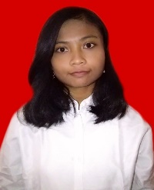  First author photograph here | Mercya Christ Sita Dewi, a student in English Department, Faculty of Education and Teacher Training, Universitas Tidar. She is interested in TEFL, technology enhanced language learning, and linguistics studies.
  Second author photograph here | Lilia Indriani, M.Pd. Lecturer in English Department, Faculty of Education and Teacher Training, Universitas Tidar. Her interest is on technology enhanced language learning and TEFL.

