
Strengthening Digital Services Through Quality, Responsiveness, and Satisfaction

Authors
Intan Nur’Aini ¹, Aisyah Diah Hapsari², Azila Putri Jelita ³, Jessenia Nadhita Nugrahini⁴, Helen Syfa Aprilia⁵, Aisya Shafa Maharani⁶, Nouval Yaafi Talitha Zahri⁷, Dwi Ernawati⁸, Daniel Oluwatosin Oyerinde⁹

Affiliations
^{1,2,3,4,5,6,7,8}Bachelor of Accounting Study Program, Surabaya State University, Indonesia.
⁹Department of Philosophy, Osun State University, Nigeria.

Corresponding Author Email
intanurain000@gmail.com

Abstract
This study investigates how system quality, service responsiveness, and perceived trust influence user trust in digital public services, with user satisfaction acting as a moderating variable. Positioned within the perspectives of Accounting Information Systems (AIS), digital governance, and public accountability, this study explains how the quality of digital public service systems shapes citizens' trust in government digital platforms. In this study, perceived trust refers to users' perceptions of the trustworthiness, security, and reliability of the digital platform, whereas user trust represents users' overall confidence in relying on the platform after experiencing its services. A quantitative survey was conducted using 152 valid responses from users of public service websites and applications in Madiun and surrounding areas. The data were analyzed using descriptive statistics, reliability testing, Pearson correlation, multiple regression, and moderated regression with HC3 robust standard errors. The findings indicate that system quality is strong and consistent enough predictor of user trust, while service responsiveness and perceived trust do not show significant direct effects after controlling for system quality. User satisfaction marginally improves the explanatory power of the model and significantly strengthens the relationship between perceived trust and user trust. These findings suggest that strengthening Accounting Information Systems through reliable digital infrastructure, responsive public services, and citizen-oriented digital governance can enhance public accountability and foster greater trust in digital public services.
Keywords:
Accounting Information Systems; digital governance; system quality; service responsiveness; user trust.

1. Introduction
Digital transformation has fundamentally changed how governments deliver public services by enabling greater efficiency, transparency, and accessibility through digital platforms. The increasing adoption of digital technologies in public administration has also made digital governance an important mechanism for improving public service delivery and supporting sustainable development. The United Nations Department of Economic and Social Affairs (2024) emphasizes the importance of accelerating digital transformation to strengthen the effectiveness, inclusiveness, and sustainability of e-government services. From a strategic behavioral accounting perspective, citizen trust in digital services reflects users' behavioral responses to the effectiveness of information systems in supporting reliable and accountable service delivery. Consequently, the effectiveness of digital public services must be evaluated not only by technological performance but also by their contribution to transparent governance, accountable public administration, and sustained citizen engagement. Effective digital service systems enable governments to improve administrative efficiency, reduce transaction costs, and strengthen accountability through accurate, timely, and transparent information delivery. In this context, digital transformation is also increasingly associated with organizational agility and strategic digital behavior that support sustainable economic growth and the achievement of Sustainable Development Goal 8 (Laksono et al., 2025). Consequently, the success of digital public services is no longer evaluated solely by technological adoption but also by their ability to create public value and enhance citizens' trust in government institutions.
Beyond administrative efficiency, digital public service platforms function as strategic components of Accounting Information Systems (AIS) that support organizational control, public sector performance measurement, and accountability (Knudsen, 2020; Pondrinal et al., 2026). In this context, timely and reliable government information and reporting processes are also essential for strengthening public accountability in digital governance (Wijaya et al., 2025). This perspective aligns the present study with the scope of the Journal of Strategic Behavior Accounting by integrating AIS, digital governance, public accountability, and strategic behavioral outcomes into a unified analytical framework.
From the perspective of digital governance, citizen trust represents a critical indicator of successful digital transformation. Governments increasingly rely on digital platforms to deliver licensing services, public complaints, administrative documents, taxation, and other essential public services. However, the availability of digital platforms alone does not guarantee public trust. Citizens evaluate digital public services based on the quality of information systems, the responsiveness of service providers, the reliability of digital infrastructure, and their overall service experience.
In addition, citizens’ adoption of online public services is influenced by a combination of technological, behavioral, and contextual factors (Rana et al., 2016). Research on technology acceptance has shown that users’ behavioral intentions are shaped by their perceptions of the usefulness, usability, and overall performance of technology (Davis, 1989). Similarly, the Unified Theory of Acceptance and Use of Technology emphasizes that technology adoption is influenced by multiple behavioral and contextual determinants (Venkatesh et al., 2003). These perspectives are relevant to digital public services because citizens’ decisions to use government platforms are closely connected to how they evaluate the usefulness, accessibility, and reliability of the services provided.
The Information Systems Success Model proposed by DeLone and McLean emphasizes that system quality, information quality, and service quality are fundamental determinants of successful information systems through their influence on user satisfaction and organizational benefits. Similarly, Technology Acceptance Theory and trust-based perspectives argue that citizens are more likely to adopt and continuously use digital public services when they perceive the systems as reliable, useful, secure, and trustworthy. These theoretical perspectives position digital public services not merely as technological innovations but as strategic organizational resources that improve governance performance and accountability.
Previous empirical studies consistently report that system quality, service quality, perceived trust, and user satisfaction positively influence citizens' evaluations of digital public services. Nevertheless, most studies have concentrated on technology adoption, continuance intention, or user satisfaction as the primary outcomes, while user trust has received comparatively less attention as the ultimate indicator of successful digital public service implementation. This limitation is important because trust determines whether citizens are willing to rely on government digital platforms when accessing essential public services, making it a key issue in Accounting Information Systems and digital governance research.
Although previous studies have consistently demonstrated that system quality, service quality, and user satisfaction influence citizens' evaluations of e-government services (Alkraiji, A., & Ameen, 2022; Pham et al., 2023; Taufiqurokhman et al., 2024), three important gaps remain. Despite the growing literature on digital public services, several important research gaps remain. First, previous studies based on the Information Systems Success Model predominantly examine user satisfaction, continuance intention, or technology adoption as dependent variables, whereas relatively few studies investigate user trust as the primary outcome. Since user trust reflects citizens' confidence in government digital platforms and influences the sustainability of digital public services, further investigation is required to identify its determinants.
Second, prior research generally treats user satisfaction as a direct outcome of system quality and service quality rather than as a moderating mechanism. Consequently, empirical evidence explaining whether user satisfaction strengthens or weakens the influence of system quality, service responsiveness, and perceived trust on user trust remains limited. This issue is particularly relevant because satisfied users may interpret service experiences differently from dissatisfied users, resulting in different trust formation processes.
Third, empirical findings concerning the influence of system quality, service responsiveness, and trust-related perceptions remain inconsistent across different digital service contexts. Although positive relationships have frequently been reported, the magnitude and significance of these relationships vary depending on institutional settings, digital literacy, service characteristics, and cultural contexts. Evidence from Indonesian local government digital services remains limited, making it difficult to generalize findings from previous studies conducted in other countries or private-sector digital platforms.
Addressing these gaps, this study examines the direct effects of system quality, service responsiveness, and perceived trust on user trust while simultaneously investigating the moderating role of user satisfaction. By integrating these variables into a unified empirical framework within Indonesian local digital public services, this study extends the Information Systems Success Model and contributes to the literature on Accounting Information Systems, digital governance, public accountability, and strategic behavior in digital public service management.
Accordingly, this study aims to examine the effects of system quality, service responsiveness, and perceived trust on user trust in digital public services while investigating the moderating role of user satisfaction. More importantly, this study contributes to the Journal of Strategic Behavior Accounting literature by extending the Information Systems Success Model within the context of Accounting Information Systems, digital governance, public accountability, and strategic citizen behavior toward digital public services.

2. Literature Review and Hypotheses Development
The information systems success model, technology acceptance theory, and trust theory serve as the theoretical cornerstones of this investigation. In the context of contemporary digital governance, these perspectives complement each other by recognizing that digital public services require structural technological performance, behavioral user evaluation, and strategic institutional confidence. Within the public sector, digital governance cannot be separated from the advancement of Accounting Information Systems (AIS). These systems act as the core infrastructure to process public resource data, ensure fiscal transparency, and facilitate operational governance. According to the information systems success model, system quality, information quality, service quality, utilization, satisfaction, and net benefits are all interconnected aspects of effective information systems. System quality in public service platforms refers to how well the system functions technically, including stability, dependability, accessibility, usability, and clarity of navigation. Within an administrative and AIS framework, if the underlying public policy is well-designed but citizens experience technical errors, confusing menus, or slow websites, they may perceive the platform as an unreliable mechanism for public accountability, thereby damaging the strategic relationship between citizens and the state.
According to technology acceptance theory, people assess digital systems based on perceived utility and usability. This perspective has also been applied to explain user behavior in digital service platforms, including mobile payment systems, where perceived usefulness, ease of use, and other acceptance factors shape users' behavioral responses to technology (Liébana-Cabanillas et al., 2015). System quality conceptually overlaps with the usability and dependability characteristics that encourage technological acceptance, even though this study does not evaluate perceived usefulness and perceived ease of use as independent variables. In public sector behavioral accounting, reducing cognitive load and administrative uncertainty through user-friendly systems is crucial for fostering compliance and engagement. Users of local public services frequently visit a platform to access administrative procedures, verify financial or tax requirements, file grievances, or receive public updates. When the platform efficiently facilitates these duties, the behavioral experience can foster trust in the public organization, reinforce digital governance structures, and validate the effectiveness of the underlying AIS channel.
Because public service transactions require consumers to rely on organizations that handle personal data, provide information, and respond to requests, trust theory is especially pertinent. The willingness of users to think that the platform and the organization behind it are capable, trustworthy, and honest is known as trust in digital public services. From a behavioral accounting perspective, formal authority is not the only source of trust; repeated behavioral and administrative experiences play a pivotal role. Confidence in public accountability can be raised and perceived operational risk can be decreased with a technically sound platform, clear information, and prompt public service support. On the other hand, a poor user experience could raise questions about whether the digital platform is really effective or just symbolic window-dressing, thereby undermining the strategic goals of public governance.
The study's first independent variable is system quality. System quality, as used in the literature on information systems and digital governance, refers to a system's desired technical features, including functionality, security, adaptability, dependability, responsiveness, and simplicity of use. High system quality in digital public services refers to the ability of users to easily access features, comprehend instructions, and carry out service-related tasks such as public reporting or financial transactions without needless hassles. Additionally, a well-designed system minimizes the need for repeated tries to accomplish basic activities and offers consistent information, which satisfies the transparency requirements of public accountability. Because public agencies can enhance system quality through improved interface design, server stability, user testing, and maintenance procedures, it is a highly controllable dimension from a managerial and organizational control standpoint.
Theoretically, there is a substantial correlation between user trust and system quality. In behavioral accounting and technology adoption literature, users typically view technological performance as physical proof of organizational seriousness and institutional competence. If a platform functions well, people might think the public organization possesses the necessary capability to handle complex digital transformation and ensure strategic accountability. Conversely, if citizens encounter persistent system failures, they may doubt the institution's legitimacy as well as its competence in managing public resources. As a result, system quality should positively impact user trust. This logic leads to the following formulation of the first hypothesis:
H1: System quality has a positive effect on user trust in digital public services.

The second independent variable is service responsiveness. It describes how promptly, responsibly, and suitably a service provider responds to user demands, grievances, inquiries, or requests made via digital media. Service responsiveness is a critical behavioral indicator in public service environments since many consumers use digital platforms to address real-world, urgent administrative and civic issues. A prompt, institutional response might boost the impression that the public institution is paying attention, fulfills its public accountability mandate, and lessens user annoyance. However, a delayed or ambiguous answer might reduce the platform's perceived value, particularly since citizens expect faster digital service than traditional, bureaucratic ones. The organizational, human, and control aspects of digital public governance are thus directly reflected in service responsiveness.
Theoretically, as responsiveness shows institutional benevolence and strategic responsibility, service responsiveness should increase user trust. When the organization follows up on issues and offers clear guidance, citizens may tolerate minor technical constraints because they perceive active public accountability. Because users are aware that someone is actively managing and controlling the digital channel, responsive service interactions also foster psychological assurance and reduce behavioral anxiety. Consequently, the following is the formulation of the second hypothesis:
H2: Service response has a positive effect on user trust in digital public services.

The third independent variable is perceived trust. To avoid conceptual redundancy and tautology, this study establishes a sharper conceptual distinction between perceived trust and user trust. In this research, perceived trust is conceptualized strictly as an antecedent perception regarding the structural, institutional, and platform-specific characteristics of the digital environment. It encompasses the user's cognitive evaluation of institutional legitimacy, platform data security, and systemic integrity (such as trust in financial data security and encrypted transaction channels). In research on technology adoption and behavioral accounting, such structural perceived trust is frequently considered an initial cognitive anchor. For instance, in digital financial services, such as paylater and QR-based digital payment contexts, initial perceived trust in platform security has been demonstrated to be important in explaining intention and usage behavior (Putri et al., 2026; Wiguna et al., 2026).
In contrast, user trust is defined as the distinct behavioral and relational outcome. It represents the user's cumulative, overall psychological confidence in the public institution as a dependable entity after actively experiencing the system's quality, the administration's responsiveness, and their personal satisfaction with the interaction. By separating initial platform or institutional security perceptions (perceived trust as an antecedent) from final relational confidence (user trust as an outcome), this study evaluates whether a citizen's initial trust in the digital environment's security and legitimacy remains significant once active technical and service-response factors are fully accounted for. This clear distinction avoids tautology in the model and enables a more precise evaluation of behavioral trust formation. The following is the formulation of the third hypothesis:
H3: Perceived trust has a positive effect on user trust in digital public services.

Included as a moderating variable as well as an extra predictor is user satisfaction. The degree to which citizens believe their interaction with the digital public service fulfills their operational and behavioral expectations is reflected in their level of satisfaction. Because it encapsulates the user experience following direct interactions with system features, data information, and service support, satisfaction is a key evaluative response in information systems and public sector accounting research. Satisfaction is also crucial to digital governance and strategic public management since it serves as a key performance indicator of whether residents gain significantly from public sector digital transformation. A satisfied citizen is more likely to view the governing platform as capable, utilize it for future administrative needs, and perceive the public institution as transparent.
Because user satisfaction boosts positive appraisal and lessens behavioral disappointment, it is anticipated that it will increase user trust as a direct predictor. When citizens are satisfied with their administrative outcomes, they may assume that the organization providing the service is operationally capable and publicly accountable. Consequently, the following is the formulation of the fourth hypothesis:
H4: User satisfaction has a positive effect on user trust in digital public services.

The strength of the association between user trust and system-related perceptions can be altered by user satisfaction acting as a behavioral and evaluative moderator. For instance, users who are satisfied may see system features more favorably, which could amplify the positive impact of system quality on final user trust. Because responsive engagement from public officials is more meaningful when the overall administrative experience is favorable, high satisfaction may also amplify the influence of service responsiveness on relational trust. Similarly, when users are highly satisfied with the digital service outcomes, their initial perceived trust regarding platform security and institutional legitimacy is more powerfully translated into long-term user trust. This perspective aligns with the reasoning in behavioral accounting that users employ satisfaction as an experiential filter to evaluate and weigh technical, relational, and institutional cues within digital governance.
Based on this argument, the study formulates three moderation hypotheses.
H5a: User satisfaction moderates the relationship between system quality and user trust.
H5b: User satisfaction moderates the relationship between service response and user trust.
H5c: User satisfaction moderates the relationship between perceived trust and user trust.
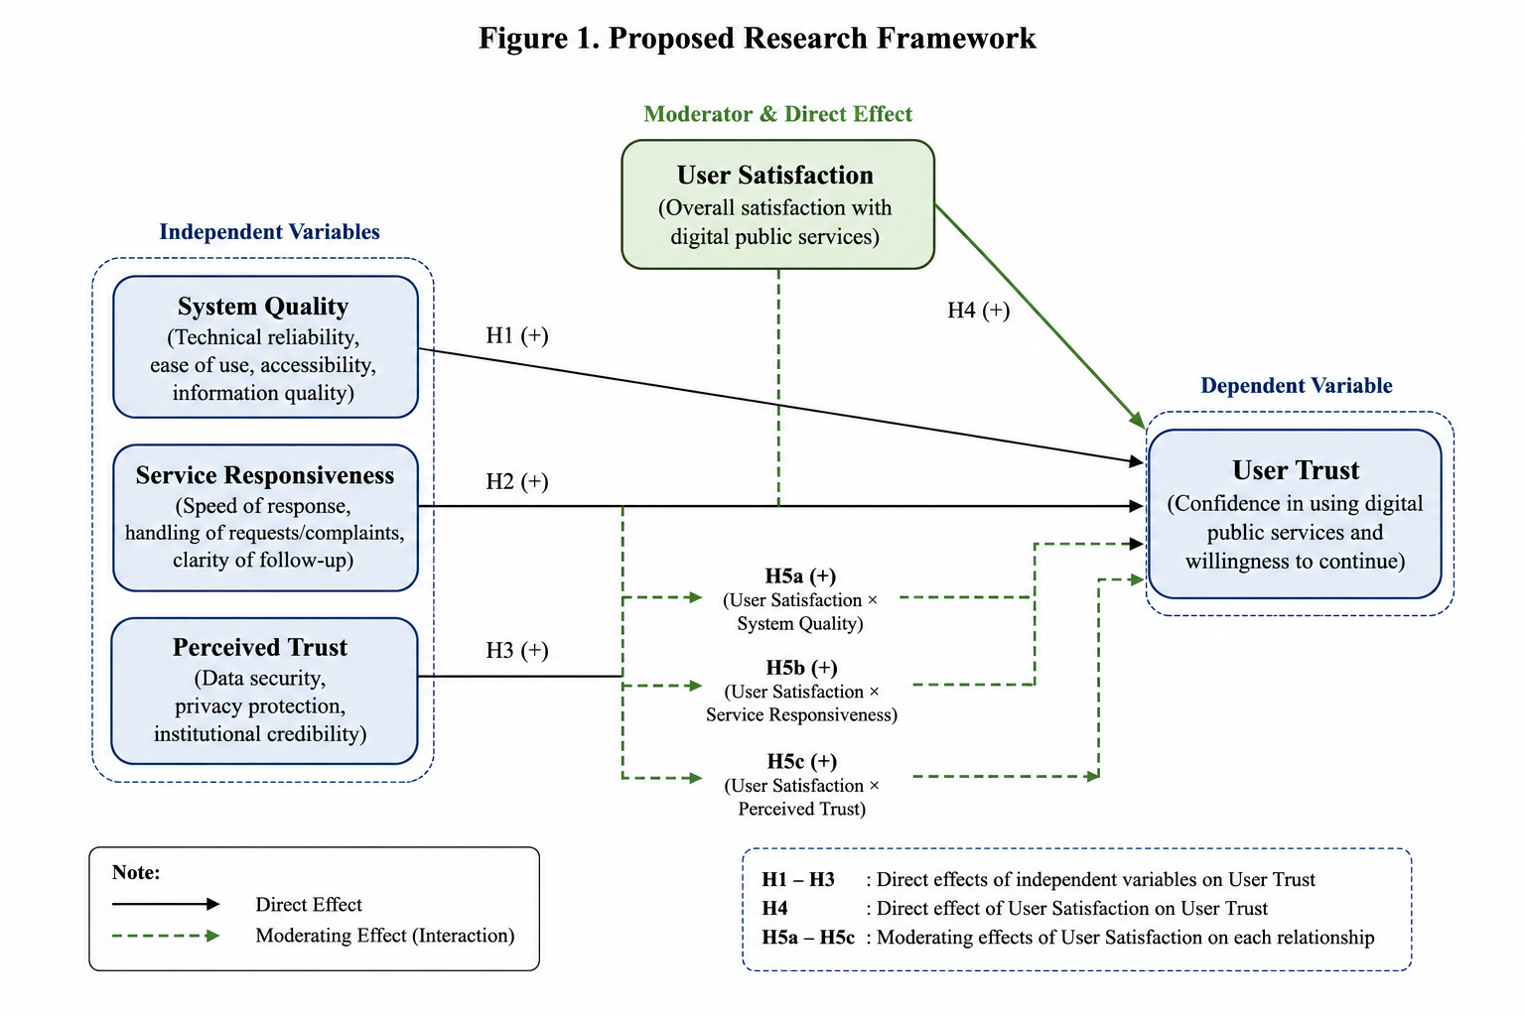
Figure 1 presents the proposed research framework of this study. The framework is developed based on recent studies on digital public services, which suggest that system quality, service responsiveness, and perceived trust are important determinants of user trust and satisfaction in e-government services (Alkraiji, A., & Ameen, 2022; Pham et al., 2023; Taufiqurokhman et al., 2024). Accordingly, this study proposes that system quality, service responsiveness, and perceived trust directly influence user trust. Furthermore, user satisfaction is hypothesized to have both a direct effect on user trust and a moderating effect on the relationships between each independent variable and user trust. This integrated framework provides a comprehensive understanding of trust formation in digital public services and reflects the interaction between technical quality, service performance, and users' evaluation of digital government services (Kala et al., 2024; Rahmatullah et al., 2025).
3. Research Methodology
This study employed an explanatory quantitative approach to examine the effects of system quality, service responsiveness, and perceived trust on user trust in digital public services, as well as to test whether user satisfaction moderates these relationships. A quantitative design was considered appropriate because the study aims to measure associations among variables using numerical survey data and inferential statistical analysis.
The target population comprised individuals who had used digital public service platforms, including public service websites and applications. A non-probability sampling technique with a purposive sampling method was applied, whereby respondents were selected based on their relevance to the research objectives. To be eligible, respondents had to have used at least one digital public service. Data were collected between December 2025 and January 2026 through an online questionnaire. After data screening and cleaning, 152 valid responses were retained for analysis. The respondents included students, employees, business owners, and other members of the public who had used various digital public service applications. The majority of respondents were young users, including school and college students, which is consistent with the broader trend of increasing adoption of digital platforms among younger demographic groups. Public service websites represented the most frequently used category, followed by Pendekar, complaint platforms, MASS, EJSC, and services related to digital identity.
To ensure that respondents belonged to the target population, a screening question was included at the beginning of the questionnaire, such as: “Have you ever used a digital public service through a website or an application?” Only those who answered “yes” were allowed to proceed. As an additional verification step, respondents were also asked to indicate the type of digital public service they had used. This procedure ensured that only individuals with actual experience using digital public services were included in the study. During the data-cleaning stage, incomplete responses, duplicate entries, and responses that did not meet the inclusion criteria were excluded from the analysis.
The research instrument used a five-point Likert scale ranging from 1 (“strongly disagree”) to 5 (“strongly agree”). System quality was measured using 10 items, service responsiveness using 3 items, perceived trust using 2 items, user satisfaction using 7 items, and user trust using 2 items. The questionnaire items were adapted from prior studies relevant to e-government, electronic service quality, and user trust.
The system quality items were adapted from the information systems success model developed by DeLone and McLean (2003), as well as from e-government studies that operationalized system quality in digital public service settings, such as Wang and Liao (2008) and Rahmatullah et al. (2025). These items captured dimensions such as ease of use, reliability, access speed, system stability, and ease of navigation. The service responsiveness items were adapted from the electronic service quality literature, particularly the responsiveness dimension proposed by Parasuraman et al. (2005), and were contextualized to digital public services following Alkraiji and Ameen (2022) and Taufiqurokhman et al. (2024). These indicators assessed the timeliness of responses, readiness to provide assistance, and the ability of service providers to address users’ needs or complaints.
The perceived trust and user trust items were adapted from the trust literature in digital and e-government contexts, particularly Carter and Bélanger (2005), Gefen et al. (2003), and Teo et al. (2008). These measures focused on users’ confidence in the security, reliability, integrity, and credibility of digital public service platforms. User satisfaction items were adapted from studies on satisfaction in e-government and information systems, including DeLone and McLean (2003), Alkraiji and Ameen (2022), Kala et al. (2024), and Rahmatullah et al. (2025). All items were reworded as necessary to fit the context of digital public services without altering the conceptual meaning of the original constructs.
To ensure comparability across variables with different numbers of indicators, construct scores were computed as mean scores. Prior to hypothesis testing, the data were evaluated using descriptive statistics, corrected item–total correlations to assess item validity, Cronbach’s alpha to examine reliability, Pearson correlations to explore bivariate associations among constructs, and regression diagnostics to assess model suitability. The use of Cronbach’s alpha followed Cronbach (1951), while reliability interpretation was guided by conventional psychometric standards (Nunnally & Bernstein, 1994).
The analysis proceeded in four stages. First, respondent characteristics and overall response patterns were examined using descriptive statistics. Second, item validity and construct reliability were assessed to ensure adequate internal consistency. Third, bivariate relationships among the constructs were examined using Pearson correlation. Fourth, the hypotheses were tested using multiple regression and moderated regression analysis (MRA). The analytical procedures and interpretation of the measurement and structural relationships were conducted with reference to established guidelines for evaluating latent constructs and empirical models in behavioral research (Hair et al., 2022). HC3 robust standard errors were employed to reduce potential bias in standard error estimation in the presence of mild deviations from normality. In addition, all predictor variables were mean-centered prior to generating interaction terms in order to reduce multicollinearity in the moderation model.
The main regression model is specified as follows:
UTᵢ = β₀ + β₁SQᵢ + β₂SRᵢ + β₃PTᵢ + β₄USᵢ + β₅(SQᵢ × USᵢ) + β₆(SRᵢ × USᵢ) + β₇(PTᵢ × USᵢ) + εᵢ
where UT denotes user trust, SQ denotes system quality, SR denotes service responsiveness, PT denotes perceived trust, US denotes user satisfaction, and ε denotes the random error term.
From an ethical standpoint, participation in the study was voluntary. Before completing the questionnaire, respondents were informed about the purpose of the study, the participant criteria, and the fact that the data would be used solely for academic purposes. They were also informed that no personally identifying information would be directly collected and that all responses would be treated anonymously and confidentially. Completion of the questionnaire was therefore considered to constitute informed consent to participate in the study.

4. Result
  - Respondent Profile
Table 1. Respondent Profile
Characteristic | n | Percentage
Age <20 | 119 | 78.29%
Age 20-29 | 23 | 15.13%
Female | 112 | 73.68%
Male | 40 | 26.32%
Student | 93 | 61.18%
Senior high student | 32 | 21.05%
Worker | 22 | 14.47%
Entrepreneur | 5 | 3.29%
Madiun domicile | 111 | 73.03%
Public service website user | 81 | 53.29%
Pendekar user | 37 | 24.34%
Complaint platform user | 23 | 15.13%
Source: Processed survey data, 2026
Table 1 demonstrates that young respondents make up the majority of the sample. Users under 20 make up 78.29% of the sample, with those between the ages of 20 and 29 making up 15.13%. There are 73.68% female responders and 26.32% male respondents. Students make up the majority of the sample (61.18%), followed by workers (14.47%) and senior high school students (21.05%). According to this profile, the dataset primarily represents the digital service experience of younger consumers, who are probably accustomed to using mobile applications and interacting online.
The local relevance of the findings is strengthened by the fact that (73.03%) of the respondent are domiciled in Madiun. The most common application type is public service websites (53.29%), which are followed by Pendekar (24.34%) and complaint platforms (15.13%). This distribution indicates that the respondents use a variety of public digital service channels rather than relying on a single platform. Therefore, the results reflect user’s overall perceptions of local digital public services rather than the evaluation of a single platform.

  - Descriptive Statistics of Main Constructs

Table 2. Descriptive Statistics of Research Constructs
Construct | N | Mean | Std. Dev. | Min | Median | Max
System Quality | 152 | 3.573 | 0.671 | 1.800 | 3.700 | 5
Service Response | 152 | 3.412 | 0.932 | 1.333 | 3.667 | 5
Perceived Trust | 152 | 3.493 | 0.924 | 1.000 | 3.500 | 5
User Satisfaction | 152 | 3.571 | 0.697 | 1.714 | 3.643 | 5
User Trust | 152 | 3.842 | 0.720 | 1.500 | 4.000 | 5
Source: Processed survey data, 2026.
According to the descriptive statistics, the constructs' mean scores on a five-point scale vary from 3.41 to 3.84. At 3.842, user trust has the highest mean score, suggesting that respondents usually have a positive level of trust in digital public services. The mean scores for system quality and user satisfaction are comparable, at 3.573 and 3.571, respectively, indicating that respondents had a rather favorable opinion of the technical and experiential aspects of the services. Service responsiveness has the lowest mean score (3.412), whereas perceived trust has a mean score of (3.493).
From a managerial perspective, the comparatively lower mean score for service responsiveness is noteworthy. It implies that even though users generally perceive the platform positively, they still expect service administrators to be more responsive. In public service administration, responsiveness encompasses not only timeline but also clarity, empathy, and certainty of follow-up. Even when the system functions well, users may perceive the quality of digital services as inadequate if they do not receive prompt responses or timely updates.
Figure 2. Mean Scores of Research Constructs
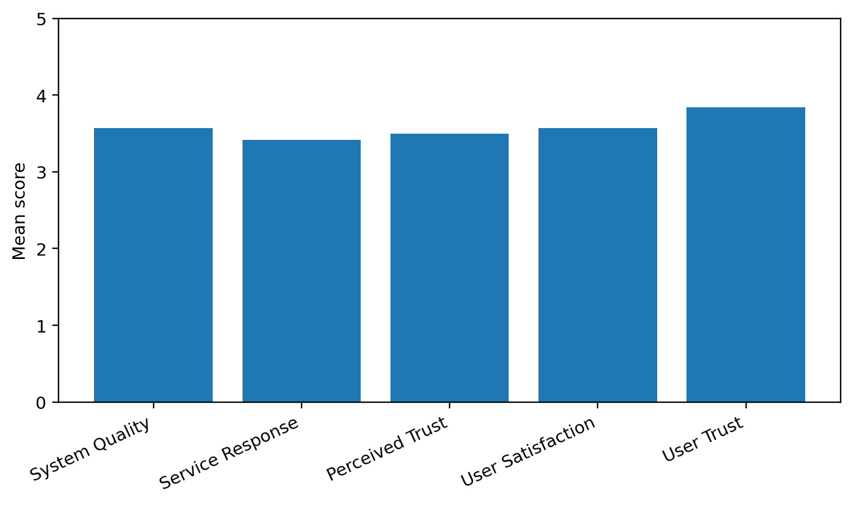
Source: Processed survey data, 2026.
User trust is the component with the greatest rating, while service responsiveness has the lowest, as seen in Figure 2. This trend suggests that although users may already have a relatively high level of trust in digital public services, improving the responsiveness dimension is still a top concern. In order to prevent digital channels from becoming passive information boards, the study recommends that public bodies invest not only in digital platforms but also in service procedures, monitoring systems, and response standards.

  - Reliability and Item Validity
Table 3. Reliability and Construct Score Summary
Construct | Items | Cronbach Alpha | Mean | Std. Dev. | Min | Max
System Quality (X1) | 10 | 0.869 | 3.573 | 0.671 | 1.800 | 5
Service Response (X2) | 3 | 0.788 | 3.412 | 0.932 | 1.333 | 5
Perceived Trust (X3) | 2 | 0.770 | 3.493 | 0.924 | 1.000 | 5
User Satisfaction (M) | 7 | 0.807 | 3.571 | 0.697 | 1.714 | 5
User Trust (Y) | 2 | 0.265 | 3.842 | 0.720 | 1.500 | 5
Source: Processed survey data, 2026.
As shown in Table 3, all constructs demonstrated satisfactory internal consistency, with Cronbach's alpha values meeting the acceptable threshold for exploratory research. In contrast, the user trust construct produced a Cronbach's alpha of 0.265, indicating relatively low internal consistency. This result is likely related to the use of only two measurement items, which may not fully capture the multidimensional nature of user trust. Accordingly, the findings associated with this construct should be interpreted with caution and viewed as exploratory rather than conclusive.
Despite this limitation, the user trust construct was retained because it represents the primary dependent variable and the central focus of this study. Therefore, the findings should be considered preliminary empirical evidence providing initial insights into user trust in digital public services. Future studies are encouraged to employ a more comprehensive measurement scale with additional indicators to improve construct reliability and provide more robust empirical evidence.

Table 4. Range of Corrected Item–Total Correlations
Construct | Lowest corrected item-total correlation |  | Highest corrected item-total correlation
Perceived Trust (X3) | 0.626 | 0.626
Service Response (X2) | 0.590 | 0.714
System Quality (X1) | 0.461 | 0.752
User Satisfaction (Z) | 0.186 | 0.706
User Trust (Y) | 0.153 | 0.153
Source: Processed survey data, 2026.
The majority of constructs have corrected item-total correlations greater than 0.30, as Table 4 demonstrates. Perceived trust has a corrected item-total correlation of 0.626, system quality items range from 0.461 to 0.752, and service response items range from 0.590 to 0.714. User satisfaction items range from 0.186 to 0.706, suggesting that one item may need to be reviewed. The low corrected item-total correlations for the user trust construct (0.153) are consistent with the limitation identified in the reliability analysis.
There are useful implications for future research based on these measurement results. The instrument section should be strengthened by examining the user satisfaction item with a low item-total correlation and adding more user trust indicators if the manuscript is revised for submission to a higher-impact journal. However, the existing findings still offer valuable preliminary evidence about the service aspects that have the strongest correlation with user trust.

  - Correlation Analysis

Table 5. Pearson Correlation Matrix
Construct | System Quality | Service Response | Perceived Trust | User Satisfaction | User Trust
System Quality | 1.000 | 0.770 | 0.712 | 0.846 | 0.627
Service Response | 0.770 | 1.000 | 0.684 | 0.831 | 0.453
Perceived Trust | 0.712 | 0.684 | 1.000 | 0.738 | 0.407
User Satisfaction | 0.846 | 0.831 | 0.738 | 1.000 | 0.569
User Trust | 0.627 | 0.453 | 0.407 | 0.569 | 1.000
Source: Processed survey data, 2026. All correlations are positive; p-values are below 0.001 based on the processed correlation output.
The correlation matrix reveals that all primary constructs exhibit positive relationships with user trust, and all correlations are statistically significant (p < 0.001). Among these variables, system quality shows the highest correlation with user trust (r = 0.627), followed by user satisfaction (r = 0.569), service responsiveness (r = 0.453), and perceived trust (r = 0.407). These findings provide initial evidence that technical quality, service experience, and perceived trust are associated with user trust in digital public services. However, correlation analysis does not account for the combined influence of multiple predictors; therefore, these results should be interpreted as preliminary.
Strong correlations are also observed among the independent variables. For instance, system quality is highly correlated with user satisfaction (r = 0.846), while service responsiveness shows a similarly strong correlation with user satisfaction (r = 0.831). These findings suggest that users evaluate digital public services in an integrated manner, where technical performance and service experience are closely interrelated. At the same time, these high intercorrelations may indicate potential conceptual overlap among the variables, reinforcing the need for regression analysis to better identify the unique contribution of each predictor.

  - Direct Effect and Moderation Model
Table 6. Model Fit Summary
Model | R Square | Adjusted R Square | F | p-value
Model 1: Direct effects | 0.397 | 0.385 | 32.486 | 0.000
Model 2: Added User Satisfaction | 0.414 | 0.398 | 25.930 | 0.000
Model 3: Moderation | 0.450 | 0.423 | 16.830 | 0.000
Incremental interaction test | 0.036 |  | 3.168 | 0.026
Source: Processed survey data, 2026.
Table 6 presents the explanatory power of the three regression models. Model 1, which includes system quality, service responsiveness, and perceived trust, explains 39.7% of the variance in user trust. The inclusion of user satisfaction in Model 2 increases the R-square to 41.4%. Model 3, which incorporates interaction terms, further increases the R-square to 45.0%. The incremental interaction test shows an additional R-square of 3.6% with a p-value of 0.026, indicating that the inclusion of moderation terms provides a statistically significant, although modest, improvement in the model’s explanatory power.

Table 7. Direct Regression Results Predicting User Trust
Variable | B | Std. Error | t | p-value | 95% CI Lower | 95% CI Upper
Constant | 1.423 | 0.298 | 4.775 | 0.000 | 0.834 | 2.012
System Quality | 0.764 | 0.151 | 5.049 | 0.000 | 0.465 | 1.063
Service Response | -0.039 | 0.098 | -0.395 | 0.693 | -0.231 | 0.154
Perceived Trust | -0.052 | 0.067 | -0.771 | 0.442 | -0.184 | 0.080
Source: Processed survey data, 2026. Robust standard errors HC3 are reported.
Table 7 shows that system quality has a positive and statistically significant effect on user trust (β = 0.764, p < 0.001), supporting H1. In contrast, service responsiveness does not have a significant effect (β = -0.039, p = 0.693), indicating that H2 is not supported. Similarly, perceived trust does not show a significant effect (β = -0.052, p = 0.442), meaning that H3 is also not supported. These results indicate that system quality is the most consistent predictor within the direct-effect model.

Table 8. Regression Results with User Satisfaction
Variable | B | Std. Error | t | p-value | 95% CI Lower | 95% CI Upper
Constant | 1.256 | 0.317 | 3.964 | 0.000 | 0.630 | 1.881
System Quality | 0.629 | 0.170 | 3.699 | 0.000 | 0.293 | 0.964
Service Response | -0.126 | 0.111 | -1.130 | 0.260 | -0.346 | 0.094
Perceived Trust | -0.090 | 0.074 | -1.226 | 0.222 | -0.236 | 0.055
User Satisfaction | 0.304 | 0.170 | 1.789 | 0.076 | -0.032 | 0.640
Source: Processed survey data, 2026. Robust standard errors HC3 are reported.
Table 8 indicates that system quality remains positive and statistically significant after the inclusion of user satisfaction (β = 0.629, p < 0.001). Service response (β = -0.126, p = 0.260) and perceived trust (β = -0.090, p = 0.222) do not show significant effects. User satisfaction shows a positive coefficient (β = 0.304) but is not statistically significant at the 5% level (p = 0.076). Therefore, H4 is not supported at the 5% significance level and should be interpreted as showing only marginal support.

Table 9. Moderated Regression Results Predicting User Trust
Variable | B | Std. Error | t | p-value | 95% CI Lower | 95% CI Upper
Constant | 3.768 | 0.068 | 55.731 | 0.000 | 3.634 | 3.901
System Quality (centered) | 0.507 | 0.183 | 2.769 | 0.006 | 0.145 | 0.870
Service Response (centered) | -0.056 | 0.122 | -0.455 | 0.650 | -0.297 | 0.186
Perceived Trust (centered) | -0.030 | 0.079 | -0.372 | 0.710 | -0.186 | 0.127
User Satisfaction (centered) | 0.293 | 0.176 | 1.667 | 0.098 | -0.054 | 0.640
System Quality × User Satisfaction | -0.308 | 0.221 | -1.394 | 0.165 | -0.745 | 0.129
Service Response × User Satisfaction | 0.172 | 0.145 | 1.192 | 0.235 | -0.113 | 0.458
Perceived Trust × User Satisfaction | 0.219 | 0.110 | 1.990 | 0.049 | 0.001 | 0.436
Source: Processed survey data, 2026. Predictors are mean-centered before interaction terms are created; robust standard errors HC3 are reported.
Table 9 presents the full moderation model. System quality remains statistically significant (β = 0.507, p = 0.006). The interaction between perceived trust and user satisfaction is positive and statistically significant (β = 0.219, p = 0.049), supporting H5c. However, this result is at the threshold of statistical significance and should be interpreted cautiously. The interaction between system quality and user satisfaction is not significant (β = -0.308, p = 0.165), and the interaction between service responsiveness and user satisfaction is also not significant (β = 0.172, p = 0.235). Therefore, H5a and H5b are not supported.

Table 10. Conditional Effects of Perceived Trust at Different Levels of User Satisfaction
User Satisfaction | Effect | SE | t | p
Low (-1 SD) | -0.1499 | 0.0898 | -1.6696 | 0.0971
Mean | 0.0076 | 0.0817 | 0.0929 | 0.9261
High (+1 SD) | 0.1652 | 0.1004 | 1.6460 | 0.1019
Source: PROCESS Model 1 output, processed survey data (2026).
To provide a more comprehensive interpretation of the significant interaction effect, a simple slope analysis was conducted by estimating the conditional effect of perceived trust on user trust at three levels of user satisfaction, namely low (−1 SD), the mean, and high (+1 SD). As presented in Table 10 the conditional effects were not statistically significant at any individual level of user satisfaction. At the low level of user satisfaction, perceived trust exhibited a negative but insignificant effect on user trust (β = −0.1499, p = 0.0971). At the mean level, the effect was close to zero (β = 0.0076, p = 0.9261), while at the high level of user satisfaction the coefficient became positive (β = 0.1652, p = 0.1019), although it remained statistically insignificant.
Although the conditional effects are individually insignificant, the overall interaction term remains statistically significant (β = 0.219, p = 0.049). This finding suggests that user satisfaction moderates the strength and direction of the relationship between perceived trust and user trust. Therefore, user satisfaction functions as a moderating variable rather than a direct predictor of user trust.

Figure 3. Interaction Effect of Perceived Trust and User Satisfaction on User Trust
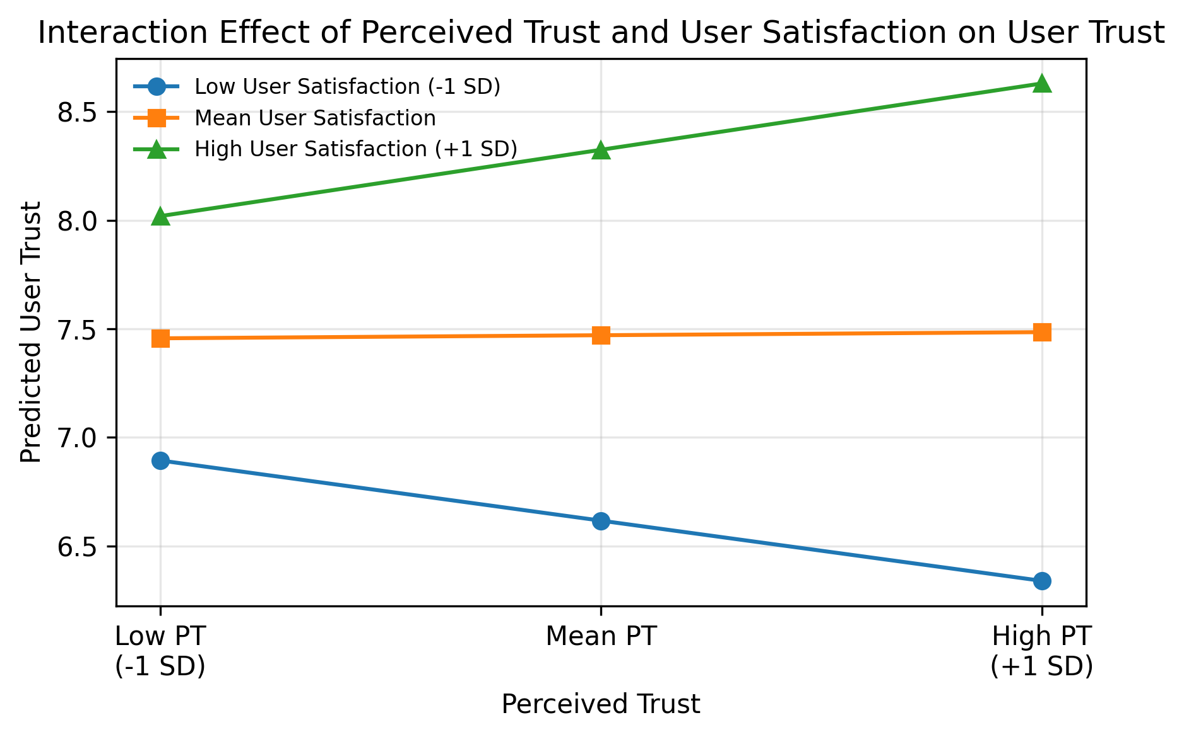
Source: Processed survey data (2026).
Figure 3 illustrates that the relationship between perceived trust and user trust becomes more positive as user satisfaction increases. Users with higher levels of satisfaction tend to translate their perceptions of platform trustworthiness into stronger overall trust in digital public services. Conversely, when user satisfaction is relatively low, perceived trust contributes less to the development of user trust. Although the conditional effects at each moderator level are not statistically significant, the significant interaction coefficient indicates that user satisfaction moderates the relationship between perceived trust and user trust. Consequently, the moderation effect identified in H5c should be interpreted as a conditional strengthening mechanism rather than a uniformly significant effect across all levels of user satisfaction.

Table 11. Multicollinearity Diagnostics
Variable | VIF
System Quality (centered) | 4.335
Service Response (centered) | 3.881
Perceived Trust (centered) | 2.642
User Satisfaction (centered) | 5.295
System Quality × User Satisfaction | 4.120
Service Response × User Satisfaction | 4.353
Perceived Trust × User Satisfaction | 2.348
Source: Processed survey data, 2026.
Table 11 indicates that all VIF values are below the commonly accepted threshold of 10, with user satisfaction exhibiting the highest VIF at 5.295. This suggests that multicollinearity is present to some extent but remains within an acceptable range for regression analysis. The use of mean-centering helps reduce potential multicollinearity in the interaction model.
Additionally, these diagnostic results indicate that the regression model satisfies the key assumptions required for multiple regression analysis. The absence of heteroscedasticity, the acceptable Durbin–Watson statistic, and the application of robust standard errors to address the slight deviation from normality increase confidence in the stability and reliability of the estimated coefficients.

Table 12. Regression Assumption Tests
Test | Statistic | p-value | Interpretation
Breusch-Pagan heteroscedasticity | 10.884 | 0.144 | There is no indication of heteroscedasticity in α=0.05
Durbin-Watson | 1.666 |  | Approaching the acceptable range for cross-section survey data
Jarque-Bera normality | 6.510 | 0.039 | Residuals deviate slightly from normal; use robust SE HC3
Source: Processed survey data, 2026.
Table 12 presents the regression assumption tests. The Breusch–Pagan test yields a p-value of 0.144, indicating no evidence of heteroscedasticity at the 5% significance level. The Durbin–Watson statistic is 1.666, which is within an acceptable range for cross-sectional data. The Jarque–Bera test shows a p-value of 0.039, indicating a slight deviation from normality; therefore, robust standard errors (HC3) are applied.

5. Discussions and Conclusions
Given the low internal consistency of the user trust construct (Cronbach's alpha = 0.265), the findings of this study should be interpreted with caution and regarded as exploratory rather than conclusive. Although HC3 robust standard errors were employed to improve the reliability of statistical estimation under potential heteroskedasticity, they do not address the limited reliability of the measurement construct itself. Consequently, the low internal consistency of the dependent variable may reduce the precision of the estimated relationships. Therefore, the discussion focuses on identifying empirical patterns and their theoretical implications within the contexts of Accounting Information Systems (AIS), digital governance, and public accountability, while avoiding broad generalizations beyond the present sample.
These findings highlight the importance of reliable infrastructure, usability, and accessibility in shaping trust in digital public services. A system that is stable and provides clear information can support the development of user trust even before users evaluate other relational aspects of the service. This finding is consistent with prior research in information systems, which identifies system quality as a fundamental determinant of user evaluation, and extends its relevance to the context of public digital services (DeLone & McLean, 2003; Rahmatullah et al., 2025; Wang & Liao, 2008).
From an Accounting Information Systems (AIS) perspective, system quality serves as the technical support that enables transparent and accountable public service delivery. When citizens interact with digital platforms that function reliably, they are more likely to perceive the underlying administrative processes as competent and trustworthy. This finding reinforces the argument that digital governance cannot be separated from the advancement of AIS, as these systems serve as the core infrastructure for processing public resource data, ensuring fiscal transparency, and supporting operational governance.
Although perceived trust is often considered a key determinant of user behavior, the findings suggest that trust is not solely formed through perception-based indicators. This implies that public institutions should not rely solely on communication strategies or image building, but should also ensure that the actual service experience meets user expectations. The absence of significant direct effects for service responsiveness and perceived trust after controlling for system quality may indicate conceptual overlap between these variables, as indicated by the strong correlations observed in the bivariate analysis.
The moderation analysis further reveals that user satisfaction plays a conditional role in strengthening the relationship between perceived trust and user trust. The significant interaction between perceived trust and satisfaction suggests that when users are satisfied with the service, their initial perceptions of platform security and institutional legitimacy are more likely to translate into overall trust. However, this effect lies at the threshold of statistical significance and should be interpreted cautiously. In contrast, the absence of significant moderation effects for system quality and service responsiveness suggests that these factors operate more directly and are less dependent on satisfaction as a conditioning mechanism.
The finding that user satisfaction moderates the relationship between perceived trust and user trust extends the theoretical understanding of trust formation in digital public services. From a behavioral accounting perspective, satisfaction appears to function as citizens' evaluation of institutional cues. When users are satisfied with their administrative outcomes, they may assume that the organization providing the service is competent and accountable to the public. Conversely, dissatisfied users may discount their initial perceptions of trust, resulting in weaker overall trust over the long term.

Conclusion
This study evaluated the influence of system quality, service responsiveness, and perceived trust on user trust in digital public services, as well as the moderating role of user satisfaction. Based on 152 valid survey responses, the findings indicate that system quality is the only variable that consistently demonstrates a positive and significant effect on user trust, thereby supporting H1. Conversely, service responsiveness and perceived trust do not show significant direct effects after controlling for system quality in the multiple regression model, meaning that H2 and H3 are not supported. User satisfaction also does not show a significant direct effect at the 5% significance level, although its coefficient is positive and approaches marginal significance (p = 0.076), indicating that H4 is not supported. In the moderation model, only the interaction between perceived trust and user satisfaction is significant (p = 0.049), supporting H5c, while the other moderation hypotheses (H5a and H5b) are not supported.
These findings suggest that system quality is a more consistent predictor of user trust than perceived trustworthiness or service responsiveness in this context. Users are more likely to trust a platform when the system is easy to use, stable, and provides clear and complete information. The lack of significant direct effects of service responsiveness and perceived trustworthiness should be examined further in future research, as this may reflect conceptual overlap with system quality and user satisfaction, as reflected in the high intercorrelations between these constructs. The significant interaction term indicates that user satisfaction moderates the relationship between perceived trust and user trust, Nevertheless, given the relatively low reliability of the user trust construct, these findings should be interpreted with caution and regarded as exploratory rather than conclusive.

Practical Implications
Based on the findings of this study, several practical recommendations can be provided to digital public service managers, particularly within the framework of Accounting Information Systems (AIS), digital governance, and public accountability. First, system quality needs to be prioritized to build user trust by improving server stability, ease of navigation, access speed, mobile compatibility, and clear and consistent information presentation. Given that system quality emerged as the strongest predictor, investment in technical infrastructure should be considered a strategic priority for public institutions seeking to increase citizen trust. In addition, digital governance needs to be strengthened by implementing service responsiveness standards. Although service responsiveness did not show a significant direct effect, it still received the lowest average score among all constructs, indicating room for improvement. Public institutions should establish clear response time targets, complaint resolution procedures, and communication protocols to ensure that citizens receive timely and helpful assistance through digital channels.
Furthermore, user-centered service designs need to be developed to strengthen the relationship between perceived trust and user trust. Because satisfaction moderates the trust-building process, public institutions should focus on creating positive user experiences that reinforce initial perceptions of trust and translate into sustained trust in digital service platforms. Furthermore, digital public service managers need to integrate key performance indicators, such as response time, system error rates, complaint resolution rates, and user satisfaction levels, into service monitoring mechanisms. Regularly measuring and reporting these indicators can support continuous improvement efforts and strengthen public accountability.
Comprehensive trust measurement instruments need to be developed for future evaluations, encompassing dimensions of data security, service reliability, process transparency, institutional accountability, competence, integrity, and benevolence, including trust in institutional follow-up. Current measurement approaches should be refined to capture the multidimensional nature of user trust in digital public services, enabling more accurate assessments and supporting the sustainable enhancement of citizen trust. Local governments need to align digital service development with Accounting Information Systems and public accountability frameworks to create a transparent, accountable, and efficient service ecosystem. By integrating digital services with Accounting Information Systems and broader governance structures, public institutions can ensure that digital transformation contributes to improved public sector performance and citizen trust.

6. Limitations of Research
This study has several limitations that should be considered when interpreting the findings :
- Low Reliability of the User Trust Construct
The main limitation is the low reliability of the user trust construct, which was assessed using just two indicators, yielding a corrected item–total correlation of 0.153 and a Cronbach's alpha of 0.265. This suggests that the construct may not adequately capture the multidimensional nature of trust and exhibits poor internal consistency. As a result, the findings related to user trust should therefore be interpreted with caution and regarded as exploratory rather than conclusive.
- Limited Sample Representativeness
The majority of respondents in the sample are young, especially students under the age of 20, which could restrict the generalizability of the findings results. Furthermore, the geographic concentration of respondents in the Madiun area limits the generalizability of the findings to other areas with different institutional and service contexts.
- Heterogeneity of Digital Public Service Platforms
The study includes various digital public service platforms, including websites, complaint systems, and local government applications. As a result, the findings reflect general user perceptions rather than platform-specific assessments, which could mask variations among different types of services.
- Potential Common Method Bias
There is a potential for common method bias because all variables were collected simultaneously through a self-reported questionnaire. This should be taken into account when interpreting the findings, as it may result in an inflated relationship among the variables.

References
Affairs., U. N. D. of E. and S. (2024). United Nations E-Government Survey 2024: Accelerating digital transformation for sustainable development. In United Nations. https://doi.org/https://publicadministration.un.org/egovkb/en-us/Reports/UN-E-Government-Survey-2024
Alkraiji, A., & Ameen, N. (2022). The impact of service quality, trust and satisfaction on young citizen loyalty towards government e-services. Information Technology & People, 35(4), 1239–1270. https://doi.org/10.1108/ITP-04-2020-0229
Carter, L., & Bélanger, F. (2005). The utilization of e-government services: Citizen trust, innovation and acceptance factors. Information Systems Journal, 15(1), 5–25. https://doi.org/10.1111/j.1365-2575.2005.00183.x
Cronbach, L. J. (1951). Coefficient alpha and the internal structure of tests. Psychometrika, 16(3), 297–334. https://doi.org/10.1007/BF02310555
Davis, F. D. (1989). Perceived usefulness, perceived ease of use, and user acceptance of information technology. MIS Quarterly, 13(3), 319–340. https://doi.org/10.2307/249008
DeLone, W. H., & McLean, E. R. (2003). The DeLone and McLean model of information systems success: A ten-year update. Journal of Management Information Systems, 19(4), 9–30. https://doi.org/10.1080/07421222.2003.11045748
Gefen, D., Karahanna, E., & Straub, D. (2003). Trust and TAM in online shopping: An integrated model. MIS Quarterly, 27(1), 51–90. https://doi.org/10.2307/30036519
Hair, J. F., Hult, G. T. M., Ringle, C. M., & Sarstedt, M. (2022). A primer on partial least squares structural equation modeling (PLS-SEM) (3rd ed.). Sage.
Kala, D., Chaubey, D. S., Meet, R. K., & Al-Adwan, A. S. (2024). Impact of user satisfaction with e-government services on continuance use intention and citizen trust using TAM-ISSM framework. Interdisciplinary Journal of Information, Knowledge, and Management, 19, 1–29. https://doi.org/10.28945/5248
Knudsen, D. R. (2020). Elusive boundaries, power relations, and knowledge production: A systematic review of the literature on digitalization in accounting. International Journal of Accounting Information Systems, 36, 100441. https://doi.org/10.1016/j.accinf.2019.100441
Laksono, B. R., Widiastutik, R. N., Putri, I. S., Wijaya, N. R., & Wiguna, R. A. R. (2025). Digital strategic behaviour for sustainable economic growth: Aligning organizational agility with SDG 8. Jurnal Ekonomika, 16(3), 478–495. https://doi.org/10.35334/9fk5sn60
Liébana-Cabanillas, F., Luna, I. R. de, & Ríos, F. J. M. (2015). User behaviour in QR mobile payment system: The QR payment acceptance model. Technology Analysis & Strategic Management, 27(9), 1031–1049. https://doi.org/10.1080/09537325.2015.1047757
Nunnally, J. . ., & Bernstein, I. H. (1994). Psychometric theory (3rd ed.). McGraw-Hill.
Parasuraman, A. P., Zeithaml, V. A., & Malhotra, A. (2005). E-S-QUAL: A multiple-item scale for assessing electronic service quality. Journal of Service Research, 7(3), 213–233. https://doi.org/10.1177/1094670504271156
Pham, L., Limbu, Y. B., Le, M. T. T., & Nguyen, N. L. (2023). E-government service quality, perceived value, satisfaction, and loyalty: Evidence from a newly emerging country. Journal of Public Policy, 43(4), 812–833. https://doi.org/10.1017/S0143814X23000296
Pondrinal, M., Bahari, A., Rahayu, R., & Juita, V. (2026). The evolution of accounting VL. Information Systems Research: A 10-Year Bibliometric Analysis. Jurnal Ilmiah Universitas Batanghari Jambi, 26(1), 119–126. https://doi.org/10.33087/jiubj.v26i1.6399
Putri, I. S., Wiguna, R. A. R., & Anaege, A. E. (2026). Digital payment adoption and its role in promoting financial inclusion in the context of SDG 8. E3S Web of Conferences, 696, 02002. https://doi.org/10.1051/e3sconf/202669602002
Rahmatullah, R., Habibi, A., Khaeruddin, K., Yaqin, L. N., Alharmali, T. K., Fauzee, M. S. O., & Mahat, J. (2025). A study of user satisfaction and net benefits in Indonesia through the DeLone and McLean model for e-government success. Discover Sustainability, 6(1), 710. https://doi.org/10.1007/s43621-025-01645-4
Rana, N. P., Dwivedi, Y. K., Williams, M. D., & Weerakkody, V. (2016). Adoption of online public grievance redressal system in India: Toward developing a unified view. Computers in Human Behavior, 59, 265–282. https://doi.org/10.1016/j.chb.2016.02.019
Taufiqurokhman, T., Satispi, E., Andriansyah, A., Murod, M., & Sulastri, E. (2024). The impact of e-service quality on public trust and satisfaction in e-government public services. International Journal of Data and Network Science, 8(2), 765–772. https://doi.org/10.5267/j.ijdns.2024.1.002
Teo, T. S. H., Srivastava, S. C., & Jiang, L. (2008). Trust and electronic government success: An empirical study. Journal of Management Information Systems, 25(3), 99–132. https://doi.org/10.2753/MIS0742-1222250303
Venkatesh, V., Morris, M. G., Davis, G. B., & Davis, F. D. (2003). User acceptance of information technology: Toward a unified view. MIS Quarterly, 27(3), 425–478. https://doi.org/10.2307/30036540
Wang, Y. S., & Liao, Y. W. (2008). Assessing eGovernment systems success: A validation of the DeLone and McLean model of information systems success. Government Information Quarterly, 25(4), 717–733. https://doi.org/10.1016/j.giq.2007.06.002
Wiguna, R. A. R., Wijaya, N. R., Putri, I. S., Widiastutik, R. N., & Laksono, B. . (2026). Determinasi niat menggunakan Buy Now, Pay Later (BNPL) di kalangan mahasiswa: Peran sikap, persepsi risiko, dan literasi keuangan. YUME: Journal of Management, 9(1), 1776–1790. https://doi.org/10.37531/yume.v9i1.11379
Wijaya, N. R., Putri, I. S., Wiguna, R. A. R., & Widiastutik, R. N. (2025). Enhancing the timeliness of local government financial reporting: An agency theory and compliance theory perspective. International Journal of Business, Accounting and Management, 8(2), 1–15., 8(2), 1–15. https://doi.org/10.36406/ijbam.v8i2.190

