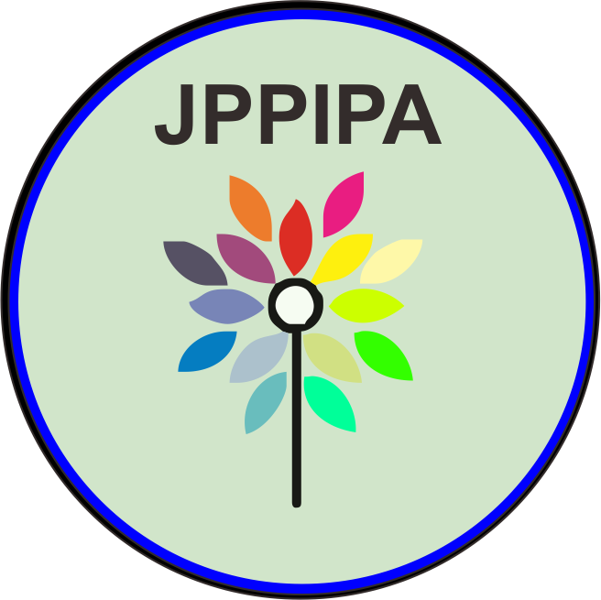
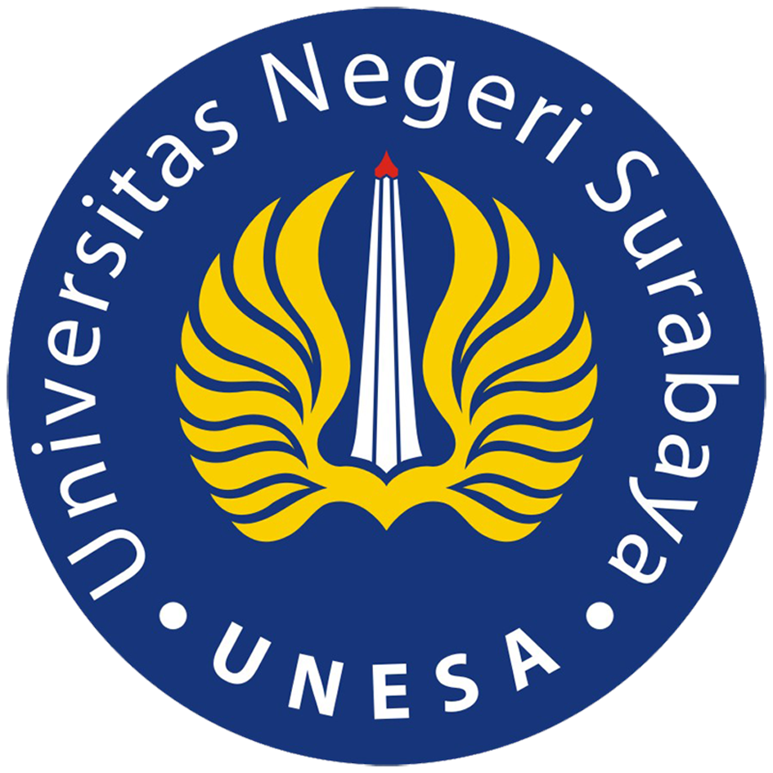
JPPIPA, Vol.5 No.1 2020
Jurnal Penelitian Pendidikan IPA
http://journal.unesa.ac.id/index.php/jppipa

IMPROVEMENT OF SCIENCE PROCESS SKILLS THROUGH DISCOVERY LEARNING MODEL IN PHYSICS EDUCATION STUDENTS
Oleh:
Sugiarti¹, Dwi Ratnaningdyah²
^{1,2} Physics Education Study Program, Faculty of Teacher Training and Education, University of PGRI Palembang, State of Indonesia

Abstract
Discovery Learning Model is a learning model that guides students to make discoveries through a series of inquiry and discovery activities. The purpose of this study is to describe the ability to improve students' science process skills in Basic Physics course material after the discovery learning model is applied. This research method is a quasi-experimental method because subjects are not randomly grouped, but are accepted as is. And the research design used was a one shot pretest-posttest design. The improvement of science process skills in the observation aspect is the science process skills that have the highest gain that is equal to 0.62 followed then by the science process skills in the measurement and concluding aspects of 0.61 and 0.58. While the lowest gain in science process skills is the science process skills in the classification and predicting aspects of 0.38 and 0.34. The average increase in science process skills in the Basic Physics course is 0.51 in the medium category.
Keywords: Science Process Skills, Discovery Learning Model.

© 2020 Universitas Negeri Surabaya

²Alamat Korespondensi:  Prodi Pendidikan Fisika, Universitas PGRI Palembang  Lrng. Gotong Royong 9/10 Ulu Palembang, Sumatera Selatan  E-mail: sugiartialatiq@gmail.com | p-ISSN: 2527-7537  e-ISSN: 2549-2209

INTRODUCTION
Based on data sources from the ILO's Indonesia Employment Report (2017) the average unemployment rate among young people is around 19.4%, as many as 2,127 young people who have a bachelor's degree in the labor market are unemployed. One reason for the high unemployment rate is the mismatch between graduate competencies and work needs.
Based on data sources from the ILO's Indonesia Employment Report (2017) the average unemployment rate among young people is around 19.4%, as many as 2,127 young people who have a bachelor's degree in the labor market are unemployed. One cause of the high unemployment rate is the mismatch between graduate competencies and work needs.
Implementation of the characteristics of the world of work is the main task of an educational institution which in this case is a tertiary institution. Law number 14 of 2005 governing teachers and lecturers states that teachers are professional educators whose main task is to educate, teach, and guide, then direct, and train, assess and evaluate students in early childhood education through formal education, education elementary and secondary education. To realize this based on PERMNENDIKBUD No. 73 of 2013 concerning the Indonesian National Qualification Framework (KKNI) in Higher Education, and Permenristekdikti Number 44 of 2015 concerning SNPT states that the formulation of graduate learning outcomes must refer to the description of learning achievements of KKNI graduates and have equality with the qualifications levels at KKNI.
One of the competencies that must be possessed by a prospective Physics teacher is the science process skills. Science process skills are very important for every individual, because they are almost always used in every day life (Rustaman, 2009). Science process skills are an understanding of a set of skills used in carrying out science activities, producing and using scientific information, and problem solving (Aktamis & Ergin, 2008).
After conducting a preliminary study of students in the Physics education study program at Palembang PGRI University, it was found that there was still a low ability of students' science process skills. Hilman (2014) states that science process skills are very important possessed by every individual because these skills are used in daily life, increasing scientific ability, quality and standard of living. To improve students' science process skills, it is necessary to optimize the factors that influence them. Some things that affect students' science process skills include learning strategies, facilities and teaching staff. Learning strategies that lack building students' science process skills and are dominated by lecture methods from teachers, are inadequate in building science process skills. Meanwhile according to Iswatun (2014) the lack of science process skills is due to the lack of understanding and knowledge of teachers in applying learning that leads to science process skills. And the lack of development of teaching materials that are specifically able to direct teachers and students to practice science process skills.
In order to improve students' science process skills, a number of efforts have been made including designing a learning model and strategy so that learning activities can be student-centered. As well as utilizing laboratory facilities as a means of learning resources where students can conduct discovery and investigation activities through experimental activities. One learning model that can make students active and directly involved in making discoveries through a series of experimental activities is the discovery learning model (Sugiarti, 2018).
One of the efforts of teachers and students is to make students active in learning activities. Learning activities are supported by methods, models and strategies designed by the teacher so that learning activities are student-centered. By designing learning, one of them by making students learn in groups and conducting an experiment or experiment can make students more active in learning activities. In addition to making students more active, students can use the skills they have from the learning they do.
Among the learning methods that provide opportunities for students to form their own experiences and can improve the ability of science process skills one of which is guided discovery. Learning by the discovery method is a teaching method where students are encouraged to learn, mostly through their own active involvement with concepts and principles, and the teacher encourages students to have experience and conduct experiments that enable them to find principles for themselves (Nur, 2008 ). Discovery learning emphasizes active learning experiences that are student-centered, students find themselves and take their own meaning (Arends, 2008). Where it is in line with KKNI learning outcomes set by the Physics Education Study Program at the PGRI University of Palembang.
The American Association for the Advancement of Science (AAAS) defines science process skills related to a person's ability to learn and get answers to a science concept or product (Rustaman, 2003). Science process skills are skills that involve cognitive or intellectual, manual, and social skills. Manual skills are clearly seen when using tools and materials, measuring, constructing, or assembling tools. Social skills are seen when students' interactions occur, for example discussing observations (Zeidan, 2015). Science process skills consist of two categories namely basic process skills and integrated process skills. Basic science process skill is a foundation to practice more complex integrated or integrated science process skills. 1) Observation is carried out using the human senses. 2) Classification is the grouping of objects according to certain properties. 3) Prediction is the submission of results that might result from an experiment. 4) Communication is saying what you know by saying words, writing, pictures, demonstrations or graphics. 5) Measurement is the discovery of the size of an object, what is the mass of an object, how much space is occupied by an object. 6) Inference is the use of what is observed to explain something that has happened (Dynamic, 2008).
By paying attention to the description above, this study was designed to see "Improving Science Process Skills Using Discovery Learning Models in Physics Education Study Program Students at PGRI University of Palembang".

METHOD
This research method is a quasi-experimental method because subjects are not randomly grouped, but are accepted as is (Ruseffendi, 2005). The selection of quasi-experimental methods by considering existing classes has been formed beforehand and students have registered in accordance with the existing curriculum, so that no more random groupings are made.
The research design used was a one-shot pretest-posttest design (Fraenkel, 2008). In summary the design of the experiment can be described as follows:
O₁ X O₂
Information:
O1: Pretest the science process skills.
X: Treatment in the form of learning with guided discovery models.
O2: Postest science process skills.
The variables in this study consisted of independent variables and dependent variables. The independent variable is the guided discovery learning model, while the dependent variable is the science process skills. The initial ability of students is obtained from the results of science process skills tests before being given treatment. In this study it was assumed that students did not get learning from outside, and were not given homework. So there is no other effect besides learning with guided discovery learning model.
The population in this study were students of Physics Education at PGRI Palembang University, while the sample was Physics Education students who took part in Basic Physics II in the even semester, March-August 2019. The sampling technique used was purposive sampling. The use of this purposive technique is done because of the selection of samples with specific objectives, namely students who take the Basic Physics II course.
The data in this study are of two types, namely quantitative data and qualitative data. Quantitative data were obtained through analysis of students' answers on science process skills tests conducted before (pretest) and after (posttest) learning activities. Qualitative data were obtained from observations on the activities of lecturers and students, and the results of interviews with students. Qualitative data were analyzed descriptively to support the completeness of quantitative data.
Quantitative data obtained from the results of the pretest and posttest are then processed by calculating the increase in science process skills using the normalized gain formula <g>. The normalized gain formula according to Hake R.R (1997) is as follows.
$$\left\langle g\right\rangle =\frac{\text{scorepretest}−\text{scoreposttest}}{\text{score}\text{max}\text{imum}−\text{scorepretes}}$$

Normalized gain criteria can be seen in Table 1.
Table 1. Normalized gain criteria.
<g> | Criteria
(<g>) ≥ 0.7 | High
0.3 < (<g>) < 0.7 | Moderate
(<g>) < 0.3 | Low

In this study the observation activity is direct observation, where the observer observes student activities directly during the learning process. Observation assessment uses a tool or instrument in the form of an observation sheet with a check list and a rating scale. Data analysis technique was in the form of observation sheet analysis.

RESULTS AND DISCUSSIONS
Determination of increasing the ability of science process skills in Basic Physics II is based on the processing of pretest and posttest data. The data is processed using the <g> normalized gain formula. As stated earlier, the treatment of one group is said to be more effective in improving science process skills if it has a normalized average gain value with a higher category. The results of the data analysis found an increase in science process skills obtained by students is listed in Figure 1 as follows:
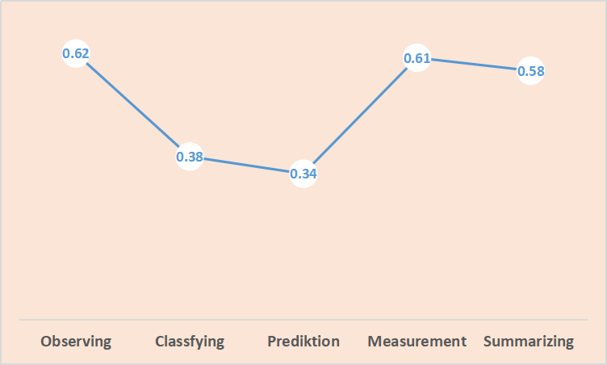
Figure 1. Improving Student Science Process Skills.
The science process skills in the observation aspect are the science process skills that have the highest gain of 0.62 followed by the science process skills in the measurement and conclusion aspects of 0.61 and 0.58. While the gain in the science process skills is the lowest is a science process skill on the aspect of classifying and predicting namely 0.38 and 0.34.
Observation is one of the most basic aspects of science process skills. There are several activities that are included in observing skills, among others, using the senses, sight, smell, listener, taste, and touch when observing the characteristics of an object, as well as using facts that are relevant and adequate from observations. Observation activities include various activities such as counting, measuring, classifying, and finding relationships between space and time. The ability to make good observations is also important for developing other scientific process skills such as communication, classifying, measuring, inferring and predicting. Student activities include experimental activities in groups and discussions to conduct observations on electrical material experiments. Students are guided to conduct observational activities such as observing the level of bright-dim lights on an electrical circuit, investigating the value of resistance in the conducting wire and calculating the energy and electrical power in an electrical circuit. Discovery learning is one of the strategies that can help students in guiding students to make observations. Students are guided to make good observations with the aim that observations are detailed and accurate as well as details so that they can improve students about the concepts of Basic Physics 2 material learned. Students are guided to make observations by maximizing all the senses they have, as well as describing what they observe in pictures, graphs and filling in the data tables that have been provided.
Then the classification skills show the ability of students to identify the observed traits. In classifying skills students are expected to be able to sort objects or phenomena into groups based on their observations. The grouping of objects or events is a way that is based on similarities, differences, and relationships. The classification skills show the ability of students to identify the observed traits. As for the ability of science process skills of students in classifying skills increased with the category of moderate increase of 0.38. According to Hartono (2014) discovery learning models assisted by LKS can improve students' skills in identifying and classifying traits to be observed.
Furthermore, the ability to predict or commonly called predicting skills shows the ability of students to predict what will happen about an event. Through the discovery learning model the students 'ability to act and think scientifically is more developed, so the students' ability to predict or predict what will happen is even more developed. Sutisna (2012) in her research stated that prediction skills are not just predicting an event that will occur, but must be based on patterns or data obtained. In the learning activities of static electricity material students are asked to predict things related to the light and dim lights due to the relationship of strong currents, voltages and obstacles. The ability to predict in this study includes a medium category with an increase in value of 0.34.
The next science process skills observed were measurement skills which showed the ability of students to use measuring instruments and correctly state the units. Students with high science process skills tend to carry out experiments according to standard scientific methods. Students have the skills to conduct experiments that are observing, measuring and calculating, designing experiments, and presenting data in charts and graphs (Nur, 2011).
Furthermore, the ability of students' initial science process skills at the conclusion stage is at a low level, students are still very low at 1.34. This is in accordance with Marnita's research (2013) which states that most students do not yet have the confidence to convey the findings of their experiments. Then it increases when using the discovery learning model to 3.48 in the medium category. As revealed by Ilmi et al. (2012) which states that the discovery learning model can improve science skills because in the model there are stages that support aspects of science process skills such as providing stimuli, identifying problems, collecting data, processing data, verifying to the stage of drawing conclusions.
In discovery learning according to Bergstrom & O'Brien, 2001; Wilcox, 1993 in Slavin (2003), students are encouraged to primarily learn by themselves through active involvement with concepts and principles, and teachers encourage students to have experience and conduct experiments that allow them to find principles for themselves. Discovery learning is a tool or way in which students use problem solving in developing knowledge or abilities. A better explanation of learning discovery is learning that is deliberately designed through the resolution of observed problems that include scientific investigation methods.
In Democracy and Education, Dewey (1916) described learning as an activity that arises from students to other students in the community and builds knowledge by applying conclusions from experiments that have been conducted. From several discovery learning theories, the basis of guided discovery learning is constructivist. Philosophically guided discovery learning formulated in four stages, namely; 1) accepting invitations to learn, 2) searching, finding, and creating, 3) proposing explanations and solutions, and 4) taking steps towards what is learned (Carin, 1993).
The application of learning using discovery learning models is not only centered on the acquisition of concepts, but also trains the science process skills used in each phase of learning, so learning by applying guided discovery learning models is meaningful learning, because students are actively involved in the learning process by training his science process skills.

CONCLUSIONS AND SUGGESTIONS
Conclusion
After doing the research, it was found that there was an increase in the ability of science process skills of students in the Physics education study program in the Basic Physics II course after the discovery learning model was applied. The average increase in science process skills in the Basic Physics course is 0.51 in the medium category.
Suggestion
Discovery learning model is one of the learning models that requires quite a long time. Therefore both students and teachers must have a thorough preparation before carrying out the learning process activities. In addition there are several.

REFERENCES
Arends, R.,I., .2008. Learn to Teach. Terjemah Helly Prajitnon dan Sri Mulyantini. Yogyakarta: Pustaka belajar.

Aktamis H and Ergin O 2008 The Effect of Scientifict Process Skills Education on Student’s Scientifict Creativity, Science Attitudes and Academic Achievement Asia-Pacific Forum on Science Learning Teaching.

Carin, A.A. 1993. Teaching Science Through Discoverry. Canada: MacMillan Publising Company.

Fraenkel, J. R. (2008). How to Design and Evaluate Research in Education (Seventh Edition). Amerika Serikat: McGraw-Hill International.

Hake, R.R (1998). Interactive-enggagement versus traditional methods: A six thousandstudent survey of mechanics test data for introductory physics course. Am.J. Physics., 66(1), 64-74

Hartono & W. R. Oktafianto (2014) Kefektifan Pembelajaran Praktikum IPA Berbantu LKS Discovery Untuk Mengembangkan Keterampilan Proses Sains. Unnes Physic Education Journal 3 (1)

Ilmi, A.N.A., Indrowati, M., & Probosari, R.M. 2012. Pengaruh Penerapan Metode Pembelajaran Guided Discovery terhadap Keterampilan Proses Sains Siswa Kelas X SMA Negeri 1 Teras Boyolali. Jurnal Pendidikan Biologi, 4 (2): 44–52.

Iswatun, I., Mosik, M., Subali, B. (2017). Penerapan Model Pembelajaran Inkuiri Terbimbing untuk Meningkatkan KPS dan Hasil Belajar Siswa SMP Kelas VIII. Jurnal Inovasi Pendidikan IPA, 3 (2), 2017, 150-160.

Laporan Ketenagakerjaan Indonesia 2017. Memanfaatkan Teknologi untuk Pertumbuhan dan Penciptaan Lapangan Kerja/ Organisasi Perburuhan Internasional, Kantor Jakarta; ILO 2017.

Marnita. 2013. Peningkatan Keterampilan Proses Sains melalui Pembelajaran Kontekstual pada Mahasiswa Semester 1 Materi Dinamika. Jurnal Pendidikan Fisika Indonesia, 9: 43–52.

Nur,M. 2008: 21. Model Pembelajaran Berdasarkan Masalah, Surabaya: Pusat Sains dan Matematika Unesa.

Nur, Muhammad. 2011. Modul Keterampilan Proses Sains. Surabaya: Pusat Matematika dan Sains Sekolah (PSMS) Universitas Negeri Surabaya.

Rustaman, N.Y. (2003). Strategi Belajar Mengajar Biologi. Bandung: Jurusan Pendidikan Biologi FMIPA UPI.

Slavin, R., E.. 2008. Psikologi Pendidikan Teori dan Praktek edisi ke delapan. Terjemah Samosir, M.. Jakarta: PT Indeks.

Sugiarti, 2018. Penilaian psikomotor siswa pada pembelajaran fisika melalui model pembelajaran guided inquiry. Journal of Physics and Science Learning (PASCAL). UISU. Vol 2 No 1 2018.

Zeidan, A. H., Jayosi, M. R. (2015). Science Process Skills and Attitudes toward Science among Pelistinian Secondary School Students. World Journal Education 5 (1)

