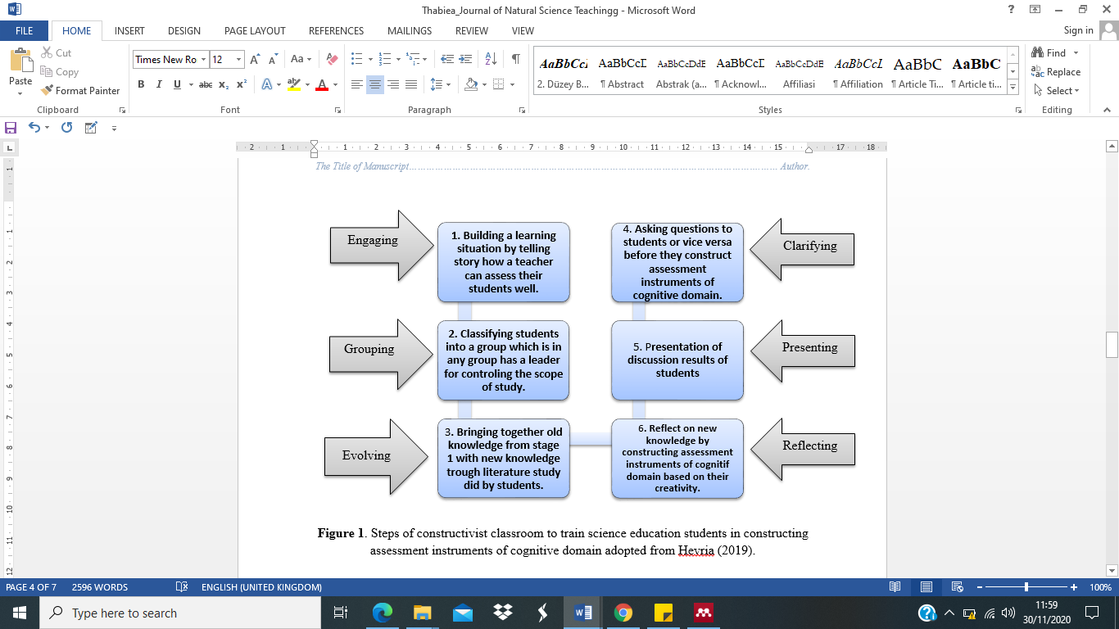

Figure 1. Steps of constructivist classroom to train science education students in constructing assessment instruments of cognitive domain adopted from Hevria (2019).

