

JPPIPA, Vol.xxx No.xxx 20xx
Jurnal Penelitian Pendidikan IPA
http://journal.unesa.ac.id/index.php/jppipa

DEVELOPMENT OF AUGMENTED REALITY MEDIA ON BEE METAMORPHOSIS
(Apis Sp.)

Oleh:
Ospa Pea Yuanita Meishanti¹, Zaidatur Roziqo ²,
^{1,2} Biology Education Study Programme, Faculty of Education , KH. A. Wahab Hasbullah University of East Java, Indonesia.

Abstract
Augmented Reality is actually not something foreign to the general public, it's just that they don't know what Augmented Reality itself means, Augmented Reality cards can generally be found in some snacks, which the cards can be scanned through a special application available on the Playstore. However, currently researchers are making Augmented Reality for learning, in this case researchers are using bee metamorphosis, so learning becomes more interesting. This study aims to describe the feasibility of Augmented Reality media for bee metamorphosis and to determine student responses to the attractiveness of Augmented Reality media for bee metamorphosis. The development model used is the ADDIE model which includes: Analysis, Design, Development, Implementation and Evaluation. Products are validated by one media expert and one material expert. The attractiveness test was carried out on 5 students of MTs Al-Ihsan Kalijaring Jombang. Data obtained from media experts, namely 80% with proper qualifications, criteria from material experts, namely 88% with very decent qualifications, while from the data students get a score of 88.75% with qualifications strongly attractiveness. The results of the assessment of media experts, material experts and student responses show that the bee metamorphosis Augmented Reality can be used as a learning media.

keywords: Augmented Reality, Learning Media

© 2016 Universitas Negeri Surabaya

¹Correspondence Address:  Biology Education Study Programme, Faculty of Education , KH. A. Wahab Hasbullah University  E-mail: ospapea@unwaha.ac.id | p-ISSN: 2527-7537  e-ISSN: 2549-2209

INTRODUCTION
Ki Hajar Dewantara argued that education is a requirement in the growth of children, in the sense that education guides all the natural forces that exist in these children, so that they as humans and as members of society can achieve the highest safety and happiness. Education is a form of embodiment of dynamic human culture and development requirements (Meishanti, 2020). Education is an activity of receiving and imparting knowledge so that culture can be passed on from generation to generation, education is also an individual process to develop talents, strengths, abilities and interests (Lecturer Team of Educational Administration Department, 2008). Educators as educational implementers are not only required to be able to master the material being taught. Educators must also be able to be creative in developing learning media that are innovative, varied, interesting, contextual, and in accordance with the level of student needs. These things will determine the competencies that students will achieve and have after the teaching and learning process takes place. In the whole educational process in schools most teaching and learning activities are successful or not, student learning achievement depends on how the learning process (Meishanti, 2018). The success of a teaching and learning process in the classroom depends on its components, including students, curriculum, teachers, methods, infrastructure, media, and the environment (Meishanti, 2019).
Learning media is an intermediary tool between educators and students in learning that is able to connect, provide information and flow messages so that an effective and efficient learning process is created. If the learning process does not use media, there is no learning process (Mustaqim, 2016). One form of learning media is computer technology-based learning media such as Augmented Reality (AR). Augmented Reality (AR) is a concept that combines virtual reality with world reality, so that 2-dimensional (2D) or 3-dimensional (3D) virtual objects appear real and blend with the real world. In AR technology, users can see the real world around them with the addition of virtual objects generated by computers (Mustika, 2015).
Augmented Reality (AR) is a concept that combines virtual reality with world reality, so that 2-dimensional (2D) or 3-dimensional (3D) virtual objects appear real and unite with the real world. In AR technology, users can see the real world around them with the addition of virtual objects generated by computers (Mustika, 2015). Augmented Reality (AR) was first implemented by Ivan Sutherland in 1962. Augmented Reality as a methodology has also been developed by various parties so that it can be implemented in various devices. The application of Augmented Reality also does not require special enhancements which generally require a lot of money and time for the purchase and installation process (Young, 2015). An Object. The advantages of Augmented Reality compared to systems that use the Virtual Reality method include: the interaction feels real, the implementation is cheaper, the possibility of system congestion that is displayed is less (Young, 2015). The development of Augmented Reality media is expected to increase students' interest in learning about bee metamorphosis.
Augmented Reality learning media about bee metamorphosis has never been developed before. Meanwhile, for the metamorphosis of Augmented Reality that has developed, namely butterfly metamorphosis, grasshopper metamorphosis and frog metamorphosis, it is necessary to make Augmented Reality (AR) media in honey bee metamorphosis (Apis sp.).
The purpose of developing this research is to describe the feasibility of Augmented Reality (AR) learning media for bee metamorphosis to be developed in this study and to see student responses to the attractiveness of Augmented Reality (AR) media on bee metamorphosis material.

METHOD
Research Design
The research method uses the ADDIE development model with 5 stages, namely Analysis, Design, Development, Implementation and Evaluation. At the analysis stage, the main activity carried out is analyzing the needs for developing Augmented Reality (AR) media in the learning process. The design stage is designing the learning media after a needs analysis is carried out by designing a storyboard.
The ADDIE (Analysis-Design-Develop-Implement-Evaluate) instructional design model developed by Reiser and Mollenda in the 1990s is a generic instructional design model that serves as a guide in building training program tools and infrastructure that are effective, dynamic and support training performance. itself. So that it helps training instructors in managing training and learning (Jauhari, 2013).

Figure 3.1 Stages of the ADDIE Development Model
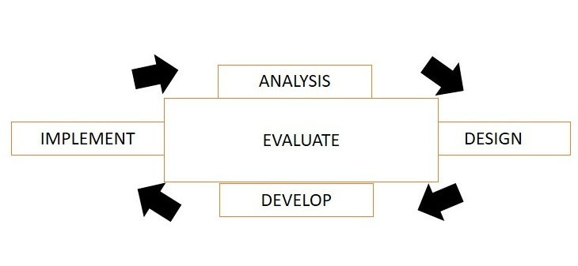
Research Objectives
The next stage is to develop a way to develop learning media from the storyboard that has been made. The implementation stage is conducting trials on students. And finally, an evaluation is carried out before the product is declared valid. Augmented Reality learning media for bee metamorphosis was validated by media experts from KH University. A. Wahab Hasbullah and material experts from science subject teachers at MTs Al-Ihsan Kalijaring Jombang.

Data Collection Technique
Product trials were conducted by students of MTs Al-Ihsan Kalijaring Jombang. The instrument in the researcher data instrument used a questionnaire. The results obtained from the data analysis are used as a reference for revising the developed learning media application. Data obtained from expert validation and student responses were analyzed using the following formula:

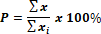

Explanation:
P = Big percentage
= The number of scores obtained from validators or respondents (students)
= The maximum number of scores expected

RESULTS AND DISCUSSION
Based on the ADDIE development model, here are the results and discussion of Augmented Reality media on bee metamorphosis.

1. Analysis (analysis)

At this stage, the main activity is to analyze the need to develop Augmented Reality (AR) media in the learning process. The development of Augmented Reality (AR) media begins with a problem in learning that has been applied and the media used is less attractive, after analyzing the problem, it is necessary to develop interesting media, so researchers make a media in the form of Augmented Reality (AR) media development.

2.Design (design)
Designing instructional media is a step that will be taken after conducting a needs analysis. The initial planning activities carried out by researchers were designing the conceptual framework of Augmented Reality (AR), and compiling a storyboard of the Augmented Reality display.

3. Development
Development in the ADDIE model contains product design realization activities. In the design phase, a conceptual framework for implementing Augmented Reality (AR) media has been prepared. In the development stage, the conceptual framework is realized into a product that is ready to be implemented.
Augmented Reality (AR) learning media on bee metamorphosis was validated by 2 validators, namely Ino Angga Putra, M.Pd. as a media expert, Eny Widiastutik, S.Pd. as material expert, and 5 respondents from MTs Al-Ihsan Kalijaring Jombang. Presentation of research data from media expert validators can be seen in table 3.1 and media expert validators in table 3.2.

Table 3.1 Table Results Data by Media Experts
Number | Criteria | Score |  |  | Explanation
Number | Criteria | X | Xi | % | Explanation
1. | Effective and efficient in the development and use of instructional media | 3 | 5 | 60 | feasible
2. | Augmented Reality (AR) media is suitable for use | 4 | 5 | 80 | Quite feasible
3. | Augmented Reality (AR) media is easy to operate | 5 | 5 | 100 | Very feasible
4. | Augmented Reality (AR) media is easy to understand | 5 | 5 | 100 | Very feasible
5. | Interesting pictures or videos | 4 | 5 | 80 | Quite feasible
6. | Audio is clear | 4 | 5 | 80 | Quite feasible
7. | Attractive visuals (including: appearance, colors and fonts) | 4 | 5 | 80 | Quite feasible
8. | Creative in expressing ideas and ideas | 3 | 5 | 60 | feasible
Total |  | 32 | 40 | 80 | Quite feasible
Explanation:
X = Scores from Media Experts
Xi = Maximum Score

The total answers obtained from the media experts were 32 and the maximum score of all answers was 40, so that the overall score obtained from the media experts above obtained an average value of 80% with the appropriate criteria. Effective and efficient aspects in the development and utilization of learning as well as creative aspects in ideas and in pouring ideas get an average score of 60% with the criteria "quite feasible". The media aspect of Augmented Reality (AR) is feasible, the image or video aspect is attractive, the audio aspect is clear, and the visual aspect is attractive (including: appearance, color, and letters) getting an average score of 80%. From this assessment, it can be concluded that there is a need for further improvement in terms of media so that the media is more feasible to be applied in the learning process. Criticisms and suggestions from media experts, namely the Augmented Reality (AR) card are designed like playing cards with full color front and back so that they attract attention / are seen.

Table 3.2 Data on Assessment Results by Material Experts
Number | Criteria | Score |  |  | Explanation
Number | Criteria | X | Xi | % | Explanation
1. | Material according to KI/KD 3.2 Analyzing developmental systems in plants and animals as well as the application of technology to plant and animal reproductive systems. (Curriculum 2013) | 5 | 5 | 100 | Very feasible
2. | The material presented is in accordance with the learning objectives | 4 | 5 | 80 | feasible
3. | The clarity of the material presented | 4 | 5 | 80 | feasible
4. | Convey the material well | 4 | 5 | 80 | feasible
5. | Drawings and concepts in accordance with KD | 5 | 5 | 100 | Very feasible
6. | Complete bee metamorphosis process | 5 | 5 | 100 | Very feasible
7. | Sequential bee metamorphosis process | 5 | 5 | 100 | Very feasible
8. | Language according to the EYD | 4 | 5 | 80 | feasible
9. | Language is easy to understand | 4 | 5 | 80 | feasible
10. | Can motivate students | 4 | 5 | 80 | feasible
Total |  | 44 | 50 | 88 | Very feasible
Explanation:
X = Scores from Material Experts
Xi = Maximum Score

The total answers obtained from the media experts were 44 and the maximum score of the overall answers was 50, so from the overall score obtained from the media experts above, it was obtained an average value of 88% with very feasible criteria. The material aspects presented are in accordance with the learning objectives, the aspects of the clarity of the material presented, the aspects of the delivery of the material are good, the language aspects are in accordance with the EYD, the language aspects are easy to understand, and the aspects can motivate students to get an average score of 80% with the criteria 'feasible'. From this assessment, it can be concluded that there needs to be further improvements in terms of material in order to be more feasible to apply in the learning process. Criticism and suggestions from material experts are to better communicate with students.

4. Implementation
At this stage the designs and methods that have been developed are implemented in real situations, namely in the classroom. During implementation, the Augmented Reality (AR) media design is applied to actual conditions. The material presented is in accordance with the Augmented Reality (AR) media. After the application of Augmented Reality (AR) media, an evaluation was carried out to provide responses to the application of Augmented Reality (AR) media through a questionnaire. Augmented Reality media of bee metamorphosis was tested on 5 students of MTs Al-Ihsan Kalijaring Jombang. The results of student responses can be seen in table 3.3.

Table 3.3 Testing Results Data
Number | Aspect | Criteria | Score |  |  | Explanation
Number | Aspect | Criteria | ∑X | ∑Xi | %
1 | Theory | I easily understand the material in Augmented reality (AR) | 4,20 | 5,00 | 84,00 | Strongly agree
1 | Theory | The material on Augmented Reality (AR) is clear | 4,00 | 5,00 | 80,00 | Agree
1 | Theory | The bee metamorphosis in Augmented Reality (AR) is more interesting | 5,00 | 5,00 | 100,00 | Strongly agree
1 | Theory | Average | 4,40 | 5,00 | 88,00 | Strongly agree
2. | Display | The appearance and color composition of Augmented Reality (AR) media is attractive | 4,20 | 5,00 | 84.00 | Strongly agree
2. | Display | Display clear Augmented Reality (AR) media images and videos | 4,20 | 5,00 | 84,00 | Strongly agree
2. | Display | The animation display in Augmented Reality (AR) media is interesting | 4,40 | 5,00 | 88,00 | Strongly agree
2. | Display | The display and text in Augmented Reality (AR) media are clear and easy to read | 4,20 | 5,00 | 84,00 | Strongly agree
 |  | Average | 4,25 | 5,00 | 85,00 | Strongly agree
3. | Language | Media Augmented Reality (AR) uses Indonesian language rules that are good and correct | 4,40 | 5,00 | 88,00 | Strongly agree
3. | Language | The language used in the Media Augmented Reality (AR) is simple and easy to understand | 5,00 | 5,00 | 100,00 | Strongly agree
3. | Language | Average | 4,70 | 5,00 | 94,00 | Strongly agree
4. | Presentation | Augmented Reality (AR) media is easy to operate | 4,20 | 5,00 | 84,00 | Strongly agree
4. | Presentation | Augmented Reality (AR) media is interesting | 4,60 | 5,00 | 92,00 | Strongly agree
4. | Presentation | Average | 4,40 | 5,00 | 88,00 | Strongly agree
Average Total |  |  | 4,44 | 5,00 | 88,75 | Strongly agree
Explanation:
∑X = Total Average Score of All Respondents
∑Xi = Total Maximum Average Score of All Respondents

Table 3.3 shows the results of the student response questionnaire and the mean score was 88.75% with the criteria "strongly agree". The material aspects of the material criteria for Augmented Reality (AR) clearly get an average value of 80% with the criteria "agree". In the data above, the highest average value is found in the language aspect with an average value of 94% with the criteria 'strongly agree' and the lowest average value is in the display aspect, namely with an average value of 85% with the criteria 'strongly agree '. Looking at the display aspect that gets the lowest average value, there is a need for improvement, namely regarding the appearance and the Augmented Reality (AR) media to make it more attractive.

5. Evaluation
Evaluation aims to assess an object through the use of relevant data and information. Evaluation can also be interpreted as a systematic process carried out in designing, collecting, reporting, and applying information to decide the value and usefulness of an object (Pribadi, 2016). Evaluation is carried out to produce products that are relevant and suitable for use as learning media.Based on the advice of media experts, it is necessary to carry out several evaluations which can be seen in table 3.4.

Table 3.4 Revisions Based on Expert Suggestions
Number | Revised Points | Visualization
1. | AR card | - AR cards use thicker paper  - Front and rear view is made full color  - The edge of the card is made curved (not sharp)
2. | Front view before revision | 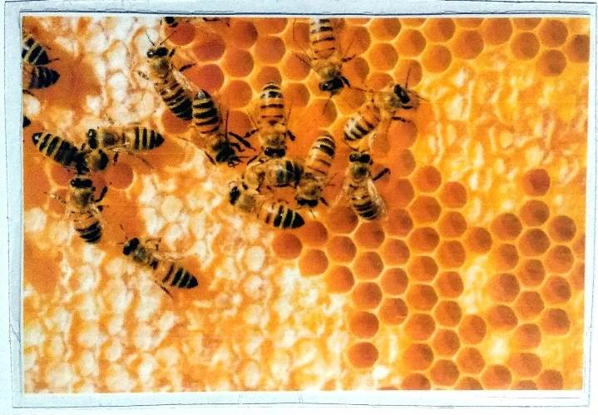
2. | Front view after revision | 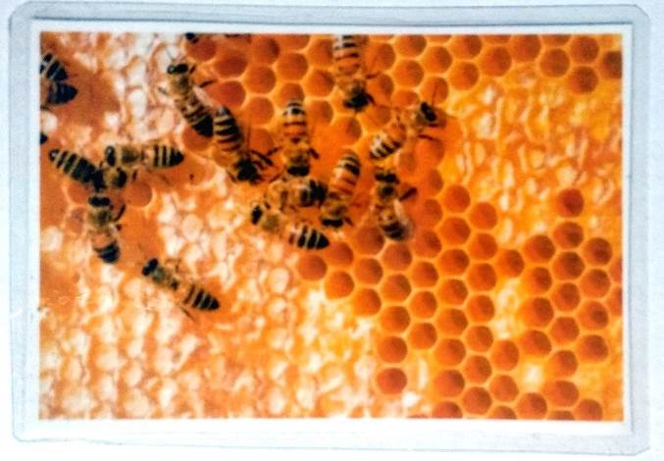
3 | Back view before revision | 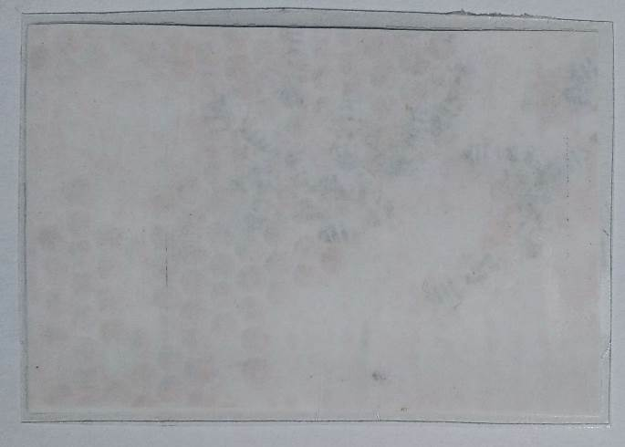
3 | Back view after revision | 

CONCLUSIONS AND SUGGESTIONS

Conclusion
The development of Augmented Reality (AR) media on bee metamorphosis was declared feasible. This is based on the assessment of the media expert validator, the material expert validator, and several respondents from 5 students. The results of the validation from the media expert got a percentage of 80% with proper criteria, while the results of the validation from the material experts got a percentage of 88% with very feasible criteria. The results of the user trial (students) got a percentage of 88.75% with very feasible criteria. Based on the validation of media experts, material experts, and user trials (students) of Augmented Reality (AR) media on the metamorphosis of bees, it is stated that they are suitable for use as teaching materials.

Suggestion
1. Augmented Reality (AR) media was further developed to cover some metamorphosis material, not only bees.
2. The appearance of Augmented Reality (AR) media is made more attractive so that students don't get bored.
3. The size of the video / image in Augmented Reality (AR) is made according to the screen of the cellphone, so that when the cellphone is moved away or near it has no effect.
4. It is hoped that the Augmented Reality (AR) media can be distributed via Android, because the images use real photos, the Augmented Reality media in this bee metamorphosis can be used for various levels of school, from Elementary School to Higher Education and even for the general public. Henceforth, the writer will try to distribute it to Google Play so that students can also use it themselves.

REFERENCES
Asyhar, R. (2012). Kreatif Mengembangkan Media Pembelajaran. Jakarta: Referensi.
Arsyad, A. (2010). Media Pembelajaran. Jakarta: PT RajaGrafindo Persada
Campbel, N. A & J. B. Reece. (2010). 3. Biologi: Edisi Kedelapan Jilid 3. Terjemahan: Damaring Tyas Wulandari. Jakarta: Erlangga
Mustika, D. 2015. Implementasi Augmented Reality Sebagai Media Pembelajaran Interaktif. Citec Journal, 2(4): 277-290.
Mustaqim, I. 2016. Pemanfaatan Augmented Reality Sebagai Media Pembelajaran. Jurnal Pendidikan Teknologi dan Kejuruan, (Online), Vol 13, No. 2, (https://ejournal.undiksha.ac.id/index.php/JPTK/aticle/view/8525, diakses 11 Mei 2019).
Meishanti, OPY. 2020. Analisis Keterlaksanaan Praktikum Biologi Terhadap Hasil Belajar Psikomotor Peserta Didik Kelas XI IPA di MA Al Ihsan Tembelang Jombang. Jurnal Eduscope (online). VOL. 6, No. 1, http://ejournal.unwaha.ac.id/index.php/eduscope/article/view/874/433 diakses 31 Oktober 2020
Meishanti, OPY. 2018. Pelibatan Aktor Pendidikan Dalam System Three Way Traffic Communication Untuk Meningkatkan Mutu Peserta Didik Sekolah Dasar Di Jombang. Jurnal Akrab Juara (online), Vol. 3, No. 1, http://akrabjuara.com/index.php/akrabjuara/article/view/140 diakses 31 Oktober 2020
Meishanti, OPY. 2019. Pengaruh Pemberian Kuis Terhadap Hasil Belajar Siswa Kelas VII Di SMPN Bandarkedungmulyo Jombang. Jurnal Eduscope (Online), Vol. 4, No. 01, http://ejournal.unwaha.ac.id/index.php/eduscope/article/view/380/300 diakses 31 Oktober 2020
Pribadi, Dr, Benny A. 2016. Desain dan Pengembangan Program Pelatihan Berbasis Kompetensi: Implementasi Model ADDIE. Jakarta: Prenada Media Group.
Tim Dosen Jurusan Administrasi Pendidikan. 2008. Manajemen Pendidikan. Bandung: Alfabeta.
Young, J. C. 2015. Marketing Communication Menggunakan Augmented Reality. ULTIMATICS, 7(1): 14-15

