Research Documentation

FIGURE 1. Special School Tegar Harapan, Yogyakarta, Indonesia
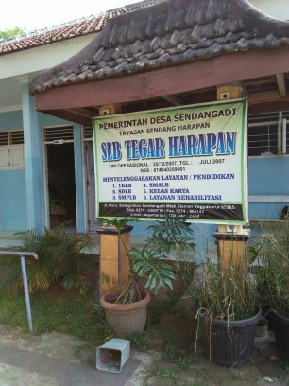

FIGURE 2. Classroom field in Special School Tegar Harapan, Yogyakarta, Indonesia
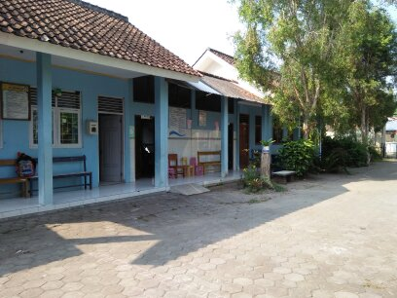

FIGURE 3. Playground in Special School Tegar Harapan, Yogyakarta, Indonesia
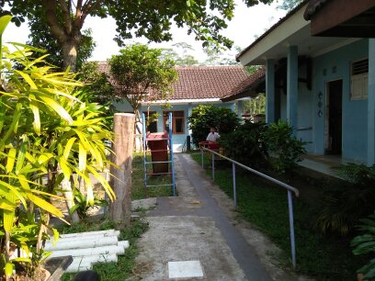
FIGURE 4. The field of teacher’s room Special School Tegar Harapan, Yogyakarta, Indonesia
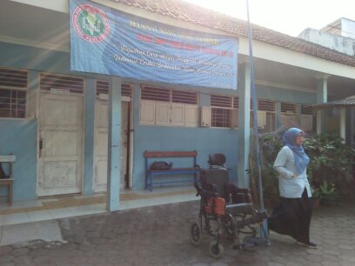

FIGURE 4. School teacher in Special School Tegar Harapan when filling the research questionnaire
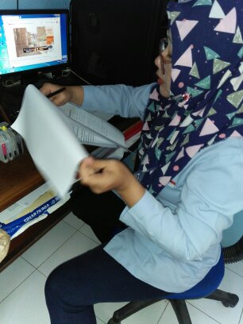

FIGURE 5. School teacher in Special School Tegar Harapan when filling the research questionnaire
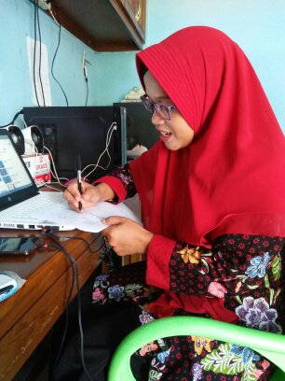

FIGURE 6. School teacher in Special School Tegar Harapan when filling the research questionnaire
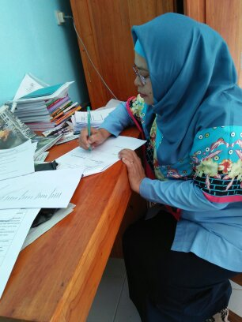

FIGURE 7. School teacher in Special School Tegar Harapan when filling the research questionnaire
