OUTPUT AMOS

UJI VALIDITAS DAN RELIABILITAS
Variabel | Indikator | Strandardized Loading | Standardized Loading2 | Measurement Error | Variance Extracted | Discriminant Validity | Construct Reliability
Financial Literacy | X1 | 0.860 | 0.740 | 0.260 | 0.515 | 0.717 | 0.919
 | X2 | 0.687 | 0.472 | 0.528
 | X3 | 0.664 | 0.441 | 0.559
 | X4 | 0.816 | 0.666 | 0.334
 | X5 | 0.500 | 0.250 | 0.750
 | X6 | 0.726 | 0.527 | 0.473
 | X7 | 0.763 | 0.582 | 0.418
 | X8 | 0.507 | 0.257 | 0.743
 | X9 | 0.737 | 0.543 | 0.457
 | X10 | 0.756 | 0.572 | 0.428
 | X11 | 0.782 | 0.612 | 0.388
 | ∑ | 7.798 | 5.661 | 5.339
Financial Manegement Behavior | X12 | 0.569 | 0.324 | 0.676 | 0.502 | 0.702 | 0.939
 | X13 | 0.524 | 0.275 | 0.725
 | X14 | 0.731 | 0.534 | 0.466
 | X15 | 0.655 | 0.429 | 0.571
 | X16 | 0.775 | 0.601 | 0.399
 | X17 | 0.581 | 0.338 | 0.662
 | X18 | 0.592 | 0.350 | 0.650
 | X19 | 0.757 | 0.573 | 0.427
 | X20 | 0.739 | 0.546 | 0.454
 | X21 | 0.769 | 0.591 | 0.409
 | X22 | 0.811 | 0.658 | 0.342
 | X23 | 0.768 | 0.590 | 0.410
 | X24 | 0.655 | 0.429 | 0.571
 | X25 | 0.691 | 0.477 | 0.523
 | X26 | 0.753 | 0.567 | 0.433
 | X27 | 0.773 | 0.598 | 0.402
 | ∑ | 11.143 | 7.879 | 8.121
Financial Satisfaction | X28 | 0.841 | 0.707 | 0.293 | 0.614 | 0.784 | 0.905
 | X29 | 0.758 | 0.575 | 0.425
 | X30 | 0.825 | 0.681 | 0.319
 | X31 | 0.833 | 0.694 | 0.306
 | X32 | 0.643 | 0.413 | 0.587
 | X33 | 0.785 | 0.616 | 0.384
 | ∑ | 4.685 | 3.686 | 2.314
UJI OUTLIER

Observations farthest from the centroid (Mahalanobis distance) (Group number 1)
Observation number | Mahalanobis d-squared | p1 | p2
155 | 61.843 | .003 | .480
171 | 61.766 | .003 | .144
145 | 61.584 | .004 | .033
132 | 61.416 | .004 | .006
140 | 60.654 | .005 | .002
9 | 59.426 | .006 | .001
165 | 59.247 | .006 | .000
172 | 56.796 | .011 | .002
186 | 54.483 | .019 | .012
127 | 53.839 | .022 | .010
66 | 53.604 | .023 | .005
144 | 52.143 | .031 | .018
148 | 51.227 | .038 | .031
187 | 49.232 | .056 | .188
174 | 49.227 | .056 | .121
129 | 49.067 | .058 | .090

UJI NORMALITAS

Assessment of normality (Group number 1)
Variable | min | max | skew | c.r. | kurtosis | c.r.
Debt | .000 | .750 | .765 | 4.282 | .111 | .311
Income | 1.000 | 4.000 | -.262 | -1.469 | -.827 | -2.316
X28 | 1.000 | 4.000 | -.879 | -4.921 | .181 | .506
X29 | 1.000 | 4.000 | -.140 | -.781 | -1.238 | -3.465
X27 | 1.000 | 4.000 | -.587 | -3.288 | .095 | .265
X26 | 1.000 | 4.000 | .048 | .269 | -1.021 | -2.857
X25 | 1.000 | 4.000 | -.456 | -2.555 | -.606 | -1.695
X24 | 1.000 | 4.000 | -.930 | -5.204 | .397 | 1.112
X23 | 1.000 | 4.000 | -.264 | -1.477 | -1.168 | -3.270
X22 | 1.000 | 4.000 | -.638 | -3.573 | -.464 | -1.299
X21 | 1.000 | 4.000 | -.706 | -3.953 | -.307 | -.860
X20 | 1.000 | 4.000 | -.389 | -2.179 | -.964 | -2.697
X19 | 1.000 | 4.000 | -.696 | -3.898 | -.281 | -.788
X18 | 1.000 | 4.000 | -.537 | -3.007 | -.639 | -1.789
X17 | 1.000 | 4.000 | -.953 | -5.332 | .469 | 1.311
X16 | 1.000 | 4.000 | -.390 | -2.183 | -.929 | -2.601
X11 | 1.000 | 4.000 | -.678 | -3.798 | -.382 | -1.070
X10 | 1.000 | 4.000 | -.404 | -2.263 | -.809 | -2.265
X9 | 1.000 | 4.000 | -.533 | -2.983 | -.837 | -2.341
X8 | 1.000 | 4.000 | -.352 | -1.969 | -.733 | -2.052
X7 | 1.000 | 4.000 | -.580 | -3.249 | -.814 | -2.277
X6 | 1.000 | 4.000 | -.476 | -2.664 | -.613 | -1.715
X5 | 1.000 | 4.000 | -.431 | -2.411 | -.500 | -1.399
X1 | 1.000 | 4.000 | -.859 | -4.809 | -.145 | -.406
X2 | 1.000 | 4.000 | -.037 | -.209 | -1.354 | -3.790
X3 | 1.000 | 4.000 | -1.194 | -6.684 | .814 | 2.278
X4 | 1.000 | 4.000 | -.405 | -2.268 | -.914 | -2.558
X12 | 1.000 | 4.000 | -1.076 | -6.022 | 1.240 | 3.470
X13 | 1.000 | 4.000 | -1.008 | -5.643 | .650 | 1.818
X14 | 1.000 | 4.000 | -.971 | -5.435 | .259 | .726
X15 | 1.000 | 4.000 | -.447 | -2.504 | -.282 | -.788
X30 | 1.000 | 4.000 | -.868 | -4.856 | -.027 | -.076
X31 | 1.000 | 4.000 | -.504 | -2.821 | -.912 | -2.553
X32 | 1.000 | 4.000 | -.628 | -3.513 | -.294 | -.822
X33 | 1.000 | 4.000 | -.677 | -3.789 | -.241 | -.675
Multivariate |  |  |  |  | 32.544 | 4.384

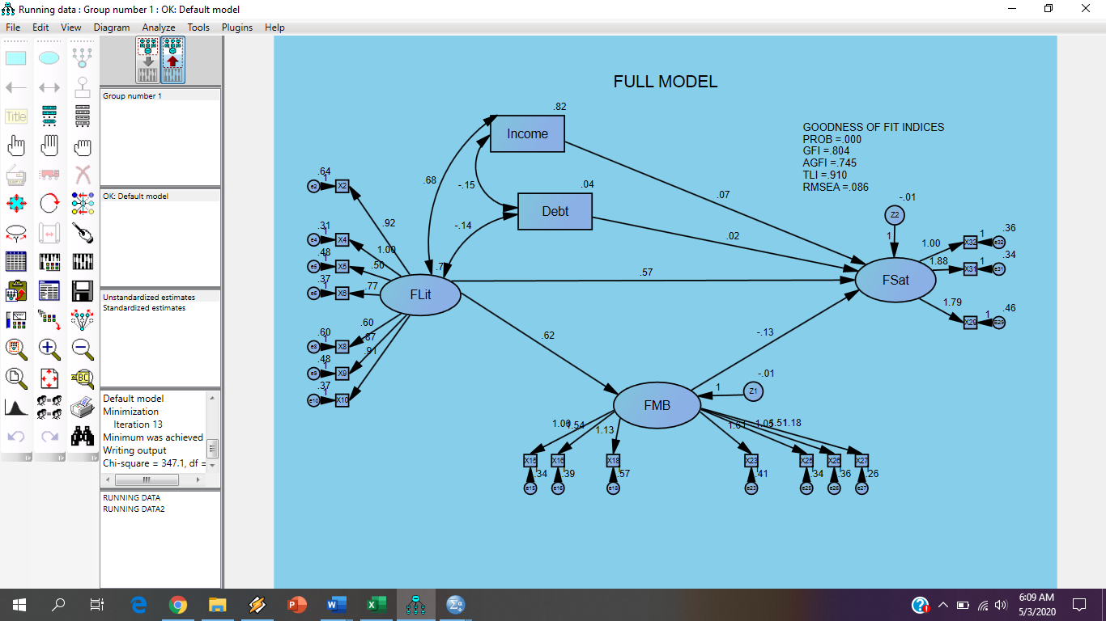

Covariances: (Group number 1 - Default model)
 |  |  | M.I. | Par Change
E29 | <--> | Debt | 8.100 | .015
E29 | <--> | FLit | 4.504 | .042
e25 | <--> | e27 | 6.616 | .057
e23 | <--> | Debt | 4.970 | .011
e23 | <--> | FLit | 6.224 | .047
e23 | <--> | E29 | 6.161 | .078
e23 | <--> | e25 | 4.292 | -.057
e16 | <--> | Income | 7.648 | -.051
e16 | <--> | FLit | 5.127 | .042
e16 | <--> | e23 | 13.588 | .111
e9 | <--> | FLit | 8.072 | -.059
e9 | <--> | e16 | 5.320 | -.076
e6 | <--> | E29 | 4.228 | -.063
e6 | <--> | e25 | 4.255 | .055
e6 | <--> | e23 | 6.292 | -.074
e5 | <--> | e10 | 5.625 | -.075
e5 | <--> | e6 | 6.234 | .079
e2 | <--> | Z1 | 4.306 | .022
e2 | <--> | e25 | 9.145 | -.105
e2 | <--> | e23 | 31.172 | .214
e2 | <--> | e16 | 15.409 | .148
e2 | <--> | e10 | 4.571 | .079
e2 | <--> | e6 | 11.501 | -.125
e4 | <--> | e23 | 4.554 | .058
e15 | <--> | Z2 | 5.857 | .022
e15 | <--> | e23 | 7.388 | -.076
e15 | <--> | e4 | 8.401 | -.072
e31 | <--> | E29 | 4.240 | .057
e31 | <--> | e25 | 7.131 | -.064
e31 | <--> | e15 | 5.089 | .055
e32 | <--> | Debt | 5.338 | -.011
e32 | <--> | FLit | 12.338 | -.062
e32 | <--> | Z2 | 4.643 | -.018
e32 | <--> | E29 | 15.921 | -.116
e32 | <--> | e25 | 7.179 | .068
e32 | <--> | e23 | 9.898 | -.088
e32 | <--> | e16 | 9.068 | -.083
e32 | <--> | e10 | 5.360 | -.062
e32 | <--> | e9 | 19.331 | .135
e32 | <--> | e6 | 12.826 | .097
e32 | <--> | e2 | 10.703 | -.115

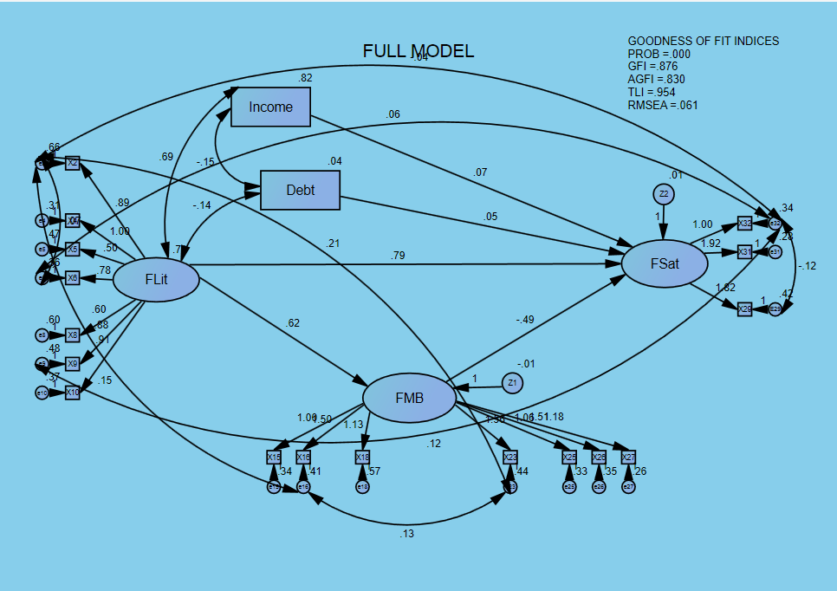

Goodness of Fit | Cut of Value | Nilai | Kesimpulan
Probabilitas | ≤ 0.050 | 0.000 | Baik
GFI | ≥ 0.900 | 0.876 | Marginal
AGFI | ≥ 0.900 | 0.830 | Marginal
TLI | ≥ 0.950 | 0.954 | Baik
RMSEA | 0.080 ≤ X ≥ 0.050 | 0.061 | Baik

Regression Weights: (Group number 1 - Default model)
 |  |  | Estimate | S.E. | C.R. | P | Label
FMB | <--- | FLit | .623 | .060 | 10.375 | *** | par_15
FSat | <--- | FLit | .792 | .561 | 1.411 | .158 | par_14
FSat | <--- | FMB | -.493 | .925 | -.533 | .594 | par_16
FSat | <--- | Income | .075 | .048 | 1.544 | .123 | par_21
FSat | <--- | Debt | .055 | .155 | .352 | .725 | par_22

