Uji Validitas Variabel Kepuasan Kerja
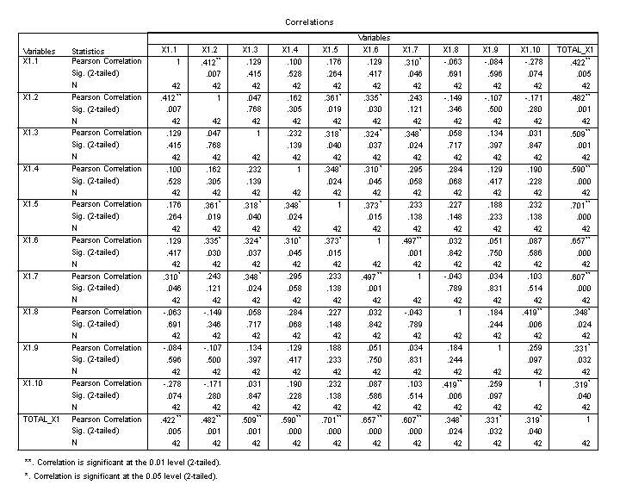
Uji Validitas Variabel Budaya Organisasi
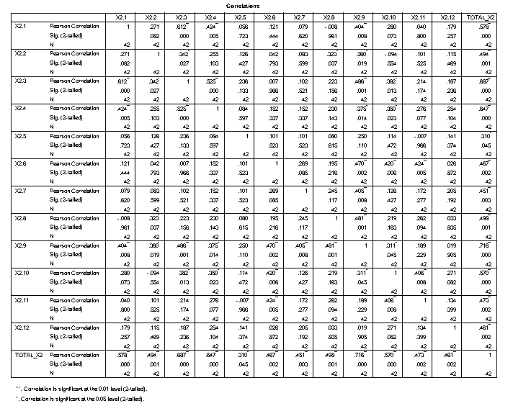
Uji Validitas Variabel Kompetensi
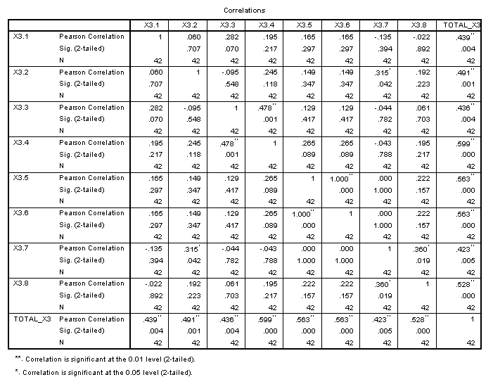
Uji Validitas Variabel Organizational Citizenship Behavior
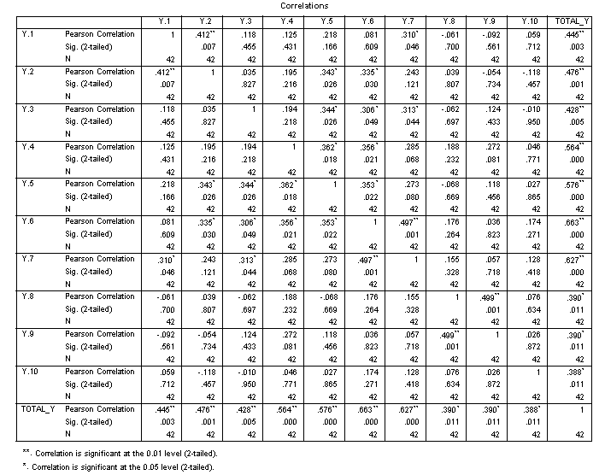

Uji Reliabilitas
- Kepuasan Kerja
Reliability Statistics
Cronbach's Alpha | Cronbach's Alpha Based on Standardized Items | N of Items
.662 | .664 | 10

- Budaya Organisasi
Reliability Statistics
Cronbach's Alpha | Cronbach's Alpha Based on Standardized Items | N of Items
.756 | .770 | 12

- Kompetensi
Reliability Statistics
Cronbach's Alpha | Cronbach's Alpha Based on Standardized Items | N of Items
.615 | .629 | 8

- Organizational Citizenship Behavior
Reliability Statistics
Cronbach's Alpha | Cronbach's Alpha Based on Standardized Items | N of Items
.625 | .664 | 10

Uji Asumsi Klasik
- Uji Normalitas
One-Sample Kolmogorov-Smirnov Test
 |  | Unstandardized Residual
N |  | 42
Normal Parameters^{a,b} | Mean | .0000000
 | Std. Deviation | 1.36230779
Most Extreme Differences | Absolute | .068
 | Positive | .068
 | Negative | -.064
Test Statistic |  | .068
Asymp. Sig. (2-tailed) |  | .200^{c,d}
a. Test distribution is Normal.
b. Calculated from data.
c. Lilliefors Significance Correction.
d. This is a lower bound of the true significance.

- Uji Multikolinieritas
Coefficientsª
Model |  | Unstandardized Coefficients |  | Standardized Coefficients | t | Sig. | Collinearity Statistics
 |  | B | Std. Error | Beta |  |  | Tolerance | VIF
1 | (Constant) | .146 | 3.925 |  | .037 | .971
 | TOTAL_X1 | .862 | .081 | .795 | 10.668 | .000 | .844 | 1.185
 | TOTAL_X2 | .197 | .058 | .271 | 3.380 | .002 | .729 | 1.373
 | TOTAL_X3 | -.131 | .098 | -.102 | -1.341 | .188 | .810 | 1.234
a. Dependent Variable: TOTAL_Y
- Uji Heteroskedastisitas
Coefficientsª
Model |  | Unstandardized Coefficients |  | Standardized Coefficients | t | Sig. | Collinearity Statistics
 |  | B | Std. Error | Beta |  |  | Tolerance | VIF
1 | (Constant) | 1.470 | 2.396 |  | .613 | .543
 | TOTAL_X1 | .020 | .049 | .070 | .405 | .688 | .844 | 1.185
 | TOTAL_X2 | .029 | .036 | .150 | .809 | .424 | .729 | 1.373
 | TOTAL_X3 | -.080 | .060 | -.234 | -1.333 | .191 | .810 | 1.234
a. Dependent Variable: ABS

Uji Kolmogorov-Smirnov

One-Sample Kolmogorov-Smirnov Test
 |  | Unstandardized Residual
N |  | 42
Normal Parameters^{a,b} | Mean | .0000000
 | Std. Deviation | 1.36230779
Most Extreme Differences | Absolute | .068
 | Positive | .068
 | Negative | -.064
Test Statistic |  | .068
Asymp. Sig. (2-tailed) |  | .200^{c,d}
a. Test distribution is Normal.
b. Calculated from data.
c. Lilliefors Significance Correction.
d. This is a lower bound of the true significance.

Uji Glejser
Coefficientsª
Model |  | Unstandardized Coefficients |  | Standardized Coefficients | t | Sig. | Collinearity Statistics
 |  | B | Std. Error | Beta |  |  | Tolerance | VIF
1 | (Constant) | 1.470 | 2.396 |  | .613 | .543
 | TOTAL_X1 | .020 | .049 | .070 | .405 | .688 | .844 | 1.185
 | TOTAL_X2 | .029 | .036 | .150 | .809 | .424 | .729 | 1.373
 | TOTAL_X3 | -.080 | .060 | -.234 | -1.333 | .191 | .810 | 1.234
a. Dependent Variable: ABS

Uji Statistik t

Coefficientsª
Model |  | Unstandardized Coefficients |  | Standardized Coefficients | t | Sig. | Collinearity Statistics
 |  | B | Std. Error | Beta |  |  | Tolerance | VIF
1 | (Constant) | .146 | 3.925 |  | .037 | .971
 | TOTAL_X1 | .862 | .081 | .795 | 10.668 | .000 | .844 | 1.185
 | TOTAL_X2 | .197 | .058 | .271 | 3.380 | .002 | .729 | 1.373
 | TOTAL_X3 | -.131 | .098 | -.102 | -1.341 | .188 | .810 | 1.234
a. Dependent Variable: TOTAL_Y

Uji Statistik f
ANOVAª
Model |  | Sum of Squares | df | Mean Square | F | Sig.
1 | Regression | 350.980 | 3 | 116.993 | 58.427 | .000^{b}
 | Residual | 76.091 | 38 | 2.002
 | Total | 427.071 | 41
a. Dependent Variable: TOTAL_Y
b. Predictors: (Constant), TOTAL_X3, TOTAL_X1, TOTAL_X2

Uji Koefisien Determinasi ($R^{2}$)
Model Summary^{b}
Model | R | R Square | Adjusted R Square | Std. Error of the Estimate | Durbin-Watson
1 | .907ª | .822 | .808 | 1.415 | 1.906
a. Predictors: (Constant), TOTAL_X3, TOTAL_X1, TOTAL_X2
b. Dependent Variable: TOTAL_Y
Statistik Deskriptif Variabel Kepuasan Kerja

X1.1
 |  | Frequency | Percent | Valid Percent | Cumulative Percent
Valid | Tidak Setuju | 1 | 2.0 | 2.4 | 2.4
 | Netral | 5 | 10.2 | 11.9 | 14.3
 | Setuju | 23 | 46.9 | 54.8 | 69.0
 | Sangat Setuju | 13 | 26.5 | 31.0 | 100.0
 | Total | 42 | 85.7 | 100.0
Missing | System | 7 | 14.3
Total |  | 49 | 100.0
X1.2
 |  | Frequency | Percent | Valid Percent | Cumulative Percent
Valid | Tidak Setuju | 1 | 2.0 | 2.4 | 2.4
 | Netral | 3 | 6.1 | 7.1 | 9.5
 | Setuju | 26 | 53.1 | 61.9 | 71.4
 | Sangat Setuju | 12 | 24.5 | 28.6 | 100.0
 | Total | 42 | 85.7 | 100.0
Missing | System | 7 | 14.3
Total |  | 49 | 100.0

X1.3
 |  | Frequency | Percent | Valid Percent | Cumulative Percent
Valid | Netral | 1 | 2.0 | 2.4 | 2.4
 | Setuju | 26 | 53.1 | 61.9 | 64.3
 | Sangat Setuju | 15 | 30.6 | 35.7 | 100.0
 | Total | 42 | 85.7 | 100.0
Missing | System | 7 | 14.3
Total |  | 49 | 100.0

X1.4
 |  | Frequency | Percent | Valid Percent | Cumulative Percent
Valid | Netral | 2 | 4.1 | 4.8 | 4.8
 | Setuju | 28 | 57.1 | 66.7 | 71.4
 | Sangat Setuju | 12 | 24.5 | 28.6 | 100.0
 | Total | 42 | 85.7 | 100.0
Missing | System | 7 | 14.3
Total |  | 49 | 100.0

X1.5
 |  | Frequency | Percent | Valid Percent | Cumulative Percent
Valid | Netral | 6 | 12.2 | 14.3 | 14.3
 | Setuju | 25 | 51.0 | 59.5 | 73.8
 | Sangat Setuju | 11 | 22.4 | 26.2 | 100.0
 | Total | 42 | 85.7 | 100.0
Missing | System | 7 | 14.3
Total |  | 49 | 100.0

X1.6
 |  | Frequency | Percent | Valid Percent | Cumulative Percent
Valid | Tidak Setuju | 1 | 2.0 | 2.4 | 2.4
 | Netral | 4 | 8.2 | 9.5 | 11.9
 | Setuju | 22 | 44.9 | 52.4 | 64.3
 | 5 | 15 | 30.6 | 35.7 | 100.0
 | Total | 42 | 85.7 | 100.0
Missing | System | 7 | 14.3
Total |  | 49 | 100.0

X1.7
 |  | Frequency | Percent | Valid Percent | Cumulative Percent
Valid | Netral | 1 | 2.0 | 2.4 | 2.4
 | Setuju | 25 | 51.0 | 59.5 | 61.9
 | Sangat Setuju | 16 | 32.7 | 38.1 | 100.0
 | Total | 42 | 85.7 | 100.0
Missing | System | 7 | 14.3
Total |  | 49 | 100.0

X1.8
 |  | Frequency | Percent | Valid Percent | Cumulative Percent
Valid | Netral | 3 | 6.1 | 7.1 | 7.1
 | Setuju | 29 | 59.2 | 69.0 | 76.2
 | Sangat Setuju | 10 | 20.4 | 23.8 | 100.0
 | Total | 42 | 85.7 | 100.0
Missing | System | 7 | 14.3
Total |  | 49 | 100.0

X1.9
 |  | Frequency | Percent | Valid Percent | Cumulative Percent
Valid | Netral | 3 | 6.1 | 7.1 | 7.1
 | Setuju | 26 | 53.1 | 61.9 | 69.0
 | Sangat Setuju | 13 | 26.5 | 31.0 | 100.0
 | Total | 42 | 85.7 | 100.0
Missing | System | 7 | 14.3
Total |  | 49 | 100.0

X1.10
 |  | Frequency | Percent | Valid Percent | Cumulative Percent
Valid | Netral | 2 | 4.1 | 4.8 | 4.8
 | Setuju | 30 | 61.2 | 71.4 | 76.2
 | Sangat Setuju | 10 | 20.4 | 23.8 | 100.0
 | Total | 42 | 85.7 | 100.0
Missing | System | 7 | 14.3
Total |  | 49 | 100.0

Statistik Deskriptif Variabel Budaya Organisasi
X2.1
 |  | Frequency | Percent | Valid Percent | Cumulative Percent
Valid | Tidak Setuju | 3 | 6.1 | 7.1 | 7.1
 | Netral | 5 | 10.2 | 11.9 | 19.0
 | Setuju | 22 | 44.9 | 52.4 | 71.4
 | Sangat Setuju | 12 | 24.5 | 28.6 | 100.0
 | Total | 42 | 85.7 | 100.0
Missing | System | 7 | 14.3
Total |  | 49 | 100.0

X2.2
 |  | Frequency | Percent | Valid Percent | Cumulative Percent
Valid | Tidak Setuju | 2 | 4.1 | 4.8 | 4.8
 | Netral | 9 | 18.4 | 21.4 | 26.2
 | Setuju | 18 | 36.7 | 42.9 | 69.0
 | Sangat Setuju | 13 | 26.5 | 31.0 | 100.0
 | Total | 42 | 85.7 | 100.0
Missing | System | 7 | 14.3
Total |  | 49 | 100.0

X2.3
 |  | Frequency | Percent | Valid Percent | Cumulative Percent
Valid | Tidak Setuju | 2 | 4.1 | 4.8 | 4.8
 | Netral | 3 | 6.1 | 7.1 | 11.9
 | Setuju | 24 | 49.0 | 57.1 | 69.0
 | Sangat Setuju | 13 | 26.5 | 31.0 | 100.0
 | Total | 42 | 85.7 | 100.0
Missing | System | 7 | 14.3
Total |  | 49 | 100.0

X2.4
 |  | Frequency | Percent | Valid Percent | Cumulative Percent
Valid | Netral | 6 | 12.2 | 14.3 | 14.3
 | Setuju | 22 | 44.9 | 52.4 | 66.7
 | Sangat Setuju | 14 | 28.6 | 33.3 | 100.0
 | Total | 42 | 85.7 | 100.0
Missing | System | 7 | 14.3
Total |  | 49 | 100.0

X2.5
 |  | Frequency | Percent | Valid Percent | Cumulative Percent
Valid | Netral | 2 | 4.1 | 4.8 | 4.8
 | Setuju | 33 | 67.3 | 78.6 | 83.3
 | Sangat Setuju | 7 | 14.3 | 16.7 | 100.0
 | Total | 42 | 85.7 | 100.0
Missing | System | 7 | 14.3
Total |  | 49 | 100.0

X2.6
 |  | Frequency | Percent | Valid Percent | Cumulative Percent
Valid | Netral | 7 | 14.3 | 16.7 | 16.7
 | Setuju | 22 | 44.9 | 52.4 | 69.0
 | Sangat Setuju | 13 | 26.5 | 31.0 | 100.0
 | Total | 42 | 85.7 | 100.0
Missing | System | 7 | 14.3
Total |  | 49 | 100.0

X2.7
 |  | Frequency | Percent | Valid Percent | Cumulative Percent
Valid | Netral | 7 | 14.3 | 16.7 | 16.7
 | Setuju | 22 | 44.9 | 52.4 | 69.0
 | Sangat Setuju | 13 | 26.5 | 31.0 | 100.0
 | Total | 42 | 85.7 | 100.0
Missing | System | 7 | 14.3
Total |  | 49 | 100.0

X2.8
 |  | Frequency | Percent | Valid Percent | Cumulative Percent
Valid | Netral | 7 | 14.3 | 16.7 | 16.7
 | Setuju | 20 | 40.8 | 47.6 | 64.3
 | Sangat Setuju | 15 | 30.6 | 35.7 | 100.0
 | Total | 42 | 85.7 | 100.0
Missing | System | 7 | 14.3
Total |  | 49 | 100.0

X2.9
 |  | Frequency | Percent | Valid Percent | Cumulative Percent
Valid | Netral | 2 | 4.1 | 4.8 | 4.8
 | Setuju | 26 | 53.1 | 61.9 | 66.7
 | Sangat Setuju | 14 | 28.6 | 33.3 | 100.0
 | Total | 42 | 85.7 | 100.0
Missing | System | 7 | 14.3
Total |  | 49 | 100.0

X2.10
 |  | Frequency | Percent | Valid Percent | Cumulative Percent
Valid | Netral | 5 | 10.2 | 11.9 | 11.9
 | Setuju | 26 | 53.1 | 61.9 | 73.8
 | Sangat Setuju | 11 | 22.4 | 26.2 | 100.0
 | Total | 42 | 85.7 | 100.0
Missing | System | 7 | 14.3
Total |  | 49 | 100.0

X2.11
 |  | Frequency | Percent | Valid Percent | Cumulative Percent
Valid | Netral | 3 | 6.1 | 7.1 | 7.1
 | Setuju | 27 | 55.1 | 64.3 | 71.4
 | Sangat Setuju | 12 | 24.5 | 28.6 | 100.0
 | Total | 42 | 85.7 | 100.0
Missing | System | 7 | 14.3
Total |  | 49 | 100.0

X2.12
 |  | Frequency | Percent | Valid Percent | Cumulative Percent
Valid | Sangat Tidak Setuju | 1 | 2.0 | 2.4 | 2.4
 | Tidak Setuju | 2 | 4.1 | 4.8 | 7.1
 | Netral | 11 | 22.4 | 26.2 | 33.3
 | Setuju | 15 | 30.6 | 35.7 | 69.0
 | Sangat Setuju | 13 | 26.5 | 31.0 | 100.0
 | Total | 42 | 85.7 | 100.0
Missing | System | 7 | 14.3
Total |  | 49 | 100.0

Statistik Deskriptif Variabel Kompetensi
X3.1
 |  | Frequency | Percent | Valid Percent | Cumulative Percent
Valid | Netral | 5 | 10.2 | 11.9 | 11.9
 | Setuju | 22 | 44.9 | 52.4 | 64.3
 | Sangat Setuju | 15 | 30.6 | 35.7 | 100.0
 | Total | 42 | 85.7 | 100.0
Missing | System | 7 | 14.3
Total |  | 49 | 100.0

X3.2
 |  | Frequency | Percent | Valid Percent | Cumulative Percent
Valid | Netral | 2 | 4.1 | 4.8 | 4.8
 | Setuju | 25 | 51.0 | 59.5 | 64.3
 | Sangat Setuju | 15 | 30.6 | 35.7 | 100.0
 | Total | 42 | 85.7 | 100.0
Missing | System | 7 | 14.3
Total |  | 49 | 100.0

X3.3
 |  | Frequency | Percent | Valid Percent | Cumulative Percent
Valid | Netral | 6 | 12.2 | 14.3 | 14.3
 | Setuju | 22 | 44.9 | 52.4 | 66.7
 | Sangat Setuju | 14 | 28.6 | 33.3 | 100.0
 | Total | 42 | 85.7 | 100.0
Missing | System | 7 | 14.3
Total |  | 49 | 100.0

X3.4
 |  | Frequency | Percent | Valid Percent | Cumulative Percent
Valid | Netral | 6 | 12.2 | 14.3 | 14.3
 | Setuju | 20 | 40.8 | 47.6 | 61.9
 | Sangat Setuju | 16 | 32.7 | 38.1 | 100.0
 | Total | 42 | 85.7 | 100.0
Missing | System | 7 | 14.3
Total |  | 49 | 100.0

X3.5
 |  | Frequency | Percent | Valid Percent | Cumulative Percent
Valid | Netral | 5 | 10.2 | 11.9 | 11.9
 | Setuju | 23 | 46.9 | 54.8 | 66.7
 | Sangat Setuju | 14 | 28.6 | 33.3 | 100.0
 | Total | 42 | 85.7 | 100.0
Missing | System | 7 | 14.3
Total |  | 49 | 100.0

X3.6
 |  | Frequency | Percent | Valid Percent | Cumulative Percent
Valid | Netral | 5 | 10.2 | 11.9 | 11.9
 | Setuju | 23 | 46.9 | 54.8 | 66.7
 | Sangat Setuju | 14 | 28.6 | 33.3 | 100.0
 | Total | 42 | 85.7 | 100.0
Missing | System | 7 | 14.3
Total |  | 49 | 100.0

X3.7
 |  | Frequency | Percent | Valid Percent | Cumulative Percent
Valid | Tidak Setuju | 1 | 2.0 | 2.4 | 2.4
 | Netral | 11 | 22.4 | 26.2 | 28.6
 | Setuju | 17 | 34.7 | 40.5 | 69.0
 | Sangat Setuju | 13 | 26.5 | 31.0 | 100.0
 | Total | 42 | 85.7 | 100.0
Missing | System | 7 | 14.3
Total |  | 49 | 100.0

X3.8
 |  | Frequency | Percent | Valid Percent | Cumulative Percent
Valid | Netral | 5 | 10.2 | 11.9 | 11.9
 | Setuju | 22 | 44.9 | 52.4 | 64.3
 | Sangat Setuju | 15 | 30.6 | 35.7 | 100.0
 | Total | 42 | 85.7 | 100.0
Missing | System | 7 | 14.3
Total |  | 49 | 100.0

Statistik Deskriptif Variabel Organizational Citizenship Behavior
Y.1
 |  | Frequency | Percent | Valid Percent | Cumulative Percent
Valid | Tidak Setuju | 1 | 2.0 | 2.4 | 2.4
 | Netral | 5 | 10.2 | 11.9 | 14.3
 | Setuju | 23 | 46.9 | 54.8 | 69.0
 | Sangat Setuju | 13 | 26.5 | 31.0 | 100.0
 | Total | 42 | 85.7 | 100.0
Missing | System | 7 | 14.3
Total |  | 49 | 100.0

Y.2
 |  | Frequency | Percent | Valid Percent | Cumulative Percent
Valid | Tidak Setuju | 1 | 2.0 | 2.4 | 2.4
 | Netral | 3 | 6.1 | 7.1 | 9.5
 | Setuju | 26 | 53.1 | 61.9 | 71.4
 | Sangat Setuju | 12 | 24.5 | 28.6 | 100.0
 | Total | 42 | 85.7 | 100.0
Missing | System | 7 | 14.3
Total |  | 49 | 100.0

Y.3
 |  | Frequency | Percent | Valid Percent | Cumulative Percent
Valid | Netral | 1 | 2.0 | 2.4 | 2.4
 | Setuju | 25 | 51.0 | 59.5 | 61.9
 | Sangat Setuju | 16 | 32.7 | 38.1 | 100.0
 | Total | 42 | 85.7 | 100.0
Missing | System | 7 | 14.3
Total |  | 49 | 100.0

Y.4
 |  | Frequency | Percent | Valid Percent | Cumulative Percent
Valid | Netral | 2 | 4.1 | 4.8 | 4.8
 | Setuju | 30 | 61.2 | 71.4 | 76.2
 | Sangat Setuju | 10 | 20.4 | 23.8 | 100.0
 | Total | 42 | 85.7 | 100.0
Missing | System | 7 | 14.3
Total |  | 49 | 100.0

Y.5
 |  | Frequency | Percent | Valid Percent | Cumulative Percent
Valid | Netral | 6 | 12.2 | 14.3 | 14.3
 | Setuju | 24 | 49.0 | 57.1 | 71.4
 | Sangat Setuju | 12 | 24.5 | 28.6 | 100.0
 | Total | 42 | 85.7 | 100.0
Missing | System | 7 | 14.3
Total |  | 49 | 100.0

Y.6
 |  | Frequency | Percent | Valid Percent | Cumulative Percent
Valid | Tidak Setuju | 1 | 2.0 | 2.4 | 2.4
 | Netral | 4 | 8.2 | 9.5 | 11.9
 | Setuju | 22 | 44.9 | 52.4 | 64.3
 | Sangat Setuju | 15 | 30.6 | 35.7 | 100.0
 | Total | 42 | 85.7 | 100.0
Missing | System | 7 | 14.3
Total |  | 49 | 100.0

Y.7
 |  | Frequency | Percent | Valid Percent | Cumulative Percent
Valid | Netral | 1 | 2.0 | 2.4 | 2.4
 | Setuju | 25 | 51.0 | 59.5 | 61.9
 | Sangat Setuju | 16 | 32.7 | 38.1 | 100.0
 | Total | 42 | 85.7 | 100.0
Missing | System | 7 | 14.3
Total |  | 49 | 100.0

Y.8
 |  | Frequency | Percent | Valid Percent | Cumulative Percent
Valid | Netral | 5 | 10.2 | 11.9 | 11.9
 | Setuju | 24 | 49.0 | 57.1 | 69.0
 | Sangat Setuju | 13 | 26.5 | 31.0 | 100.0
 | Total | 42 | 85.7 | 100.0
Missing | System | 7 | 14.3
Total |  | 49 | 100.0

Y.9
 |  | Frequency | Percent | Valid Percent | Cumulative Percent
Valid | Netral | 7 | 14.3 | 16.7 | 16.7
 | Setuju | 22 | 44.9 | 52.4 | 69.0
 | Sangat Setuju | 13 | 26.5 | 31.0 | 100.0
 | Total | 42 | 85.7 | 100.0
Missing | System | 7 | 14.3
Total |  | 49 | 100.0

Y.10
 |  | Frequency | Percent | Valid Percent | Cumulative Percent
Valid | Sangat Tidak Setuju | 1 | 2.0 | 2.4 | 2.4
 | Tidak Setuju | 2 | 4.1 | 4.8 | 7.1
 | Netral | 11 | 22.4 | 26.2 | 33.3
 | Setuju | 15 | 30.6 | 35.7 | 69.0
 | Sangat Setuju | 13 | 26.5 | 31.0 | 100.0
 | Total | 42 | 85.7 | 100.0
Missing | System | 7 | 14.3
Total |  | 49 | 100.0

