STATEMENT OF ORIGINALITY
Submitted to Jurnal Ilmu Manajemen
https://journal.unesa.ac.id/index.php/jim/index
EISSN: 2549-192X

Title of the manuscript:
PENGARUH KOMPETENSI DAN BUDAYA KERJA TERHADAP PERSON JOB FIT DAN KINERJA KARYAWAN PADA PT ANDROMEDIA
Authors:
LUTFIYAH

As the corresponding author I certify that this manuscript is original and its publication does not infringe any copyright.

As the corresponding author I declare that the manuscript has not been previously published, in whole or in part in any other journal or scientific publishing company. Also the manuscript does not participate in any other publishing process.

As the corresponding author I declare that all persons listed hereafter were committed in the creation of the paper and were informed about their participation.

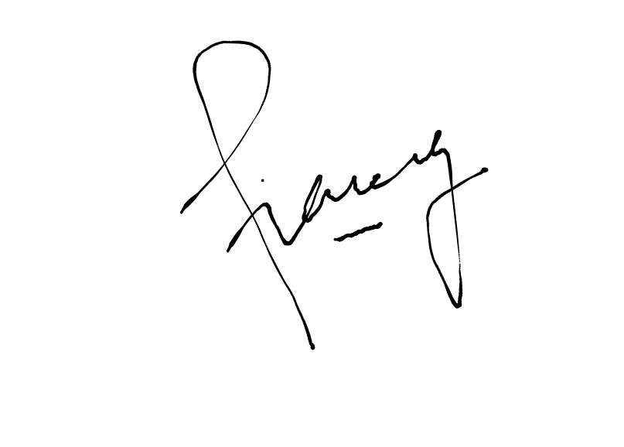 May, 7th, 2020

Lutfiyah

*)This statement must be upload for supplementary files while submitting your manuscript
or sent back to jim@unesa.ac.id

