Uji Validitas Reliabilitas 30 Responden
Variable | Item | Corrected Item – Total Correlation | Cronbach’s Alpha
Financial Technology | FT1 | 0,865 | 0,876
 | FT2 | 0,794
 | FT3 | 0,862
 | FT4 | 0,831
 | FT5 | 0,645
 | FT6 | 0,701
Succession Planning | SP1 | 0,831 | 0,727
 | SP2 | 0,774
 | SP3 | 0,817
 | SP4 | 0,562
Financial Self-Efficacy | FSE1 | 0,856 | 0,812
 | FSE2 | 0,750
 | FSE3 | 0,603
 | FSE4 | 0,670
 | FSE5 | 0,671
 | FSE6 | 0,764
Personality System | PS1 | 0,755 | 0,756
 | PS2 | 0,785
 | PS3 | 0,814
 | PS4 | 0,697
Family Business Succession | FBS1 | 0,577 | 0,804
 | FBS2 | 0,857
 | FBS3 | 0,786
 | FBS4 | 0,924
R Tabel = 0,3494
Uji Validitas Reliabilitas 110 Responden
Variable | Item | Corrected Item – Total Correlation | Cronbach’s Alpha
Financial Technology | FT1 | 0,756 | 0,766
 | FT2 | 0,670
 | FT3 | 0,695
 | FT4 | 0,702
 | FT5 | 0,621
 | FT6 | 0,635
Succession Planning | SP1 | 0,778 | 0,730
 | SP2 | 0,761
 | SP3 | 0,777
 | SP4 | 0,661
Financial Self-Efficacy | FSE1 | 0,808 | 0,864
 | FSE2 | 0,809
 | FSE3 | 0,736
 | FSE4 | 0,757
 | FSE5 | 0,752
 | FSE6 | 0,767
Personality System | PS1 | 0,707 | 0,708
 | PS2 | 0,768
 | PS3 | 0,749
 | PS4 | 0,703
Family Business Succession | FBS1 | 0,678 | 0,718
 | FBS2 | 0,769
 | FBS3 | 0,716
 | FBS4 | 0,785
R Tabel = 0,1857
UJI ASUMSI KLASIK
Uji Normalitas
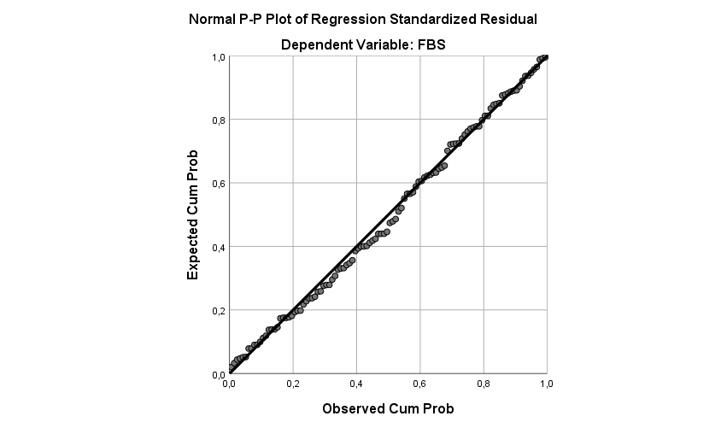

One-Sample Kolmogorov-Smirnov Test
 |  | Unstandardized Residual
N |  | 110
Normal Parameters^{a,b} | Mean | ,0000000
 | Std. Deviation | 1,27924350
Most Extreme Differences | Absolute | ,055
 | Positive | ,055
 | Negative | -,034
Test Statistic |  | ,055
Asymp. Sig. (2-tailed) |  | ,200^{c,d}
a. Test distribution is Normal.
b. Calculated from data.
c. Lilliefors Significance Correction.
d. This is a lower bound of the true significance.
Data berdistribusi Normal
Uji Heteroskedastisitas
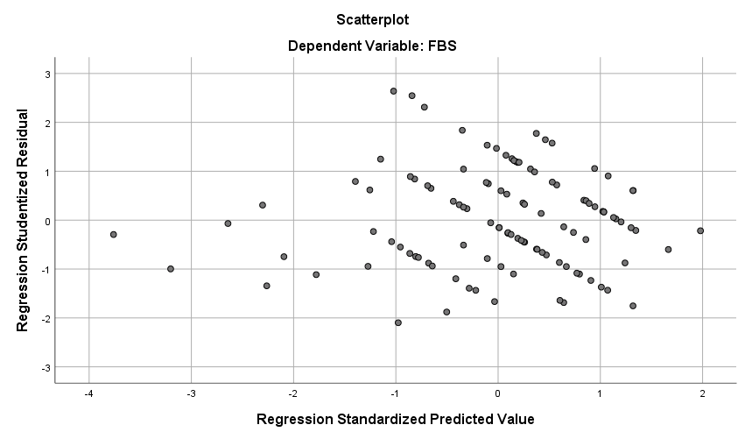

Coefficientsª
Model |  | Unstandardized Coefficients |  | Standardized Coefficients | t | Sig. | Collinearity Statistics
 |  | B | Std. Error | Beta |  |  | Tolerance | VIF
1 | (Constant) | 1,606 | ,839 |  | 1,915 | ,058
 | FT | -,017 | ,020 | -,080 | -,813 | ,418 | ,947 | 1,056
 | SP | ,051 | ,046 | ,140 | 1,126 | ,263 | ,595 | 1,682
 | FSE | ,024 | ,021 | ,117 | 1,138 | ,258 | ,871 | 1,148
 | PS | -,095 | ,049 | -,245 | -1,915 | ,058 | ,559 | 1,788
a. Dependent Variable: ABS_RES
Signifikansi uji heteroskedastisitas diatas 0,05 maka tidak terdapat gejala heteroskedastisitas

Uji Multikolonieritas
Coefficientsª
Model |  | Unstandardized Coefficients |  | Standardized Coefficients | t | Sig. | Collinearity Statistics
 |  | B | Std. Error | Beta |  |  | Tolerance | VIF
1 | (Constant) | 1,606 | ,839 |  | 1,915 | ,058
 | FT | -,017 | ,020 | -,080 | -,813 | ,418 | ,947 | 1,056
 | SP | ,051 | ,046 | ,140 | 1,126 | ,263 | ,595 | 1,682
 | FSE | ,024 | ,021 | ,117 | 1,138 | ,258 | ,871 | 1,148
 | PS | -,095 | ,049 | -,245 | -1,915 | ,058 | ,559 | 1,788
a. Dependent Variable: ABS_RES
Signifikansi uji heteroskedastisitas diatas 0,05 maka tidak terdapat gejala heteroskedastisitas

UJI REGRESI LINIER BERGANDA

Y = 1,828 + 0,074FT + (-0,163)SP + 0,09FSE + 0,828PS + e ................................. (1)

UJI T
Coefficientsª
Model |  | Unstandardized Coefficients |  | Standardized Coefficients | T | Sig.
 |  | B | Std. Error | Beta
1 | (Constant) | 1,828 | 1,505 |  | 1,214 | ,227
 | FT | ,074 | ,036 | ,130 | 2,039 | ,044
 | SP | -,163 | ,082 | -,160 | -1,990 | ,049
 | FSE | ,090 | ,037 | ,161 | 2,413 | ,018
 | PS | ,828 | ,089 | ,775 | 9,335 | ,000
a. Dependent Variable: FBS
Terdapat pengaruh variabel X1, X2, X3, X4 terhadap variabel Y karena nilai signifikansi kuranag dari 0,05 tetapi untuk variabel SP memiliki arah pengaruh yang negatif
UJI F

ANOVAª
Model |  | Sum of Squares | Df | Mean Square | F | Sig.
1 | Regression | 261,989 | 4 | 65,497 | 38,555 | ,000^{b}
 | Residual | 178,375 | 105 | 1,699
 | Total | 440,364 | 109
a. Dependent Variable: FBS
b. Predictors: (Constant), PS, FT, FSE, SP

Signifikan karena nilai signifikansi dibawah 0,05 yang berarti variabel independen berpengaruh secara simultan terhadap variabel dependen
UJI DETERMINASI
Model Summary
Model | R | R Square | Adjusted R Square | Std. Error of the Estimate
1 | ,771ª | ,595 | ,580 | 1,303
a. Predictors: (Constant), PS, FT, FSE, SP

Nilai adjusted R Square 0,585 atau 58,5 yang berarti variabel independen pada penelitian ini menjelaskan sebanyak 58,5% terhadap variabel dependen, sedangan 41,5% dijelaskan oleh variabel independen lain selain yang ada dalam penelitian ini.

