Statistik Deskriptive Variabel Penelitian
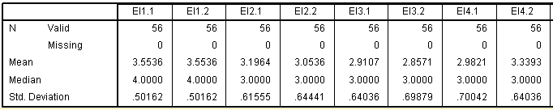

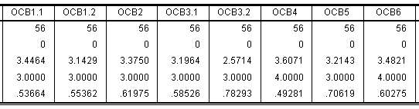

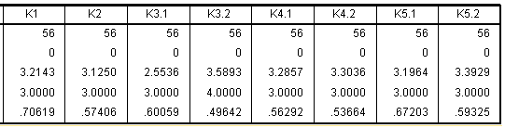

Sumber: Output SPSS

Statistik Deskriptif Emotional Intelligence
EI1.1
 |  | Frequency | Percent | Valid Percent | Cumulative Percent
Valid | 3.00 | 25 | 44.6 | 44.6 | 44.6
 | 4.00 | 31 | 55.4 | 55.4 | 100.0
 | Total | 56 | 100.0 | 100.0

EI1.2
 |  | Frequency | Percent | Valid Percent | Cumulative Percent
Valid | 3.00 | 25 | 44.6 | 44.6 | 44.6
 | 4.00 | 31 | 55.4 | 55.4 | 100.0
 | Total | 56 | 100.0 | 100.0

EI2.1
 |  | Frequency | Percent | Valid Percent | Cumulative Percent
Valid | 1.00 | 1 | 1.8 | 1.8 | 1.8
 | 2.00 | 3 | 5.4 | 5.4 | 7.1
 | 3.00 | 36 | 64.3 | 64.3 | 71.4
 | 4.00 | 16 | 28.6 | 28.6 | 100.0
 | Total | 56 | 100.0 | 100.0

EI2.2
 |  | Frequency | Percent | Valid Percent | Cumulative Percent
Valid | 1.00 | 1 | 1.8 | 1.8 | 1.8
 | 2.00 | 7 | 12.5 | 12.5 | 14.3
 | 3.00 | 36 | 64.3 | 64.3 | 78.6
 | 4.00 | 12 | 21.4 | 21.4 | 100.0
 | Total | 56 | 100.0 | 100.0

EI3.1
 |  | Frequency | Percent | Valid Percent | Cumulative Percent
Valid | 1.00 | 1 | 1.8 | 1.8 | 1.8
 | 2.00 | 11 | 19.6 | 19.6 | 21.4
 | 3.00 | 36 | 64.3 | 64.3 | 85.7
 | 4.00 | 8 | 14.3 | 14.3 | 100.0
 | Total | 56 | 100.0 | 100.0

EI3.2
 |  | Frequency | Percent | Valid Percent | Cumulative Percent
Valid | 1.00 | 2 | 3.6 | 3.6 | 3.6
 | 2.00 | 12 | 21.4 | 21.4 | 25.0
 | 3.00 | 34 | 60.7 | 60.7 | 85.7
 | 4.00 | 8 | 14.3 | 14.3 | 100.0
 | Total | 56 | 100.0 | 100.0

EI4.1
 |  | Frequency | Percent | Valid Percent | Cumulative Percent
Valid | 1.00 | 1 | 1.8 | 1.8 | 1.8
 | 2.00 | 11 | 19.6 | 19.6 | 21.4
 | 3.00 | 32 | 57.1 | 57.1 | 78.6
 | 4.00 | 12 | 21.4 | 21.4 | 100.0
 | Total | 56 | 100.0 | 100.0

EI4.2
 |  | Frequency | Percent | Valid Percent | Cumulative Percent
Valid | 2.00 | 5 | 8.9 | 8.9 | 8.9
 | 3.00 | 27 | 48.2 | 48.2 | 57.1
 | 4.00 | 24 | 42.9 | 42.9 | 100.0
 | Total | 56 | 100.0 | 100.0

Statistik Deskriptif OCB
OCB1.1
 |  | Frequency | Percent | Valid Percent | Cumulative Percent
Valid | 2.00 | 1 | 1.8 | 1.8 | 1.8
 | 3.00 | 29 | 51.8 | 51.8 | 53.6
 | 4.00 | 26 | 46.4 | 46.4 | 100.0
 | Total | 56 | 100.0 | 100.0

OCB1.2
 |  | Frequency | Percent | Valid Percent | Cumulative Percent
Valid | 1.00 | 1 | 1.8 | 1.8 | 1.8
 | 2.00 | 2 | 3.6 | 3.6 | 5.4
 | 3.00 | 41 | 73.2 | 73.2 | 78.6
 | 4.00 | 12 | 21.4 | 21.4 | 100.0
 | Total | 56 | 100.0 | 100.0

OCB2
 |  | Frequency | Percent | Valid Percent | Cumulative Percent
Valid | 1.00 | 1 | 1.8 | 1.8 | 1.8
 | 2.00 | 1 | 1.8 | 1.8 | 3.6
 | 3.00 | 30 | 53.6 | 53.6 | 57.1
 | 4.00 | 24 | 42.9 | 42.9 | 100.0
 | Total | 56 | 100.0 | 100.0

OCB3.1
 |  | Frequency | Percent | Valid Percent | Cumulative Percent
Valid | 1.00 | 1 | 1.8 | 1.8 | 1.8
 | 2.00 | 2 | 3.6 | 3.6 | 5.4
 | 3.00 | 38 | 67.9 | 67.9 | 73.2
 | 4.00 | 15 | 26.8 | 26.8 | 100.0
 | Total | 56 | 100.0 | 100.0

OCB3.2
 |  | Frequency | Percent | Valid Percent | Cumulative Percent
Valid | 1.00 | 4 | 7.1 | 7.1 | 7.1
 | 2.00 | 22 | 39.3 | 39.3 | 46.4
 | 3.00 | 24 | 42.9 | 42.9 | 89.3
 | 4.00 | 6 | 10.7 | 10.7 | 100.0
 | Total | 56 | 100.0 | 100.0

OCB4
 |  | Frequency | Percent | Valid Percent | Cumulative Percent
Valid | 3.00 | 22 | 39.3 | 39.3 | 39.3
 | 4.00 | 34 | 60.7 | 60.7 | 100.0
 | Total | 56 | 100.0 | 100.0

OCB5
 |  | Frequency | Percent | Valid Percent | Cumulative Percent
Valid | 1.00 | 1 | 1.8 | 1.8 | 1.8
 | 2.00 | 6 | 10.7 | 10.7 | 12.5
 | 3.00 | 29 | 51.8 | 51.8 | 64.3
 | 4.00 | 20 | 35.7 | 35.7 | 100.0
 | Total | 56 | 100.0 | 100.0

OCB6
 |  | Frequency | Percent | Valid Percent | Cumulative Percent
Valid | 2.00 | 3 | 5.4 | 5.4 | 5.4
 | 3.00 | 23 | 41.1 | 41.1 | 46.4
 | 4.00 | 30 | 53.6 | 53.6 | 100.0
 | Total | 56 | 100.0 | 100.0

Statistik Deskriptif Kinerja
K1
 |  | Frequency | Percent | Valid Percent | Cumulative Percent
Valid | 1.00 | 1 | 1.8 | 1.8 | 1.8
 | 2.00 | 6 | 10.7 | 10.7 | 12.5
 | 3.00 | 29 | 51.8 | 51.8 | 64.3
 | 4.00 | 20 | 35.7 | 35.7 | 100.0
 | Total | 56 | 100.0 | 100.0

K2
 |  | Frequency | Percent | Valid Percent | Cumulative Percent
Valid | 1.00 | 1 | 1.8 | 1.8 | 1.8
 | 2.00 | 3 | 5.4 | 5.4 | 7.1
 | 3.00 | 40 | 71.4 | 71.4 | 78.6
 | 4.00 | 12 | 21.4 | 21.4 | 100.0
 | Total | 56 | 100.0 | 100.0

K3.1
 |  | Frequency | Percent | Valid Percent | Cumulative Percent
Valid | 1.00 | 2 | 3.6 | 3.6 | 3.6
 | 2.00 | 22 | 39.3 | 39.3 | 42.9
 | 3.00 | 31 | 55.4 | 55.4 | 98.2
 | 4.00 | 1 | 1.8 | 1.8 | 100.0
 | Total | 56 | 100.0 | 100.0

K3.2
 |  | Frequency | Percent | Valid Percent | Cumulative Percent
Valid | 3.00 | 23 | 41.1 | 41.1 | 41.1
 | 4.00 | 33 | 58.9 | 58.9 | 100.0
 | Total | 56 | 100.0 | 100.0

K4.1
 |  | Frequency | Percent | Valid Percent | Cumulative Percent
Valid | 2.00 | 3 | 5.4 | 5.4 | 5.4
 | 3.00 | 34 | 60.7 | 60.7 | 66.1
 | 4.00 | 19 | 33.9 | 33.9 | 100.0
 | Total | 56 | 100.0 | 100.0

K4.2
 |  | Frequency | Percent | Valid Percent | Cumulative Percent
Valid | 2.00 | 2 | 3.6 | 3.6 | 3.6
 | 3.00 | 35 | 62.5 | 62.5 | 66.1
 | 4.00 | 19 | 33.9 | 33.9 | 100.0
 | Total | 56 | 100.0 | 100.0

K5.1
 |  | Frequency | Percent | Valid Percent | Cumulative Percent
Valid | 1.00 | 2 | 3.6 | 3.6 | 3.6
 | 2.00 | 2 | 3.6 | 3.6 | 7.1
 | 3.00 | 35 | 62.5 | 62.5 | 69.6
 | 4.00 | 17 | 30.4 | 30.4 | 100.0
 | Total | 56 | 100.0 | 100.0

K5.2
 |  | Frequency | Percent | Valid Percent | Cumulative Percent
Valid | 1.00 | 1 | 1.8 | 1.8 | 1.8
 | 3.00 | 31 | 55.4 | 55.4 | 57.1
 | 4.00 | 24 | 42.9 | 42.9 | 100.0
 | Total | 56 | 100.0 | 100.0

Convergent Validity
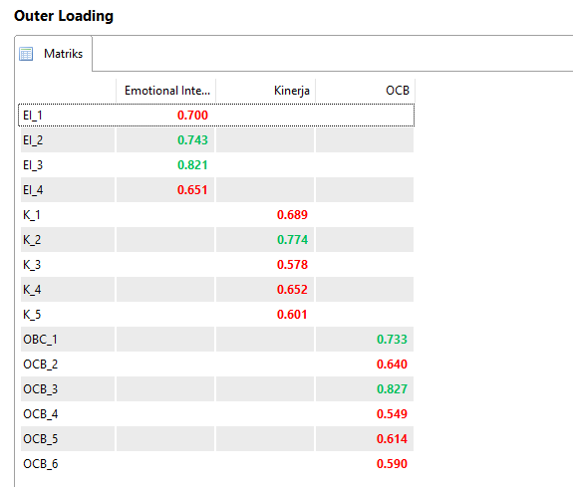 Sumber: Smart PLS 3.0.

Discriminant Validity
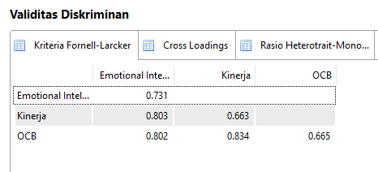
Sumber: PLS 3.0
Composite Reliability dan Cronbach Alpha
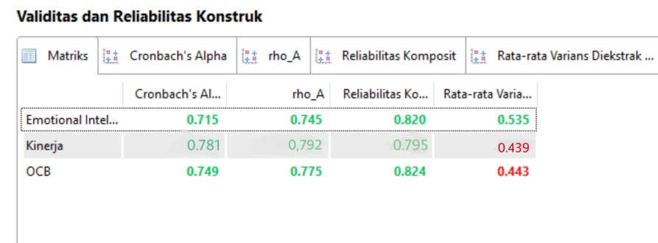
Sumber: PLS 3.0

R Square
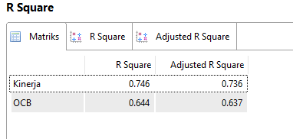
Sumber: PLS 3.0
Path Coefficients
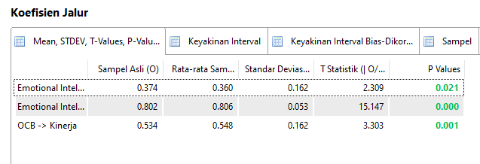
Sumber: PLS 3.0.

Indirect Effects
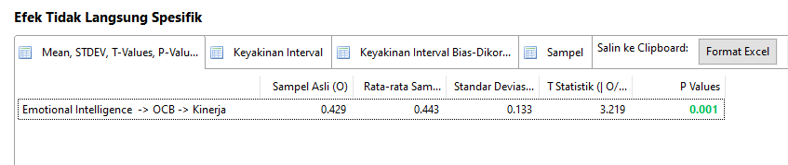 Sumber: PLS 3.0
Uji Measurement Model
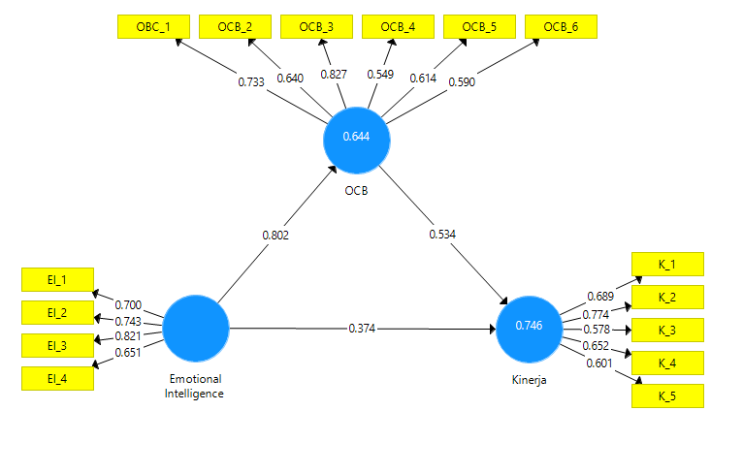
Sumber : PLS 3.0

Uji Measuremen
