Statistik Deskriptif Karakteristik Responden

Umur
 |  | Frequency | Percent | Valid Percent | Cumulative Percent
Valid | 20 | 3 | 3.7 | 3.7 | 3.7
 | 21 | 3 | 3.7 | 3.7 | 7.4
 | 22 | 3 | 3.7 | 3.7 | 11.1
 | 23 | 5 | 6.2 | 6.2 | 17.3
 | 24 | 11 | 13.6 | 13.6 | 30.9
 | 25 | 16 | 19.8 | 19.8 | 50.6
 | 26 | 5 | 6.2 | 6.2 | 56.8
 | 27 | 8 | 9.9 | 9.9 | 66.7
 | 28 | 7 | 8.6 | 8.6 | 75.3
 | 29 | 6 | 7.4 | 7.4 | 82.7
 | 30 | 3 | 3.7 | 3.7 | 86.4
 | 31 | 3 | 3.7 | 3.7 | 90.1
 | 32 | 1 | 1.2 | 1.2 | 91.4
 | 33 | 4 | 4.9 | 4.9 | 96.3
 | 34 | 1 | 1.2 | 1.2 | 97.5
 | 40 | 1 | 1.2 | 1.2 | 98.8
 | 58 | 1 | 1.2 | 1.2 | 100.0
 | Total | 81 | 100.0 | 100.0

Status
 |  | Frequency | Percent | Valid Percent | Cumulative Percent
Valid | Belum Menikah | 52 | 64.2 | 64.2 | 64.2
 | Menikah | 29 | 35.8 | 35.8 | 100.0
 | Total | 81 | 100.0 | 100.0
Pendidikan terakhir
 |  | Frequency | Percent | Valid Percent | Cumulative Percent
Valid | D3 | 9 | 11.1 | 11.1 | 11.1
 | S1 | 63 | 77.8 | 77.8 | 88.9
 | S2 | 1 | 1.2 | 1.2 | 90.1
 | SMA | 8 | 9.9 | 9.9 | 100.0
 | Total | 81 | 100.0 | 100.0

Jenis kelamin
 |  | Frequency | Percent | Valid Percent | Cumulative Percent
Valid | Laki-Laki | 26 | 32.1 | 32.1 | 32.1
 | Perempuan | 55 | 67.9 | 67.9 | 100.0
 | Total | 81 | 100.0 | 100.0

Bank tempat bekerja
 |  | Frequency | Percent | Valid Percent | Cumulative Percent
Valid | BCA | 19 | 23.5 | 23.5 | 23.5
 | BNI | 8 | 9.9 | 9.9 | 33.3
 | BRI | 26 | 32.1 | 32.1 | 65.4
 | BTN | 1 | 1.2 | 1.2 | 66.7
 | Harris | 1 | 1.2 | 1.2 | 67.9
 | Mandiri | 24 | 29.6 | 29.6 | 97.5
 | Panin | 2 | 2.5 | 2.5 | 100.0
 | Total | 81 | 100.0 | 100.0

Lampiran 8 : Tabel Hasil Statistik Deskriptif (Empirik)

Descriptive Statistics
 | N | Minimum | Maximum | Mean | Std. Deviation
Self Esteem | 81 | 36 | 50 | 44.02 | 3.866
Valid N (listwise) | 81

Descriptive Statistics
 | N | Minimum | Maximum | Mean | Std. Deviation
Psychological Well Being | 81 | 36 | 50 | 44.15 | 3.675
Valid N (listwise) | 81

Descriptive Statistics
 | N | Minimum | Maximum | Mean | Std. Deviation
Work Engagement | 81 | 17 | 25 | 21.88 | 2.353
Valid N (listwise) | 81

Descriptive Statistics
 | N | Minimum | Maximum | Mean | Std. Deviation
Job Performance | 81 | 30 | 45 | 39.15 | 3.805
Valid N (listwise) | 81

Lampiran 9 : Tabel Kategorisasi Self Esteem
Statistics
 |  | Skor_Total | Self.Esteem
N | Valid | 81 | 81
 | Missing | 0 | 0
Mean |  | 44.02 | 2.9877
Median |  | 44.00 | 3.0000
Std. Deviation |  | 3.866 | .11111
Minimum |  | 36 | 2.00
Maximum |  | 50 | 3.00

Self.Esteem
 |  | Frequency | Percent | Valid Percent | Cumulative Percent
Valid | Sedang | 1 | 1.2 | 1.2 | 1.2
 | Tinggi | 80 | 98.8 | 98.8 | 100.0
 | Total | 81 | 100.0 | 100.0

Lampiran 10 : Tabel Kategorisasi Psychological Well Being
Statistics
 |  | Skor.Total | Psychological.Well.Being
N | Valid | 81 | 81
 | Missing | 0 | 0
Mean |  | 44.15 | 2.99
Median |  | 44.00 | 3.00
Std. Deviation |  | 3.675 | .111
Minimum |  | 36 | 2
Maximum |  | 50 | 3

Psychological.Well.Being
 |  | Frequency | Percent | Valid Percent | Cumulative Percent
Valid | Sedang | 1 | 1.2 | 1.2 | 1.2
 | Tinggi | 80 | 98.8 | 98.8 | 100.0
 | Total | 81 | 100.0 | 100.0
Lampiran 11 : Tabel Kategorisasi Work Engagement
Statistics
 |  | Skor.Total | Work.Egangement
N | Valid | 81 | 81
 | Missing | 0 | 0
Mean |  | 21.88 | 2.99
Median |  | 21.00 | 3.00
Std. Deviation |  | 2.353 | .111
Minimum |  | 17 | 2
Maximum |  | 25 | 3

Work.Egangement
 |  | Frequency | Percent | Valid Percent | Cumulative Percent
Valid | Sedang | 1 | 1.2 | 1.2 | 1.2
 | Tinggi | 80 | 98.8 | 98.8 | 100.0
 | Total | 81 | 100.0 | 100.0
Lampiran 12 : Tabel Kategorisasi Job Performance
Statistics
 |  | Skor.Total | Job.Performance
N | Valid | 81 | 81
 | Missing | 0 | 0
Mean |  | 39.15 | 2.99
Median |  | 38.00 | 3.00
Std. Deviation |  | 3.805 | .111
Minimum |  | 30 | 2
Maximum |  | 45 | 3

Job.Performance
 |  | Frequency | Percent | Valid Percent | Cumulative Percent
Valid | Sedang | 1 | 1.2 | 1.2 | 1.2
 | Tinggi | 80 | 98.8 | 98.8 | 100.0
 | Total | 81 | 100.0 | 100.0

Lampiran 13: Tabel Deskriptif
Descriptive Statistics
 | N | Minimum | Maximum | Mean | Std. Deviation
Self esteem | 81 | 36 | 50 | 44.02 | 3.866
Psychologycal well being | 81 | 36 | 50 | 44.15 | 3.675
Work engagement | 81 | 17 | 25 | 21.88 | 2.353
Job performance | 81 | 30 | 45 | 39.15 | 3.805
Valid N (listwise) | 81

Descriptive Statistics
 | N | Minimum | Maximum | Mean | Std. Deviation
X1.1.1 | 81 | 4 | 5 | 4.54 | .501
X1.1.2 | 81 | 2 | 5 | 4.47 | .614
X1.2.1 | 81 | 3 | 5 | 4.41 | .565
X1.2.2 | 81 | 4 | 5 | 4.48 | .503
X1.3.1 | 81 | 2 | 5 | 4.30 | .621
X1.3.2 | 81 | 2 | 5 | 4.27 | .671
X1.4.1 | 81 | 2 | 5 | 4.46 | .571
X1.4.2 | 81 | 4 | 5 | 4.48 | .503
X1.5.1 | 81 | 4 | 5 | 4.33 | .474
X1.5.2 | 81 | 2 | 5 | 4.28 | .553
X2.1.1 | 81 | 4 | 5 | 4.31 | .465
X2.1.2 | 81 | 4 | 5 | 4.32 | .470
X2.2.1 | 81 | 3 | 5 | 4.40 | .563
X2.2.2 | 81 | 4 | 5 | 4.52 | .503
X2.3.1 | 81 | 2 | 5 | 4.23 | .763
X2.3.2 | 81 | 4 | 5 | 4.52 | .503
X2.4.1 | 81 | 4 | 5 | 4.57 | .498
X2.4.2 | 81 | 4 | 5 | 4.57 | .498
X2.5.1 | 81 | 2 | 5 | 4.27 | .689
X2.5.2 | 81 | 3 | 5 | 4.44 | .548
Z.1.1 | 81 | 3 | 5 | 4.35 | .574
Z.1.2 | 81 | 3 | 5 | 4.37 | .558
Z.2.1 | 81 | 3 | 5 | 4.40 | .563
Z.2.2 | 81 | 2 | 5 | 4.40 | .606
Z.3 | 81 | 3 | 5 | 4.37 | .601
Y.1.1 | 81 | 4 | 5 | 4.38 | .489
Y.1.2 | 81 | 4 | 5 | 4.38 | .489
Y.2.1 | 81 | 3 | 5 | 4.41 | .519
Y.2.2 | 81 | 2 | 5 | 4.33 | .689
Y.3.1 | 81 | 3 | 5 | 4.35 | .504
Y.3.2 | 81 | 3 | 5 | 4.35 | .504
Y.4.1 | 81 | 3 | 5 | 4.32 | .496
Y.4.2 | 81 | 1 | 5 | 4.22 | .671
Y.5 | 81 | 4 | 5 | 4.41 | .494
Valid N (listwise) | 81

Lampiran 14 : Statistik Deskriptif Variabel Self Esteem
X1.1.1
 |  | Frequency | Percent | Valid Percent | Cumulative Percent
Valid | 4 | 37 | 45.7 | 45.7 | 45.7
 | 5 | 44 | 54.3 | 54.3 | 100.0
 | Total | 81 | 100.0 | 100.0

X1.1.2
 |  | Frequency | Percent | Valid Percent | Cumulative Percent
Valid | 2 | 1 | 1.2 | 1.2 | 1.2
 | 3 | 2 | 2.5 | 2.5 | 3.7
 | 4 | 36 | 44.4 | 44.4 | 48.1
 | 5 | 42 | 51.9 | 51.9 | 100.0
 | Total | 81 | 100.0 | 100.0

X1.2.1
 |  | Frequency | Percent | Valid Percent | Cumulative Percent
Valid | 3 | 3 | 3.7 | 3.7 | 3.7
 | 4 | 42 | 51.9 | 51.9 | 55.6
 | 5 | 36 | 44.4 | 44.4 | 100.0
 | Total | 81 | 100.0 | 100.0

X1.2.2
 |  | Frequency | Percent | Valid Percent | Cumulative Percent
Valid | 4 | 42 | 51.9 | 51.9 | 51.9
 | 5 | 39 | 48.1 | 48.1 | 100.0
 | Total | 81 | 100.0 | 100.0

X1.3.1
 |  | Frequency | Percent | Valid Percent | Cumulative Percent
Valid | 2 | 1 | 1.2 | 1.2 | 1.2
 | 3 | 4 | 4.9 | 4.9 | 6.2
 | 4 | 46 | 56.8 | 56.8 | 63.0
 | 5 | 30 | 37.0 | 37.0 | 100.0
 | Total | 81 | 100.0 | 100.0

X1.3.2
 |  | Frequency | Percent | Valid Percent | Cumulative Percent
Valid | 2 | 2 | 2.5 | 2.5 | 2.5
 | 3 | 4 | 4.9 | 4.9 | 7.4
 | 4 | 45 | 55.6 | 55.6 | 63.0
 | 5 | 30 | 37.0 | 37.0 | 100.0
 | Total | 81 | 100.0 | 100.0

X1.4.1
 |  | Frequency | Percent | Valid Percent | Cumulative Percent
Valid | 2 | 1 | 1.2 | 1.2 | 1.2
 | 4 | 41 | 50.6 | 50.6 | 51.9
 | 5 | 39 | 48.1 | 48.1 | 100.0
 | Total | 81 | 100.0 | 100.0

X1.4.2
 |  | Frequency | Percent | Valid Percent | Cumulative Percent
Valid | 4 | 42 | 51.9 | 51.9 | 51.9
 | 5 | 39 | 48.1 | 48.1 | 100.0
 | Total | 81 | 100.0 | 100.0

X1.5.1
 |  | Frequency | Percent | Valid Percent | Cumulative Percent
Valid | 4 | 54 | 66.7 | 66.7 | 66.7
 | 5 | 27 | 33.3 | 33.3 | 100.0
 | Total | 81 | 100.0 | 100.0

X1.5.2
 |  | Frequency | Percent | Valid Percent | Cumulative Percent
Valid | 2 | 1 | 1.2 | 1.2 | 1.2
 | 3 | 1 | 1.2 | 1.2 | 2.5
 | 4 | 53 | 65.4 | 65.4 | 67.9
 | 5 | 26 | 32.1 | 32.1 | 100.0
 | Total | 81 | 100.0 | 100.0

Lampiran 15: Statistik Deskriptif Variabel Psychological Well Being
X2.1.1
 |  | Frequency | Percent | Valid Percent | Cumulative Percent
Valid | 4 | 56 | 69.1 | 69.1 | 69.1
 | 5 | 25 | 30.9 | 30.9 | 100.0
 | Total | 81 | 100.0 | 100.0

X2.1.2
 |  | Frequency | Percent | Valid Percent | Cumulative Percent
Valid | 4 | 55 | 67.9 | 67.9 | 67.9
 | 5 | 26 | 32.1 | 32.1 | 100.0
 | Total | 81 | 100.0 | 100.0

X2.2.1
 |  | Frequency | Percent | Valid Percent | Cumulative Percent
Valid | 3 | 3 | 3.7 | 3.7 | 3.7
 | 4 | 43 | 53.1 | 53.1 | 56.8
 | 5 | 35 | 43.2 | 43.2 | 100.0
 | Total | 81 | 100.0 | 100.0

X2.2.2
 |  | Frequency | Percent | Valid Percent | Cumulative Percent
Valid | 4 | 39 | 48.1 | 48.1 | 48.1
 | 5 | 42 | 51.9 | 51.9 | 100.0
 | Total | 81 | 100.0 | 100.0

X2.3.1
 |  | Frequency | Percent | Valid Percent | Cumulative Percent
Valid | 2 | 2 | 2.5 | 2.5 | 2.5
 | 3 | 10 | 12.3 | 12.3 | 14.8
 | 4 | 36 | 44.4 | 44.4 | 59.3
 | 5 | 33 | 40.7 | 40.7 | 100.0
 | Total | 81 | 100.0 | 100.0

X2.3.2
 |  | Frequency | Percent | Valid Percent | Cumulative Percent
Valid | 4 | 39 | 48.1 | 48.1 | 48.1
 | 5 | 42 | 51.9 | 51.9 | 100.0
 | Total | 81 | 100.0 | 100.0

X2.4.1
 |  | Frequency | Percent | Valid Percent | Cumulative Percent
Valid | 4 | 35 | 43.2 | 43.2 | 43.2
 | 5 | 46 | 56.8 | 56.8 | 100.0
 | Total | 81 | 100.0 | 100.0

X2.4.2
 |  | Frequency | Percent | Valid Percent | Cumulative Percent
Valid | 4 | 35 | 43.2 | 43.2 | 43.2
 | 5 | 46 | 56.8 | 56.8 | 100.0
 | Total | 81 | 100.0 | 100.0

X2.5.1
 |  | Frequency | Percent | Valid Percent | Cumulative Percent
Valid | 2 | 1 | 1.2 | 1.2 | 1.2
 | 3 | 8 | 9.9 | 9.9 | 11.1
 | 4 | 40 | 49.4 | 49.4 | 60.5
 | 5 | 32 | 39.5 | 39.5 | 100.0
 | Total | 81 | 100.0 | 100.0

X2.5.2
 |  | Frequency | Percent | Valid Percent | Cumulative Percent
Valid | 3 | 2 | 2.5 | 2.5 | 2.5
 | 4 | 41 | 50.6 | 50.6 | 53.1
 | 5 | 38 | 46.9 | 46.9 | 100.0
 | Total | 81 | 100.0 | 100.0

Lampiran 16 : Statistik Deskriptif Variabel Work Engagement
Z.1.1
 |  | Frequency | Percent | Valid Percent | Cumulative Percent
Valid | 3 | 4 | 4.9 | 4.9 | 4.9
 | 4 | 45 | 55.6 | 55.6 | 60.5
 | 5 | 32 | 39.5 | 39.5 | 100.0
 | Total | 81 | 100.0 | 100.0

Z.1.2
 |  | Frequency | Percent | Valid Percent | Cumulative Percent
Valid | 3 | 3 | 3.7 | 3.7 | 3.7
 | 4 | 45 | 55.6 | 55.6 | 59.3
 | 5 | 33 | 40.7 | 40.7 | 100.0
 | Total | 81 | 100.0 | 100.0

Z.2.1
 |  | Frequency | Percent | Valid Percent | Cumulative Percent
Valid | 3 | 3 | 3.7 | 3.7 | 3.7
 | 4 | 43 | 53.1 | 53.1 | 56.8
 | 5 | 35 | 43.2 | 43.2 | 100.0
 | Total | 81 | 100.0 | 100.0

Z.2.2
 |  | Frequency | Percent | Valid Percent | Cumulative Percent
Valid | 2 | 1 | 1.2 | 1.2 | 1.2
 | 3 | 2 | 2.5 | 2.5 | 3.7
 | 4 | 42 | 51.9 | 51.9 | 55.6
 | 5 | 36 | 44.4 | 44.4 | 100.0
 | Total | 81 | 100.0 | 100.0

Z.3
 |  | Frequency | Percent | Valid Percent | Cumulative Percent
Valid | 3 | 5 | 6.2 | 6.2 | 6.2
 | 4 | 41 | 50.6 | 50.6 | 56.8
 | 5 | 35 | 43.2 | 43.2 | 100.0
 | Total | 81 | 100.0 | 100.0

Lampiran 17 : Statistik Deskriptif Variabel Job Performance
Y.1.1
 |  | Frequency | Percent | Valid Percent | Cumulative Percent
Valid | 4 | 50 | 61.7 | 61.7 | 61.7
 | 5 | 31 | 38.3 | 38.3 | 100.0
 | Total | 81 | 100.0 | 100.0

Y.1.2
 |  | Frequency | Percent | Valid Percent | Cumulative Percent
Valid | 4 | 50 | 61.7 | 61.7 | 61.7
 | 5 | 31 | 38.3 | 38.3 | 100.0
 | Total | 81 | 100.0 | 100.0

Y.2.1
 |  | Frequency | Percent | Valid Percent | Cumulative Percent
Valid | 3 | 1 | 1.2 | 1.2 | 1.2
 | 4 | 46 | 56.8 | 56.8 | 58.0
 | 5 | 34 | 42.0 | 42.0 | 100.0
 | Total | 81 | 100.0 | 100.0

Y.2.2
 |  | Frequency | Percent | Valid Percent | Cumulative Percent
Valid | 2 | 3 | 3.7 | 3.7 | 3.7
 | 3 | 1 | 1.2 | 1.2 | 4.9
 | 4 | 43 | 53.1 | 53.1 | 58.0
 | 5 | 34 | 42.0 | 42.0 | 100.0
 | Total | 81 | 100.0 | 100.0

Y.3.1
 |  | Frequency | Percent | Valid Percent | Cumulative Percent
Valid | 3 | 1 | 1.2 | 1.2 | 1.2
 | 4 | 51 | 63.0 | 63.0 | 64.2
 | 5 | 29 | 35.8 | 35.8 | 100.0
 | Total | 81 | 100.0 | 100.0

Y.3.2
 |  | Frequency | Percent | Valid Percent | Cumulative Percent
Valid | 3 | 1 | 1.2 | 1.2 | 1.2
 | 4 | 51 | 63.0 | 63.0 | 64.2
 | 5 | 29 | 35.8 | 35.8 | 100.0
 | Total | 81 | 100.0 | 100.0

Y.4.1
 |  | Frequency | Percent | Valid Percent | Cumulative Percent
Valid | 3 | 1 | 1.2 | 1.2 | 1.2
 | 4 | 53 | 65.4 | 65.4 | 66.7
 | 5 | 27 | 33.3 | 33.3 | 100.0
 | Total | 81 | 100.0 | 100.0

Y.4.2
 |  | Frequency | Percent | Valid Percent | Cumulative Percent
Valid | 1 | 1 | 1.2 | 1.2 | 1.2
 | 2 | 1 | 1.2 | 1.2 | 2.5
 | 3 | 2 | 2.5 | 2.5 | 4.9
 | 4 | 52 | 64.2 | 64.2 | 69.1
 | 5 | 25 | 30.9 | 30.9 | 100.0
 | Total | 81 | 100.0 | 100.0

Y.5
 |  | Frequency | Percent | Valid Percent | Cumulative Percent
Valid | 4 | 48 | 59.3 | 59.3 | 59.3
 | 5 | 33 | 40.7 | 40.7 | 100.0
 | Total | 81 | 100.0 | 100.0

Lampiran 18: Outer Loading Sebelum Eliminiasi Indikator Psychological Well Being Indikator X2.2

Lampiran 19: Outer Loading Setelah Eliminiasi Indikator Psychological Well Being Indikator X2.2

Lampiran 20: Chronbach’s Alpha dan Average Variance Extracted (AVE) Sebelum Eliminiasi Indikator Psychological Well Being Indikator X2.2
Lampiran 21: Chronbach’s Alpha dan Average Variance Extracted (AVE) Setelah Eliminiasi Indikator Psychological Well Being Indikator X2.2

Lampiran 22: R Square

Lampiran 23: Path Coefficients

Lampiran 24 : Indirect Effects

Lampiran 25 : Uji Measurement Model 1
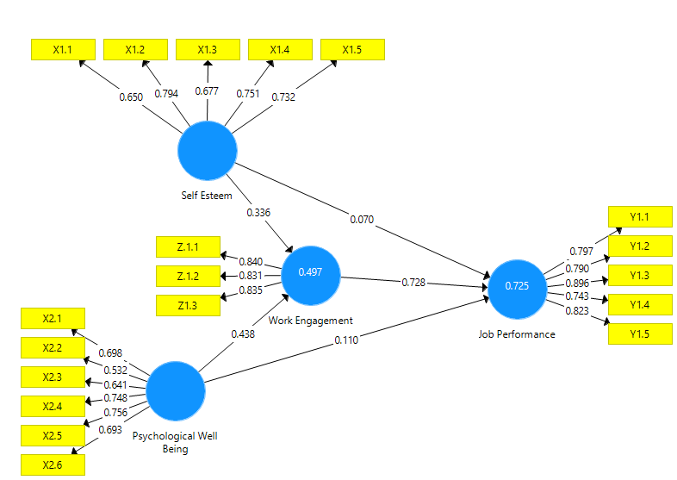

Sumber : SmartPLS 3.2.9, 2020
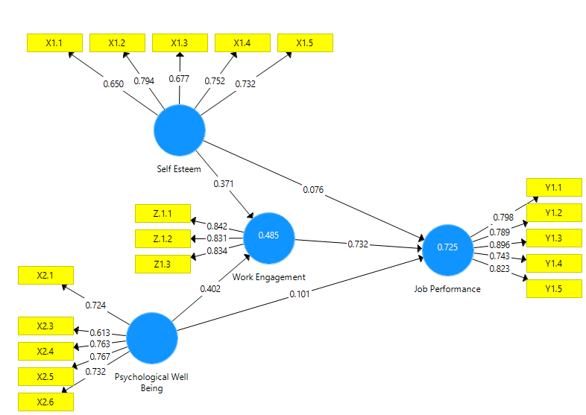
Lampiran 26 : Uji Measurement Model 2

Sumber : SmartPLS 3.2.9, 2020

