Article Title
Maximum 20 words | Times New Roman 16 pt, bold, centered. Use one concise, specific, and informative English title. Full manuscript: normally 5,000–8,000 words; maximum 25 pages including references, tables, and figures.
Author One^{1*}, Author Two¹, Author Three²
¹ Applied Bachelor Program in Public Administration, Faculty of Vocational Studies, Universitas Negeri Surabaya, Surabaya, Indonesia
² Department/Institution, University/Organization, City, Country
*Corresponding Author: author@institution.ac.id
Author names: 11 pt bold; affiliations: 10 pt; no academic degrees. Use superscript numbers for affiliations and * for the corresponding author. ORCID is optional but recommended.
ABSTRACT
150–250 words | Times New Roman 11 pt | single spacing | one paragraph. Include: research context/problem; objective; method; key findings; and conclusion/main contribution. Do not use citations, tables, figures, bullet points, or undefined abbreviations.
Write or paste the abstract here. Replace this paragraph with your final abstract while keeping the existing paragraph style.
Keywords: public administration; public policy; governance; public service
Use 3–5 keywords or short key phrases, separated by semicolons. Choose searchable terms that represent the main concepts of the article and avoid unnecessary repetition of the title.
INTRODUCTION
Times New Roman 12 pt | justified | 1.15 spacing. Build a coherent narrative that explains the research context and substantive problem, supports important claims with evidence, synthesizes relevant literature, identifies the research gap, states the novelty/contribution, and ends with a clear objective, research question, or hypothesis where relevant. Recommended proportion: about 15–20% of the main manuscript.
Write or paste the Introduction here. The first paragraph after a heading has no first-line indent; subsequent paragraphs use the predefined body style automatically.
Continue the Introduction here. Use current and relevant literature to position the study rather than presenting a list of previous studies.
METHOD
Times New Roman 12 pt | justified | 1.15 spacing. Explain, as relevant: research design/approach; setting and unit of analysis; population/sample/respondents/informants; participant selection; data sources; data collection; analytical procedures/framework/software; validity, reliability, or trustworthiness; and ethical procedures. Include only elements relevant to the study. Recommended proportion: about 10–15%.
Write or paste the Method here. Provide enough detail for readers to understand and assess how the study was conducted and how the evidence was analysed.
RESULTS AND DISCUSSION
Times New Roman 12 pt | justified | 1.15 spacing. This should be the largest analytical section (about 45–60% of the main manuscript). Present sufficient evidence, answer the research question, analyse rather than merely describe, connect findings with theory/concepts, compare with previous studies, explain similarities/differences, and identify theoretical, policy, administrative, or practical implications. Use meaningful subheadings when helpful.
Write or paste the opening paragraph of the Results and Discussion here. Introduce the analytical structure and the principal findings before moving into specific themes, dimensions, variables, or issues.
Subheading (optional)
Use Heading 2 for major themes or analytical dimensions. Use Heading 3 only when a further level is genuinely needed; avoid excessive numbering.
Write or paste the analysis for this subsection here. Each major claim should be supported by appropriate data, evidence, or scholarly references.
For a direct quotation of approximately 40 words or more, use this block-quote style: 11 pt, single spacing, 1 cm left and right indentation, and no quotation marks around the block. Delete this example if no long quotation is used.
TABLE FORMAT — Caption above the table, 11 pt bold. Table text 10–11 pt, single spacing. Keep tables within the page margins, mention and analyse every table in the text, and use a source note where appropriate.
Table 1. Characteristics of Research Participants
No. | Participant/Informant | Role | Description
1 | Informant A | Policy implementer | Replace with actual information
2 | Informant B | Service recipient | Replace with actual information
Source: Research data, 2026.
FIGURE FORMAT — Place the figure close to the paragraph that discusses it. Keep it within the text area and use publication-quality graphics (approximately 300 dpi where applicable). Caption below the figure, 11 pt; source note 10 pt italic. Figures must remain readable in grayscale.
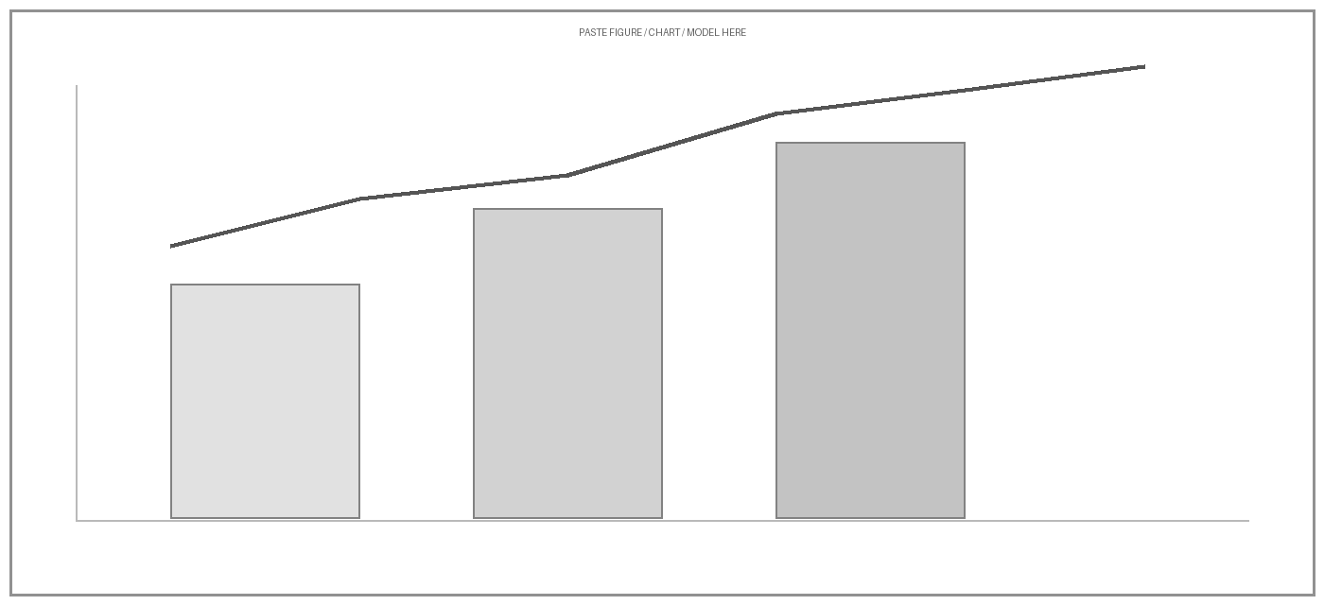
Figure 1. Title of the Figure
Source: Developed by the authors, 2026.
CONCLUSION
Times New Roman 12 pt | justified | 1.15 spacing. Directly answer the research objective/question, synthesize the key findings, state the main contribution, explain relevant theoretical/policy/administrative/practical implications, acknowledge important limitations where relevant, and provide realistic recommendations or future research directions when appropriate. Do not simply repeat the Results and Discussion. Recommended proportion: about 5–10%.
Write or paste the Conclusion here.
ACKNOWLEDGMENTS (OPTIONAL)
11 pt, single spacing. Acknowledge individuals, institutions, or non-author contributions where appropriate. Funding information should be reported separately below.
Write acknowledgments here, or delete this section if it is not applicable.
AUTHOR CONTRIBUTIONS
11 pt, single spacing. Briefly state each author’s contribution. The CRediT taxonomy may be used where appropriate.
Conceptualization: A.A.; Methodology: A.A. and B.B.; Data Collection: B.B.; Analysis: A.A. and B.B.; Writing – Original Draft: A.A.; Writing – Review and Editing: all authors.
FUNDING
11 pt, single spacing. Disclose all research or publication funding. If there was no external funding, use the statement below.
This research received no external funding.
CONFLICT OF INTEREST
11 pt, single spacing. Disclose any financial, professional, personal, academic, or institutional competing interest. If none exists, use the statement below.
The authors declare no conflict of interest.
RESEARCH ETHICS STATEMENT (WHERE APPLICABLE)
11 pt, single spacing. For research involving human participants, personal data, vulnerable groups, or other ethically sensitive material, state the relevant ethical approval, informed consent, confidentiality, and/or data-protection procedures. Delete this section if it is not applicable.
Insert the applicable research ethics statement here.
AI USE DISCLOSURE (WHERE APPLICABLE)
11 pt, single spacing. Disclose substantive use of generative AI or other AI-assisted technologies in manuscript preparation, analysis, data processing, visual generation, or other scholarly activities in accordance with the journal’s AI policy. Delete this section when no reportable AI use occurred.
Insert the applicable AI use disclosure here.
DATA AVAILABILITY STATEMENT (WHERE APPLICABLE)
11 pt, single spacing. State whether and how data supporting the findings can be accessed, subject to ethical, legal, institutional, or confidentiality restrictions. Delete this section if it is not applicable.
Insert the applicable data availability statement here.
REFERENCES
APA 7th Edition | Times New Roman 11 pt | single spacing | 1.27 cm hanging indent. Every in-text citation must appear in the reference list and every listed reference must be cited in the manuscript. Include DOI links in the form https://doi.org/... when available. Prioritize relevant literature from the last 10 years, while seminal works, foundational theory, authoritative methods, and legislation may be older. Approximately 80% scholarly journal articles and other suitable primary academic sources are preferred; original research articles will normally use at least about 20 relevant scholarly references. Zotero, Mendeley, EndNote, or equivalent reference managers are recommended.
Author, A. A., & Author, B. B. (2024). Title of the journal article. Journal Name, 12(3), 100–115. https://doi.org/10.xxxx/xxxxx
Author, C. C. (2022). Title of the book. Publisher.
Organization Name. (2025). Title of the report or policy document. Publisher/Institution. URL

