BISMA  (Bisnis dan Manajemen) | ISSN 2549-7790 (Online)  ISSN 1979-7192 (Print)  https://journal.unesa.ac.id/index.php/bisma/index

STATEMENT OF ORIGINALITY
Submitted to BISMA (Bisnis dan Manajemen)

Title of the manuscript: A three-dimensional model of MSME performance:
an agenda for further research

Authors: Maria Rio Rita & Andrew Thomas Thren

As the corresponding author I certify that this manuscript is original and its publication does not infringe any copyright.

As the corresponding author I declare that the manuscript has not been previously published, in whole or in part in any other journal or scientific publishing company. Also the manuscript does not participate in any other publishing process.

As the corresponding author I declare that all persons listed hereafter were committed in the creation of the paper and were informed about their participation.

Salatiga, October 25th 2019

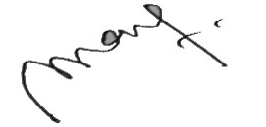

Maria Rio Rita

*)This statement must be upload for supplementary files while submitting your manuscript
or sent back to jurnalbisma@unesa.ac.id

