Artikel
by Kurniawan Pradipta

Submission date: 04-May-2020 09:40AM (UTC+0700)
Submission ID: 1315137906
File name: Kurniawan_Dwi_Pradipta_16080694083_Artikel_S1_3.docx (141.25K)
Word count: 4369
Character count: 23390

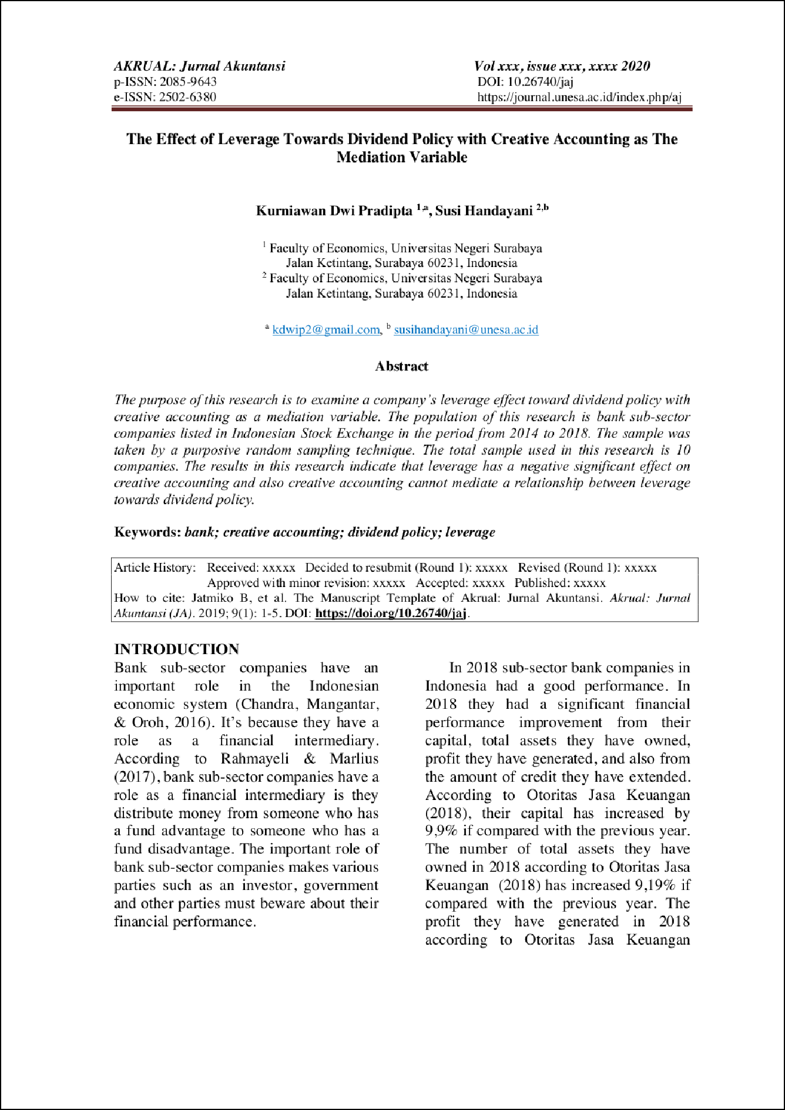

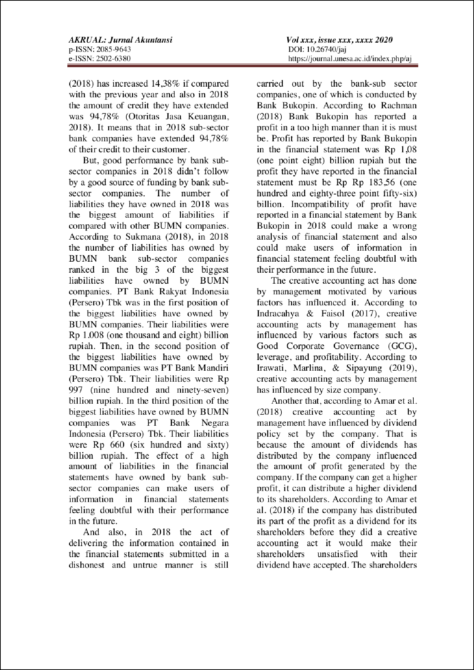

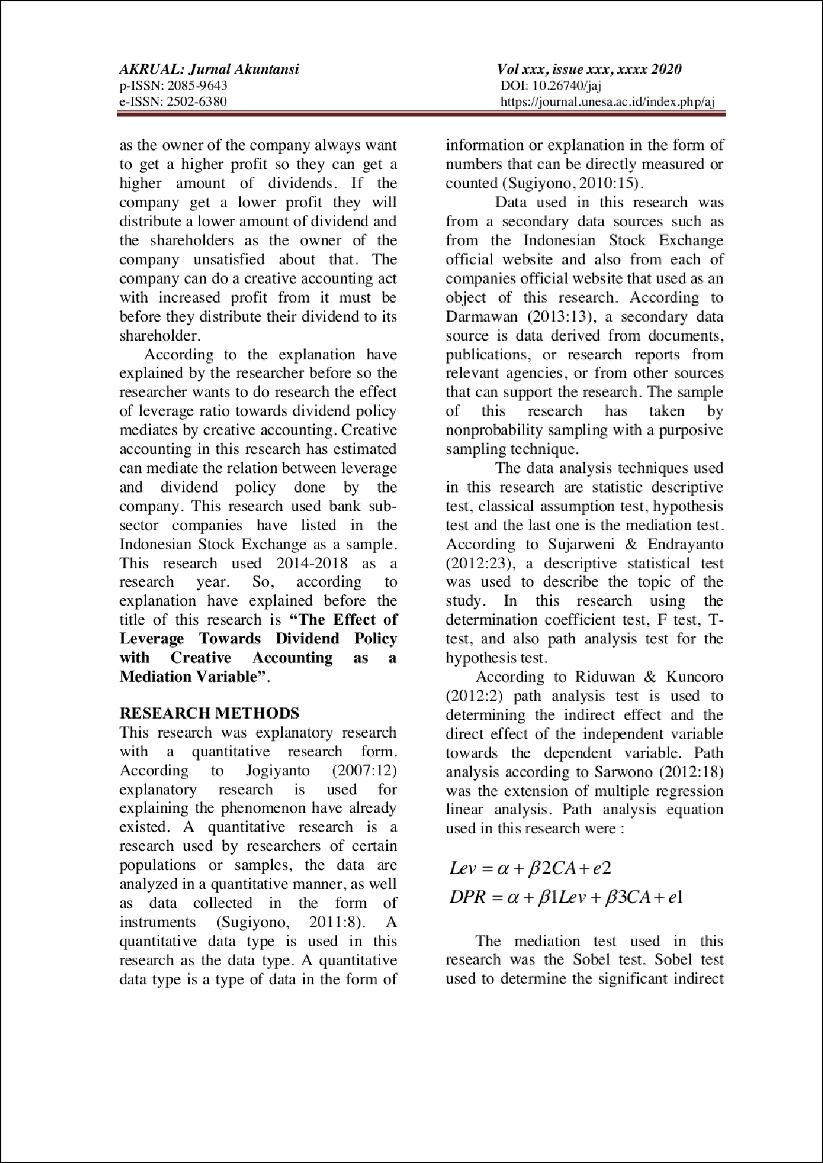

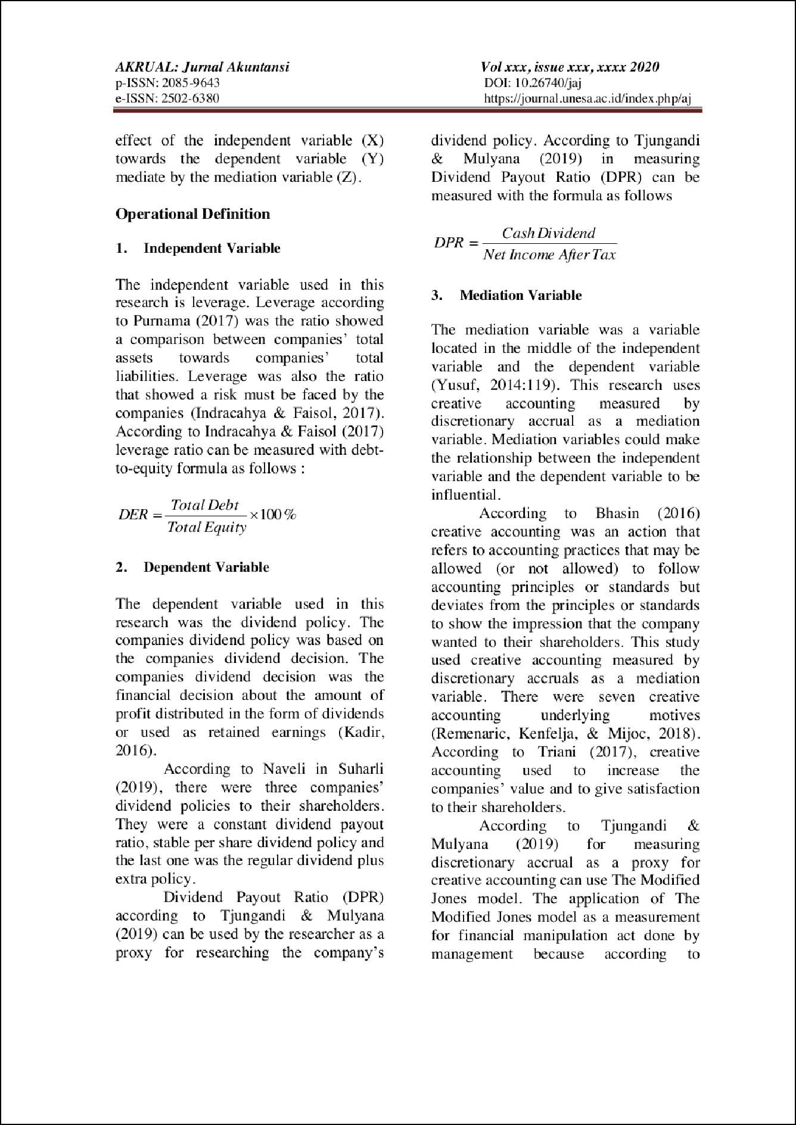

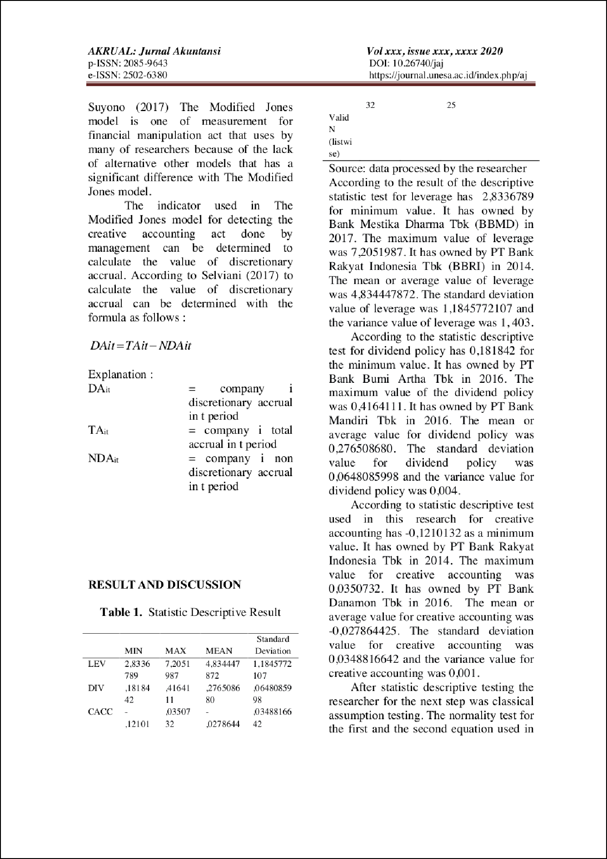

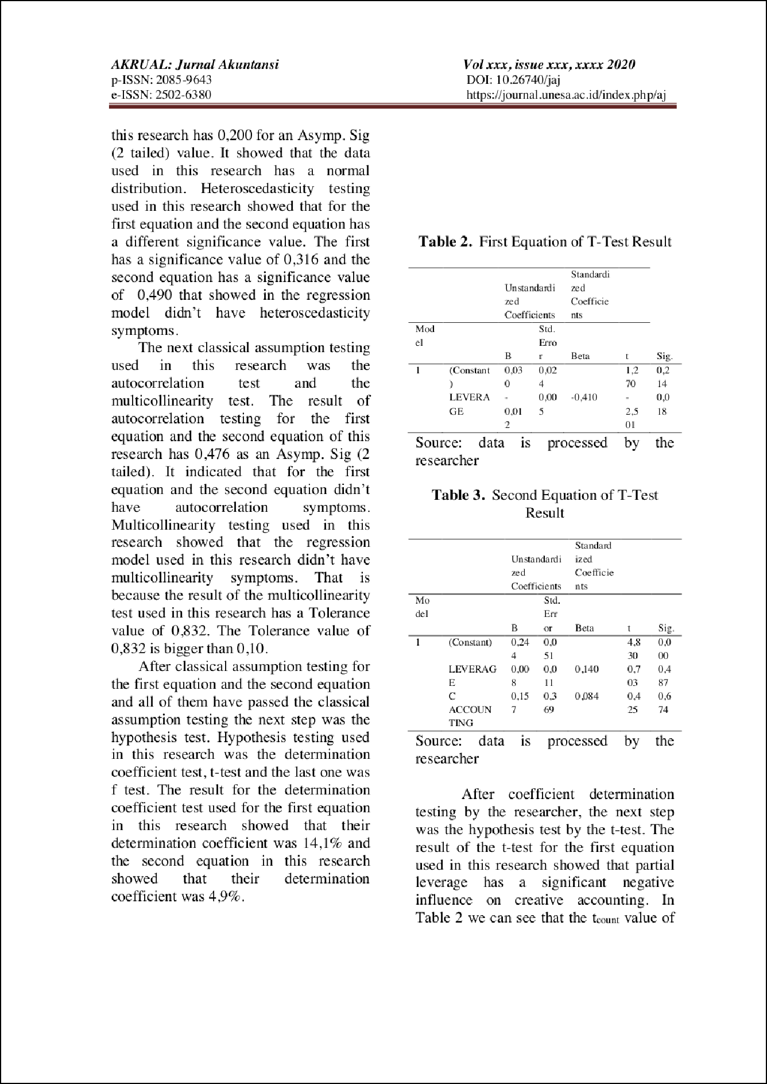

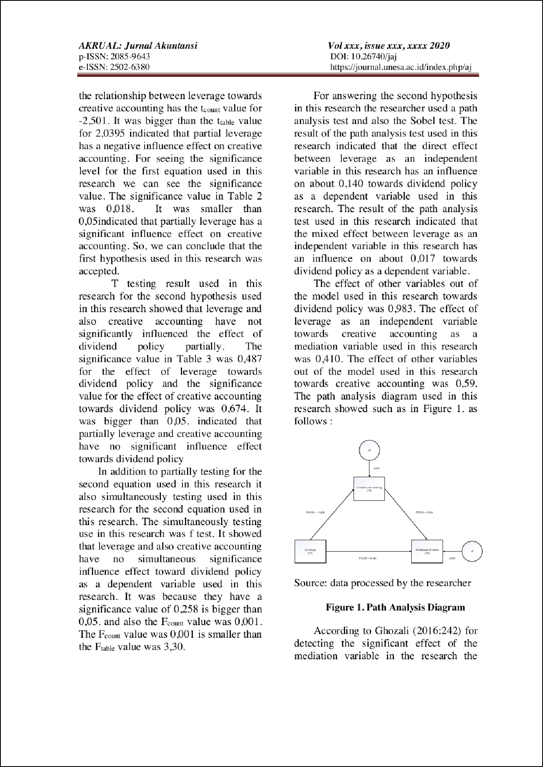

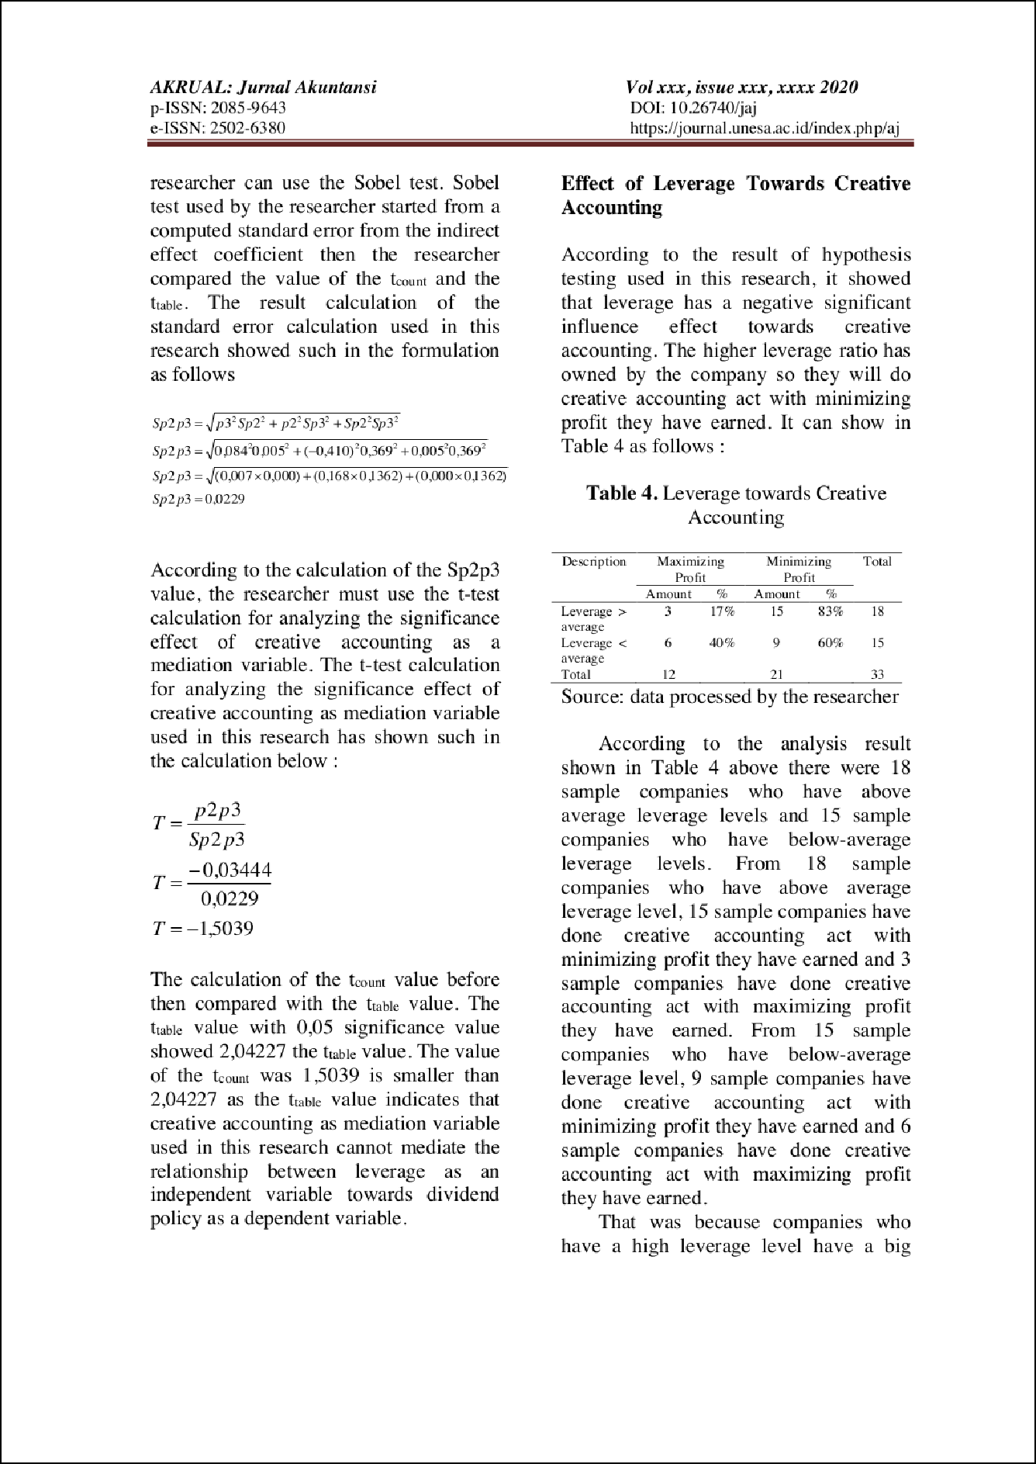

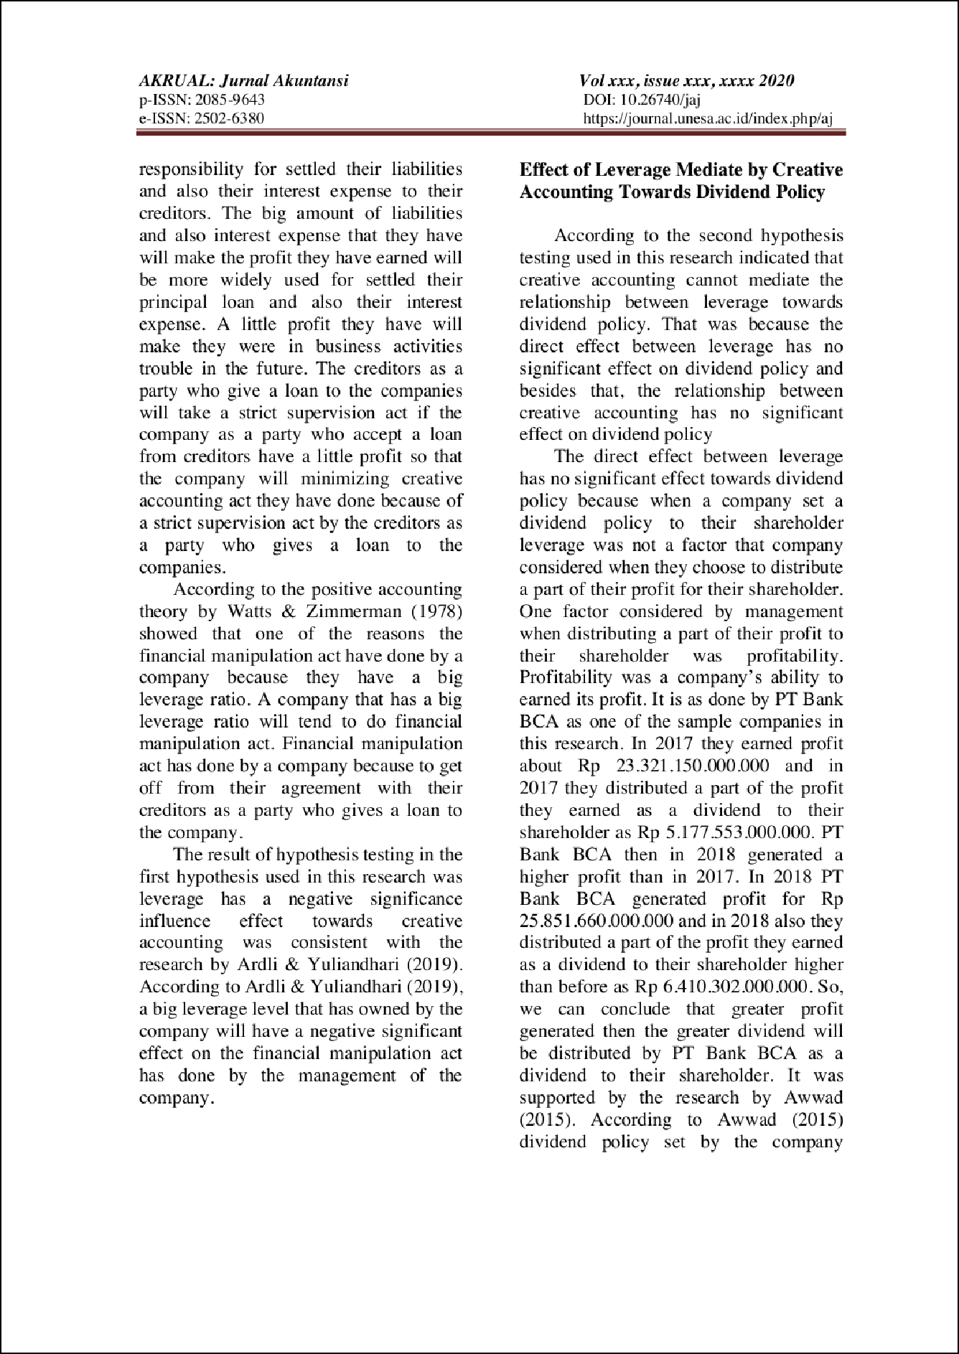

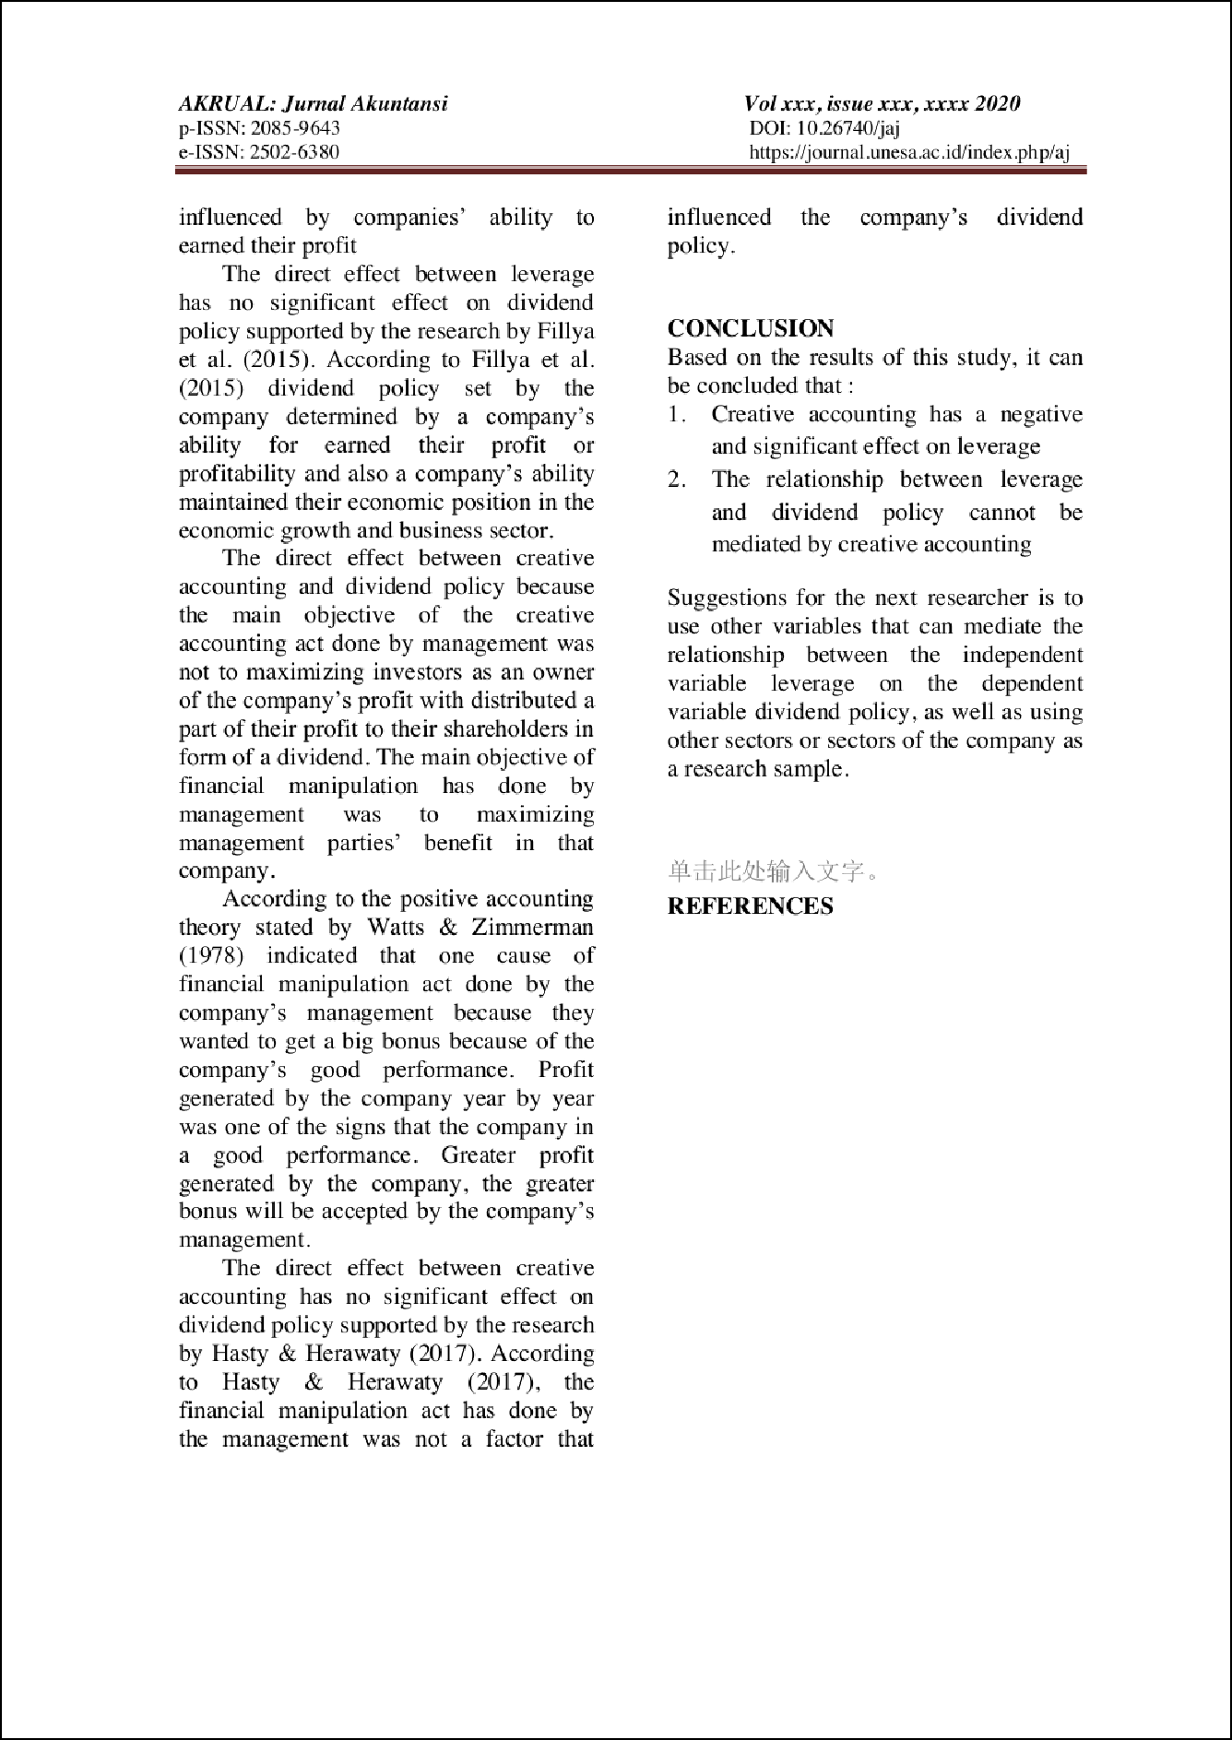

Artikel
ORIGINALITY REPORT
11% | 7% | 1% | 10%
SIMILARITY INDEX | INTERNET SOURCES | PUBLICATIONS | STUDENT PAPERS
PRIMARY SOURCES

Submitted to Universitas Kristen Satya Wacana
1
Student Paper

Submitted to President University
2
Student Paper

www.scribd.com
3
Internet Source

docplayer.net
4
Internet Source

Submitted to Iqra Uninversity, Gulshan
5
Student Paper

Submitted to iGroup
6
Student Paper

Submitted to University of Hull
7
Student Paper

2016.icwsr.org
8
Internet Source

repository.upi.edu
9
Internet Source
5%
1%
1%
1%
<1%
<1%
<1%
<1%
<1%

10 Submitted to Higher Education Commission Pakistan
Student Paper

Submitted to Holborn College
11
Student Paper

journals.sagepub.com
12
Internet Source

Submitted to Erasmus University of Rotterdam
13
Student Paper

garuda.ristekdikti.go.id
14
Internet Source

www.cdcindonesia.com
15
Internet Source

www.krohnechina.com
16
Internet Source

17 Submitted to Management Development Institute Of Singapore
Student Paper

Submitted to University of Plymouth
18
Student Paper

www.jabfm.org
19
Internet Source

20 Submitted to Universitas Katolik Indonesia Atma Jaya
Student Paper
<1%

<1%
<1%
<1%
<1%
<1%
<1%
<1%

<1%
<1%
<1%

Submitted to Taylor’s Education Group
21
Student Paper
<1%

Exclude quotes Off Exclude bibliography Off
Exclude matches Off

Artikel
GRADEMARK REPORT

FINAL GRADE

/25
GENERAL COMMENTS

Instructor

PAGE 1

PAGE 2

PAGE 3

PAGE 4

PAGE 5

PAGE 6

PAGE 7

PAGE 8

PAGE 9

PAGE 10

