Lampiran 1: Data Tabulasi Variabel Capital Buffer (BUFF), Non Performing Financing (NPF), Biaya Operasional Pendapatan Operasional (BOPO), Net Imbalan (NI), Dana Pihak Ketiga (DPK), Gross Domestic Bruto Growth (GDPG) dan inflasi (INF)
BANK | YEAR | CAR | BUFF | NPF | BOPO | NI | DPK | ln_DPK
BNIS | 2014 | 16,26 | 8,26 | 1,04 | 89,8 | 8,01 | 16246000 | 16,60
BNIS | 2015 | 15,48 | 7,48 | 1,46 | 89,63 | 7,63 | 19323000 | 16,78
BNIS | 2016 | 14,92 | 6,92 | 1,64 | 86,88 | 7,72 | 24233000 | 17,00
BNIS | 2017 | 20,14 | 12,14 | 1,5 | 87,62 | 7,58 | 29379000 | 17,20
BNIS | 2018 | 19,31 | 11,31 | 1,52 | 85,37 | 7,16 | 35497000 | 17,38
BMI | 2014 | 13,91 | 5,91 | 4,85 | 97,33 | 3,36 | 51206000 | 17,75
BMI | 2015 | 12 | 4,00 | 4,2 | 97,36 | 4,09 | 45078000 | 17,62
BMI | 2016 | 12,74 | 4,74 | 1,4 | 97,76 | 3,21 | 41920000 | 17,55
BMI | 2017 | 13,62 | 5,62 | 2,75 | 97,68 | 2,48 | 48686000 | 17,70
BMI | 2018 | 12,34 | 4,34 | 2,58 | 98,24 | 2,22 | 45636000 | 17,64
BRIS | 2014 | 12,89 | 4,89 | 3,65 | 99,77 | 6,04 | 16947388 | 16,65
BRIS | 2015 | 13,94 | 5,94 | 3,89 | 93,79 | 6,38 | 20123658 | 16,82
BRIS | 2016 | 20,63 | 12,63 | 3,19 | 91,33 | 6,37 | 22019067 | 16,91
BRIS | 2017 | 20,05 | 12,05 | 4,75 | 95,34 | 5,84 | 26359084 | 17,09
BRIS | 2018 | 29,72 | 21,72 | 4,97 | 95,32 | 5,36 | 28874575 | 17,18
BSM | 2014 | 14,12 | 6,12 | 4,29 | 100,6 | 6,22 | 59810009 | 17,91
BSM | 2015 | 12,85 | 4,86 | 4,05 | 94,78 | 6,54 | 62102378 | 17,94
BSM | 2016 | 14,01 | 3,51 | 3,13 | 94,12 | 6,75 | 69943279 | 18,06
BSM | 2017 | 15,89 | 5,39 | 2,71 | 94,44 | 7,35 | 77896821 | 18,17
BSM | 2018 | 16,26 | 5,76 | 1,56 | 90,68 | 6,56 | 87464524 | 18,29
BPDS | 2014 | 25,69 | 17,69 | 0,29 | 82,58 | 4,38 | 5076082 | 15,44
BPDS | 2015 | 20,3 | 12,30 | 1,94 | 89,29 | 3,82 | 5929057 | 15,60
BPDS | 2016 | 18,17 | 10,17 | 1,86 | 96,17 | 3,49 | 6899200 | 15,75
BPDS | 2017 | 11,51 | 3,51 | 4,83 | 217,4 | 3,13 | 7537792 | 15,84
BPDS | 2018 | 23,15 | 15,15 | 3,84 | 99,57 | 2,36 | 6907639 | 15,75
BCAS | 2014 | 29,6 | 21,60 | 0,1 | 92,9 | 4,2 | 2339506 | 14,67
BANK | YEAR | CAR | BUFF | NPF | BOPO | NI | DPK | ln_DPK
BCAS | 2015 | 34,3 | 26,30 | 0,52 | 92,5 | 4,9 | 3255154 | 15,00
BCAS | 2016 | 36,7 | 28,70 | 0,21 | 92,2 | 4,8 | 3842271 | 15,16
BCAS | 2017 | 29,4 | 21,40 | 0,04 | 87,2 | 4,3 | 4736403 | 15,37
BCAS | 2018 | 24,3 | 16,30 | 0,28 | 87,4 | 4,4 | 5506106 | 15,52
BJBS | 2014 | 15,78 | 7,78 | 3,87 | 91,01 | 8,34 | 4622231 | 15,35
BJBS | 2015 | 22,53 | 14,53 | 4,45 | 98,78 | 5,68 | 4702474 | 15,36
BJBS | 2016 | 18,25 | 10,25 | 4,94 | 122,77 | 5,16 | 5453389 | 15,51
BJBS | 2017 | 16,25 | 8,25 | 2,85 | 134,63 | 4,68 | 5977833 | 15,60
BJBS | 2018 | 16,43 | 8,43 | 1,96 | 94,63 | 5,36 | 5182147 | 15,46
BSB | 2014 | 14,8 | 6,80 | 3,34 | 96,77 | 2,75 | 3994957 | 15,20
BSB | 2015 | 16,31 | 8,31 | 2,74 | 91,99 | 3,14 | 4756304 | 15,37
BSB | 2016 | 15,15 | 7,15 | 4,66 | 109,62 | 3,31 | 5442607 | 15,51
BSB | 2017 | 19,2 | 11,20 | 4,18 | 99,2 | 2,44 | 5498424 | 15,52
BSB | 2018 | 19,31 | 11,31 | 3,65 | 99,45 | 3,17 | 4543665 | 15,33
BMS | 2014 | 19,26 | 11,26 | 1,81 | 97,61 | 8,33 | 5881056 | 15,59
BMS | 2015 | 18,74 | 10,74 | 3,16 | 99,51 | 9,34 | 4354545 | 15,29
BMS | 2016 | 23,53 | 15,53 | 2,81 | 88,16 | 7,56 | 4973126 | 15,42
BMS | 2017 | 22,19 | 14,19 | 2,75 | 89,16 | 6,03 | 5103099 | 15,45
BMS | 2018 | 20,54 | 12,54 | 1,96 | 93,84 | 5,52 | 5723208 | 15,56
MBS | 2014 | 52,13 | 44,13 | 4,29 | 69,62 | 6,65 | 1043046 | 13,86
MBS | 2015 | 38,4 | 30,40 | 4,93 | 192,6 | 6,54 | 938982 | 13,75
MBS | 2016 | 55,06 | 47,06 | 4,6 | 160,28 | 4,99 | 714716 | 13,48
MBS | 2017 | 75,83 | 67,83 | 0 | 83,36 | 8,79 | 561510 | 13,24
MBS | 2018 | 163,07 | 155,1 | 0 | 199,97 | 18,28 | 17 | 2,83
BVS | 2014 | 15,27 | 7,27 | 4,75 | 143,31 | 3,34 | 1132086 | 13,94
BVS | 2015 | 16,14 | 8,14 | 4,82 | 119,19 | 2,8 | 1151057 | 13,96
BVS | 2016 | 15,98 | 7,98 | 4,35 | 131,34 | 2,63 | 1235931 | 14,03
BVS | 2017 | 19,29 | 11,29 | 4,08 | 96,02 | 2,85 | 1532758 | 14,24
BVS | 2018 | 22,07 | 14,07 | 3,46 | 96,38 | 2,91 | 1599141 | 14,28
BTPNS | 2014 | 32,8 | 24,80 | 0,87 | 87,8 | 33,29 | 2707504 | 14,81
BANK | YEAR | CAR | BUFF | NPF | BOPO | NI | DPK | ln_DPK
BTPNS | 2015 | 19,9 | 11,90 | 1,25 | 85,8 | 34,31 | 3809967 | 15,15
BTPNS | 2016 | 23,8 | 15,80 | 0,2 | 75,1 | 35,78 | 5387564 | 15,50
BTPNS | 2017 | 28,9 | 20,9 | 0,05 | 68,8 | 35,96 | 6545879 | 15,69
BTPNS | 2018 | 40,9 | 32,9 | 0,02 | 63,4 | 32,42 | 7612114 | 15,85

BNIS = BNI Syariah
BMI = Bank Muamalat Indonesia
BRIS = BRI Syariah
BSM = Bank Syariah Mandiri
BPDS = Bank Panin Dubai Syariah
BCAS = BCA Syariah
BJBS = Bank Jabar Banten Syariah
BSB = Bank Syariah Bukopin
BMS = Bank Mega Syariah
MBS = Maybank Syariah
BVS = Bank Victoria Syariah
BTPNS = Bank Tabungan Pensiunan Nasional Syariah

Lampiran 2: Data Variabel Makroekonomi
YEAR | GDPG | INF
2014 | 5,01 | 8,36
2015 | 4,88 | 3,35
2016 | 5,03 | 3,02
2017 | 5,07 | 3,61
2018 | 5,17 | 3,13

GDPG = Grost Domestic Bruto Growth
INF = Inflasi

Lampiran 3: Hasil Deskriptif Variabel
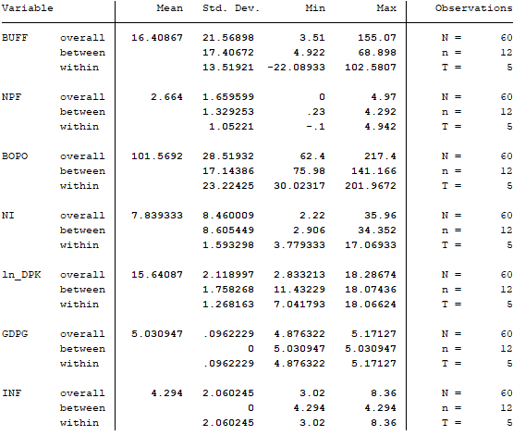

Lampiran 4: Hasil Uji Regresi Data Panel Menggunakan CEM

Lampiran 5: Hasil Uji Regresi Data Panel Menggunakan FEM

Lampiran 6: Hasil Uji Regresi Data Panel Menggunakan REM

Lampiran 7: Hasil Uji Chow

Lampiran 8: Hasil Uji Hausman

Lampiran 9: Grafik Uji Normalitas
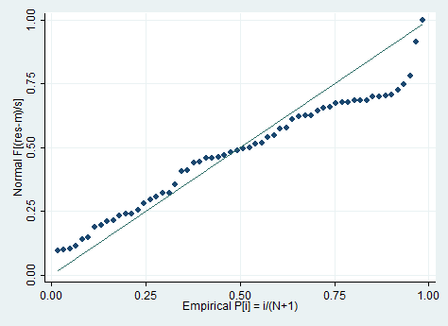
Lampiran 10: Uji Multikolinearitas
Lampiran 11: Hasil Uji Generalize Least Square (GLS)

Lampiran 12: Hasil Uji Robbustnes Test 1 (4 variabel)
Lampiran 13: Hasil Uji Robbustnes Test 2 (hanya variabel mikroekonomi)

