OUTPUT PRETEST DAN POSTTEST
VERSI SPSS 26.0

- Data Pretest
- Uji Homogenitas

Test of Homogeneity of Variances
nilai pritest
Levene Statistic | df1 | df2 | Sig.
.012 | 1 | 57 | .913

- Uji Normalitas

[DataSet1] D:\Dinna bLandina\^-)\laporan ppl\tugas kuliah\siap S.Pd\b punk\priest normalitasss.sav

Tests of Normality
 | Kolmogorov-Smirnovª |  |  | Shapiro-Wilk
 | Statistic | df | Sig. | Statistic | df | Sig.
X | .192 | 30 | .006 | .910 | 30 | .015
Y | .163 | 30 | .041 | .919 | 30 | .025
a. Lilliefors Significance Correction

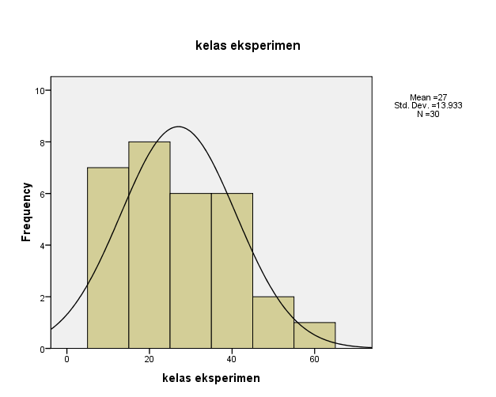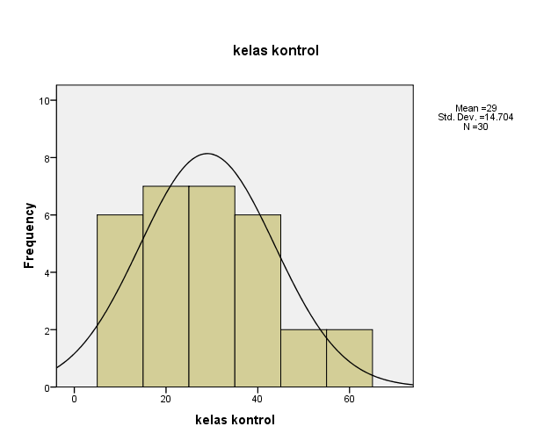

- Uji t

[DataSet1] D:\Dinna bLandina\^-)\laporan ppl\tugas kuliah\siap S.Pd\b punk\pritests homogenitas.sav

Independent Samples Test
 |  |  |  | Nilai_Pretest
 |  |  |  | Equal variances assumed | Equal variances not assumed
 | Levene's Test for Equality of Variances | F |  | .004
 |  | Sig. |  | .948
 | t-test for Equality of Means | t |  | -.541 | -.541
 |  | df |  | 58 | 57.833
 |  | Sig. (2-tailed) |  | .591 | .591
 |  | Mean Difference |  | -2.000 | -2.000
 |  | Std. Error Difference |  | 3.698 | 3.694
 |  | 95% Confidence Interval of the Difference | Lower | -9.403 | -9.404
 |  |  | Upper | 5.403 | 5.404

- Data Posttest
- Uji Homogenitas

[DataSet0]

Test of Homogeneity of Variances
Nilai posttes
Levene Statistic | df1 | df2 | Sig.
.730 | 1 | 58 | .396

- Uji Normalitas
[DataSet1] D:\Dinna bLandina\^-)\laporan ppl\tugas kuliah\siap S.Pd\b punk\homogenitas posttes new.sav

Tests of Normality
 | Kolmogorov-Smirnovª |  |  | Shapiro-Wilk
 | Statistic | df | Sig. | Statistic | df | Sig.
Kelas RME | .177 | 30 | .017 | .913 | 30 | .017
Kelas Konvensional | .092 | 30 | .200* | .967 | 30 | .459
a. Lilliefors Significance Correction
*. This is a lower bound of the true significance.

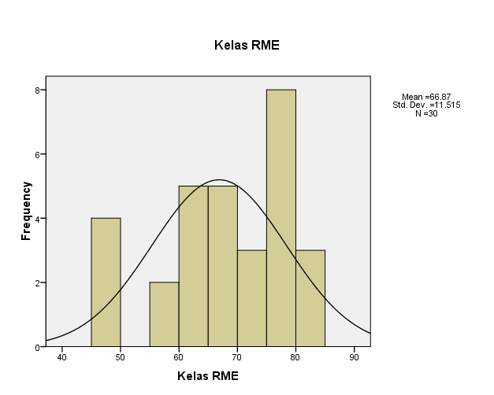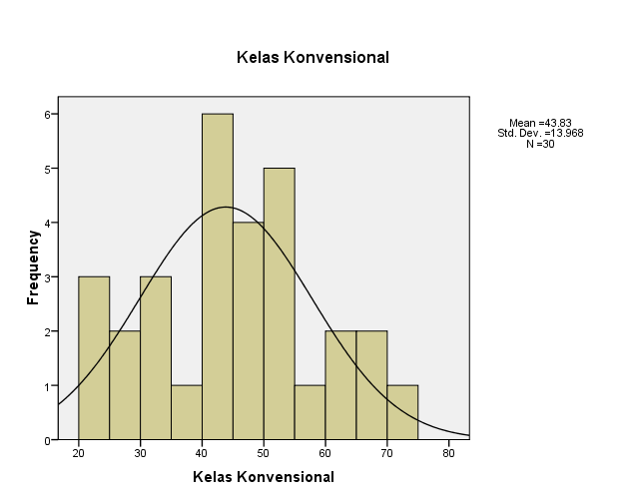

- Uji t
[DataSet1] D:\Dinna bLandina\^-)\laporan ppl\tugas kuliah\siap S.Pd\b punk\data posttes\homogenitas newww.sav

Independent Samples Test
 |  |  | Nilai_Pretest
 |  |  | Equal variances assumed | Equal variances not assumed
Levene's Test for Equality of Variances | F |  | .730
 | Sig. |  | .396
t-test for Equality of Means | t |  | 6.969 | 6.969
 | df |  | 58 | 55.964
 | Sig. (2-tailed) |  | .000 | .000
 | Mean Difference |  | 23.033 | 23.033
 | Std. Error Difference |  | 3.305 | 3.305
 | 95% Confidence Interval of the Difference | Lower | 16.417 | 16.417
 |  | Upper | 29.649 | 29.654

