REPRESENTATION OF WOMEN'S INDEPENDENCE IN FURKY SYAHRONI'S CLIMBING CONTENT ON SOCIAL MEDIA

Zainal Abidin Achmad ¹*, and Anita ²

^{1,2} Department of Communication Science, Faculty of Social Cultural and Political Sciences, Universitas Pembangunan Nasional Veteran Jawa Timur
Jalan Raya Rungkut Madya Gunung Anyar, Surabaya 60294, Indonesia
z.abidinachmad@upnjatim.ac.id

Abstract

This study aims to analyze the representation of women's independence and resilience in Furky Syahroni's social media content, which features her as an Indonesian female climber at the international level. The primary focus of this research is how narrative, visual, and symbolic strategies in TikTok, Instagram, and YouTube video uploads construct the image of women as independent, courageous, and break through gender stereotypes in extreme activities such as mountain climbing. This study uses a qualitative method with a thematic analysis of TikTok, Instagram, and YouTube content by Furky Syahroni during the period 2019–2024. Secondary data were obtained from literature, online interviews, personal blogs, and podcasts featuring Furky Syahroni. The results show that social media has become a new space for women to build a positive, equal identity in the public sphere. Furky Syahroni’s content contains educational, motivational, and courageous messages that can inspire other women to transcend social boundaries. The novelty of this research lies in the study of gender communication on the virtual platform in the context of extreme physical activities. This research contribution enriches the discourse on gender equality in digital media and demonstrates the potential of social media for women's empowerment.

Keywords: Women's Representation; Social Media; Mountain Climbers; Thematic Analysis; Gender Equality.

Abstrak

Penelitian ini bertujuan untuk menganalisis representasi kemandirian dan ketahanan perempuan dalam konten media sosial Furky Syahroni yang menampilkannya sebagai pendaki perempuan Indonesia di tingkat internasional. Fokus utama penelitian ini adalah bagaimana strategi naratif, visual, dan simbolik dalam unggahan video TikTok, Instagram, dan YouTube membangun citra perempuan sebagai sosok yang mandiri, berani, dan mendobrak stereotip gender dalam aktivitas ekstrem seperti mendaki gunung. Penelitian ini menggunakan metode kualitatif dengan pendekatan analisis tematik terhadap konten Furky Syahroni di TikTok, Instagram, dan YouTube selama periode 2019–2024. Data sekunder diperoleh dari literatur, wawancara daring, blog pribadi, dan podcast yang menampilkan Furky Syahroni. Hasil penelitian menunjukkan bahwa media sosial telah menjadi ruang ekspresi baru bagi perempuan untuk membangun identitas yang positif dan setara di ranah publik. Konten Furky Syahroni mengandung pesan-pesan edukatif, motivasi, dan keberanian yang dapat menginspirasi perempuan lain untuk melampaui batasan sosial. Kebaruan penelitian ini terletak pada kajian komunikasi gender di platform virtual dalam konteks aktivitas fisik ekstrem. Kontribusi penelitian ini memperkaya wacana tentang kesetaraan gender di media digital dan menunjukkan potensi media sosial sebagai media pemberdayaan perempuan.

Kata kunci: Representasi Perempuan; Media Sosial; Pendaki Gunung; Analisis Tematik; Kesetaraan Gender.

INTRODUCTION
The development of social media has transformed the way people construct identities, express themselves, and interact globally (Steinke et al., 2024; Steinmetz, 2012). Short-form video platforms like TikTok provide a new space for individuals to showcase personal narratives that combine entertainment, education, and self-representation (Oktaviana et al., 2021). In this context, an interesting phenomenon has emerged in which women use TikTok not only for entertainment but also as a medium for identity affirmation and self-empowerment (Dewantoro et al., 2025). This phenomenon is evident in the activities of Indonesian female creators who engage in extreme pursuits such as mountain climbing. One example is the account @furkyrs, owned by Furky Syahroni, a female climber known for her courage in conquering various mountains around the world while upholding her feminine identity.
Women's participation in extreme physical activities such as mountain climbing is still often viewed as going beyond traditional gender norms in many Asian societies, including Indonesia. These activities are often identified with masculinity, physical strength, and courage, culturally associated with men (Hewitt & McEvilly, 2022). However, through social media, women now have the space to challenge and reconstruct these images. TikTok, as a visual platform, provides opportunities for women to construct alternative narratives of courage and competence (Lee & Lee, 2023; Zahra & Achmad, 2025). The representation of female climbers like Furky Syahroni challenges stereotypes that portray women as weak or dependent (Steinke et al., 2024).
This paradigm shift is inextricably linked to women's increasing participation in digital spaces. According to a report by We Are Social, active TikTok users in Indonesia have reached over 126 million, with more than half being women aged 18–34 (Kemp, 2024). This data demonstrates that women are not only content consumers but also producers of social narratives that influence public opinion. TikTok has become a participatory space that blurs the boundaries between private and public and allows women to redefine their social roles through digital expression (Taylor & Brisini, 2024).
In the climbing context, women's representation faces a dual challenge: on the one hand, physical and natural obstacles, and on the other, negotiating the social image of women. Research by Permadani (2022) and Maulana (2023) shows that society still views solo climbing by women as high-risk and inappropriate. However, through visual narratives uploaded on TikTok, figures like Furky Syahroni reverse this construction by showcasing women's courage, discipline, and spiritual and intellectual capacity in confronting nature. She demonstrates that climbing can symbolize women's struggle against restrictive social boundaries.
This phenomenon is important to examine from the perspectives of gender communication and popular culture, as it illustrates how social media shapes meanings about women in the digital public sphere. Previous research has discussed the representation of women on social media, but most have focused on issues of beauty, lifestyle, and consumption (Dewantoro et al., 2025; Malafitri et al., 2022; Mudianto et al., 2025; Nalio et al., 2024). Meanwhile, research on the representation of women in extreme activities, such as mountain climbing, on social media remains limited, especially in Indonesia. This research gap is what this study aims to fill.
Research by Bhandari and Bimo (2022) found that TikTok's algorithm encourages users to project an "algorithmized self," which sometimes reinforces dominant gender norms. However, recent studies have shown that female creators can negotiate these algorithms to expand their visibility and articulate alternative identities (Obreja, 2024). In the context of the @furkyrs account, educational and inspirational hiking content transcends TikTok's entertainment logic by presenting values ​​of courage, simplicity, and authenticity. This demonstrates how women can adapt to digital culture without losing their identity and values ​​of equality (Lee & Lee, 2023; Nurchasanah & Basit, 2025).
From a communication theory perspective, this phenomenon can be explained through Stuart Hall's (1997) concept of representation and cultural meaning (1997), which holds that the media functions not only as a channel for messages but also as a system of meaning that shapes social reality. In the case of @furkyrs, representations of women emerge not only through visual images or climbing narratives, but also through symbols of resilience, such as the hijab, which is still worn in extreme terrain. This symbol presents a new dimension of Muslim women's agency in a digital public space often dominated by liberal and modern images. Furthermore, Judith Butler's (1988) perspective on gender performativity emphasizes that women's identities are formed through repeated, socially interpreted actions (Morgenroth & Ryan, 2018). Climbing and its documentation become new performative forms of women's courage and presence in the public sphere.
Social media is not only a communication space but also an ideological arena that reproduces and negotiates gender meanings. As a female climber engaging in high-risk activities, Furky Syahroni embodies a new dimension of female independence distinct from mainstream media representations. She emphasizes process, struggle, and resilience rather than glamorous images. This aligns with research by Duffy and Hund (2015), which finds that female creators are now building authentic self-branding through credible, inspiring narratives of physical and social struggles.
The urgency of this research lies in the need to broaden the understanding of women's empowerment through unconventional digital spaces, such as mountain-climbing content imbued with educational and courageous messages. Amid the dominance of shallow entertainment content on TikTok, accounts like @furkyrs demonstrate the platform's potential as an educational and reflective medium. Furthermore, this research provides an empirical contribution to digital communication studies in Indonesia, which remain limited in their examination of gender issues in the realm of extreme activities. The results are expected to enrich academic discourse on digital feminism and serve as a reference for more inclusive communication strategies regarding women's representation.
Conceptually, this research fills the gap between media representation theory and contemporary digital communication practices. While previous research highlighted the role of social media in shaping women's body image (Song et al., 2025), this study examines how women's identities are constructed through physical activity and symbols of courage in the digital space. Thus, this research examines not only the image of women in the media but also their symbolic performance in asserting their existence and social roles.
Based on this explanation, this research positions the @furkyrs account as a representative case study to examine how Indonesian women use TikTok to self-actualize and symbolically resist traditional gender constructs. A qualitative approach with thematic analysis is used to uncover patterns of representation of women's independence, courage, and identity in climbing content. This research is expected to make theoretical contributions to the study of gender communication and practical contributions to understanding the potential of social media as a space for women's empowerment and social transformation.

RESEARCH METHODS
This study uses a qualitative, thematic analysis to examine the representation of women's independence and resilience in the TikTok content of the @furkyrs account. This approach allows researchers to examine the meanings emerging from visual, verbal, and nonverbal symbols within the social and cultural context of digital media (Braun & Clarke, 2022). The study included video content, narrative text, and audience comments uploaded by Furky Syahroni during the period 2019–2024. The primary data consisted of mountain-climbing videos, while the secondary data were obtained from YouTube podcasts, personal blogs, and relevant online news sources. Data selection was carried out using a representativeness strategy, namely selecting content that clearly demonstrates activities that represent women's independence, courage, and active roles in climbing (Guest et al., 2020). Furthermore, researchers reviewed audience responses to understand social perceptions of female climbers in the digital space.
Data collection was conducted through online observation of the TikTok account @furkyrs and other connected social media channels, documentation in the form of screenshots and transcripts of video narratives, and documentation of supporting literature on gender, social media, and mountain climbing. Observations were conducted non-participatory to avoid disrupting the dynamics of digital interactions. All data were coded and thematically categorized (Li et al., 2019; Rysan et al., 2021). The analysis followed six stages according to Braun and Clarke (2021), starting from data familiarization to developing an analytical narrative, to identify patterns of meaning such as independence, courage, spiritual values, and the representation of women in the digital public sphere. Each video and description was analyzed using a combination of visual approaches and narrative discourse to interpret the symbols that shape the identity of female climbers. Data credibility was strengthened through source triangulation between TikTok, YouTube, and personal blogs (Nowell et al., 2017)
The validity of the results was maintained through member checking and an audit trail. At the same time, the principle of trustworthiness—including credibility, transferability, dependability, and confirmability—formed the basis for validating the findings (Lincoln & Guba, 2013). The study's limitations lie in access to primary data, as direct interviews with key subjects were not conducted; instead, it relied on publicly available secondary data. While contextual and limited to a single case study, this research provides an in-depth understanding of how women use digital media as a space for self-representation, empowerment, and resistance to traditional gender constructs. Thematic analysis highlights how visual narratives and social interactions on TikTok shape women's digital identities in the algorithmic era.

RESULTS AND DISCUSSION
This study reveals how women's independence, courage, and spirituality are represented in the TikTok content of Furky Syahroni, an Indonesian mountain climber, on the @furkyrs account. The study found that Furky Syahroni's @furkyrs TikTok account portrays a strong, independent woman through her extreme climbing activities, both at home and abroad. Discussion presents each finding in relation to relevant theories, previous studies, facts, comments, and researchers' reasonable analyses.
In addition to her TikTok account, Furky maintains a personal blog and YouTube channel. Based on observations and thematic analysis of video content, captions, comments, and her personal blog and YouTube channel, she consistently upholds the values ​​of independence, courage, and spirituality for Muslim women in the digital space. Her uploaded content includes documentation of her climbing activities, tutorials on equipment and climbing etiquette, and educational messages about environmental conservation and social responsibility (Figure 1).
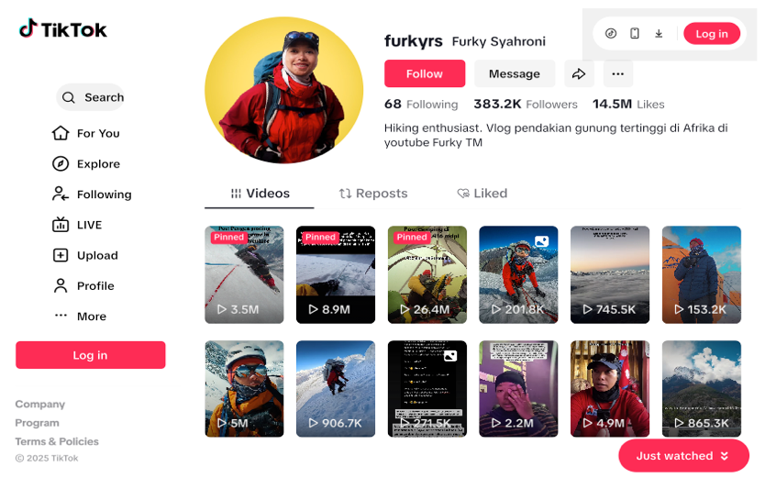
Figure 1 Furky Syahroni’s extreme climbing activities
(Source: TikTok account https://www.tiktok.com/@furkyrs)
Furky Syahroni is widely known as the "international female climber" for her consistent ascent of various mountains around the world, including Mount Kilimanjaro in Africa, which stands at 5,895 meters above sea level (Syahroni, 2020). In her personal blog, she details her climbing experiences, including physical preparation, carrying up to 50 kilograms of camera equipment, and symptoms of Altitude Mountain Sickness (AMS) due to a lack of oxygen at high altitudes (Syahroni, 2019c). These challenges demonstrate a tenacity and dedication that transcends gender boundaries.
Furthermore, Furky showcases the creative process behind her independent content creation without a professional camera operator or editor. She records every moment of her climb herself and edits the videos as a form of personal expression and documentary hobby. This activity demonstrates a woman's work ethic in managing digital technology as a means of self-expression and to demonstrate technical skills (Ibtasam et al., 2019).
Through a qualitative approach with thematic analysis of 25 videos, personal blog posts, and online interviews on her YouTube channel, it was found that the representation of women appearing in Furky's content forms three main themes: (1) Women's resilience and independence in extreme activities, (2) Educational narratives and nature ethics as a form of digital empowerment, and (3) Gender performance and spirituality in Muslim women's self-representation. Each of these themes demonstrates the dynamics of resistance to gender stereotypes, the formation of digital identities, and the dissemination of ethical and spiritual values ​​in social media spaces.
Women's Resilience and Independence in Extreme Activities
Key findings indicate that Furky Syahroni portrays herself as a strong and independent woman through her extreme climbing content across Tanzania, Nepal, and Indonesia. In her video documentation and blog, Furky showcases the physical and mental struggles of mountain climbing, particularly in challenging terrain, extreme temperatures, and health risks such as Altitude Mountain Sickness (AMS), which she experienced while conquering Mount Kilimanjaro (Syahroni, 2019c). This experience demonstrates that women's courage in extreme activities is not merely symbolic but tangible and measurable through physical experience and the ability to survive in the wilderness (Eizmendi-Iraola & Peña-Fernández, 2023).
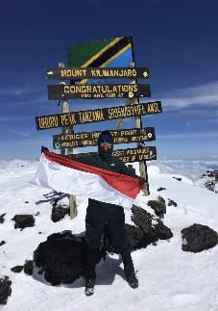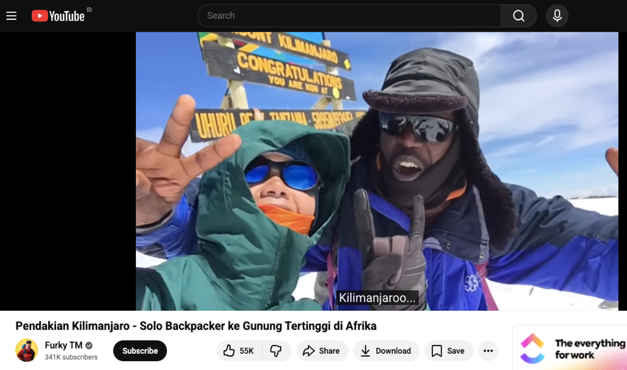
Figure 2 Furky Syahroni conquered Mount Kilimanjaro and documented the climbs herself without the assistance of a professional cameraman
(Source: IG @furkyrs and https://www.youtube.com/watch?v=TMzQkNjBj24)
Furky's independence is evident in the technical process of her climb. She documented the climbs herself without the assistance of a professional cameraman or editor (Figure 2). In several interviews, she explained that she often had to "reset the camera to certain spots" to capture every moment of her journey. This activity not only demonstrates technical tenacity but also the work ethic of a female creator capable of independently combining documentation, visual narrative, and digital promotion. Furky's content has a positive influence on the younger generation by presenting active, strong, and inspiring female figures amid the dominance of male figures in climbing (Harsa, 2024).
Furky's climbs also carry symbolic meaning about women's struggles to overcome social and cultural limitations. Activities such as carrying loads of up to 50 kilograms, managing camera equipment, and refusing to use porters demonstrate a physical independence rarely found in representations of women in the media. According to Hewitt (2022), women's bodily experiences in extreme activities form a new narrative of female resilience, namely the resilience born of the struggle against physical and social limitations.
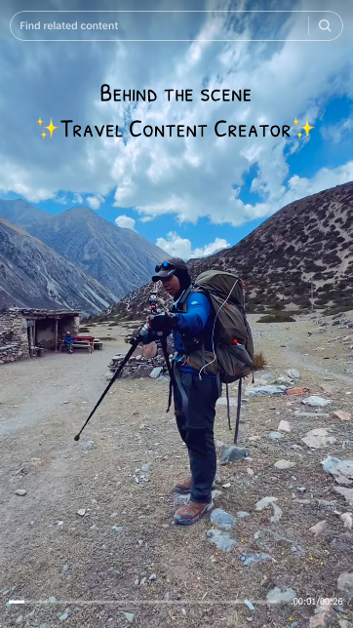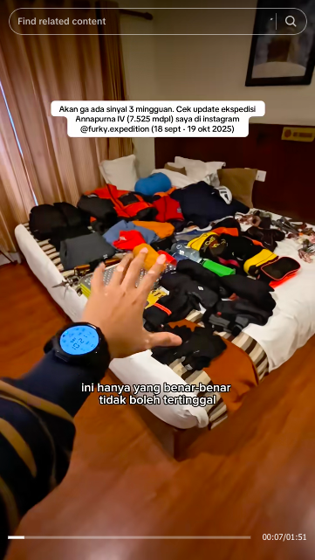
Figure 3. Furky Syahroni manages all her climbing activities, documentation, and content publication by herself
Furky's narrative of resilience also emphasizes that women can become symbols of self-made women in the digital age. She manages all her climbing activities, documentation, and content publication herself, establishing herself as a productive and independent woman in media production structures (Figure 3). This narrative aligns with the findings that female creators are now building authentic self-branding grounded in physical struggle and social values, rather than on glamorous images or body aesthetics (Tifferet & Vilnai-Yavetz, 2018; Zahra & Achmad, 2025).
Furthermore, Furky's courage in solo exploration of the world's mountains also overturns traditional views of women as necessarily under surveillance. She even traveled across the world alone to conquer the peaks of Kilimanjaro, Arjuna, and Welirang, demonstrating courage in transcending geographical and cultural boundaries. This courage affirms Butler's (1988) theory of gender performativity, in which women's identities are shaped through acts that renegotiate social and gender boundaries. In this context, climbing becomes a form of social performance that strengthens women's presence in the public sphere.
This theme demonstrates how social media has become a new space for women to rewrite the meaning of "strong" and "independent." Furky not only physically climbs mountains but also conquers social structures that have traditionally positioned women as passive subjects. In the context of gender communication, she becomes a concrete representation of digital female agency, capable of articulating power through actions and visual symbols.
Furky Syahroni's independence represents women's agency in shaping their narratives in digital media. Her courage in crossing countries alone challenges social stereotypes that position women as weak and dependent. According to Butler's (1990) theory of gender performativity, gender identity is formed through repeated actions. In this context, climbing becomes a performative act that affirms women's courage and autonomy in the public sphere.
Furky's climbing activities also contain profound social and ecological meaning. He emphasizes the importance of maintaining environmental cleanliness, respecting local customs, and building solidarity among climbers. Jumarnies et al. (2024) explain that climbing ethics are inseparable from the region's social norms and customary laws. Respect and concern for the environment are core values ​​consistently instilled in each of his posts.
Furthermore, Sastha (2007) states that mountain climbing is a combination of sport, recreation, and spiritual reflection, as it teaches perseverance, discipline, and cooperation. Furky's narrative aligns with this view: climbing is not just a physical challenge, but also a means of character development. This narrative emphasizes that the representation of women in @furkyrs' content showcases physical and mental strength alongside moral and spiritual values.
Educational Narratives and Nature Ethics as a Form of Digital Empowerment
The second theme highlights the educational dimension of @furkyrs' content, which emphasizes ethical values, safety, and environmental sustainability. Most videos feature tutorials on setting up a tent, selecting equipment, maintaining climbing etiquette, and respecting the customs of local mountain communities (Utami, 2020). This content demonstrates the shift in social media's function from entertainment to education and environmental advocacy.
Furky consistently uses TikTok to spread ecological messages and raise social awareness. She emphasizes the prohibition of littering on hiking trails and the importance of respecting local customs (Figure 4). These messages are delivered in a reflective, easily understood narrative style for a young audience. This narrative aligns with the concept of digital empowerment proposed by Taylor and Brisini (2024), namely, the use of digital space to raise social awareness and encourage public participation in environmental issues.
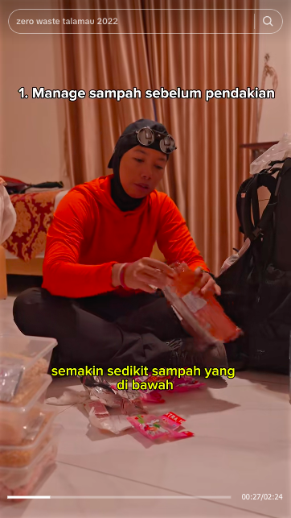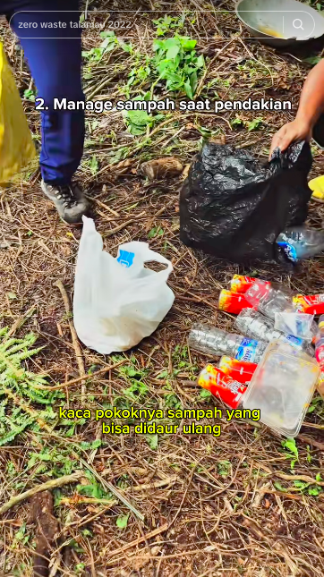
Figure 4. Furky Syahroni demonstrates how to manage waste during climbing
(Source: https://www.tiktok.com/@furkyrs/video/7536955492241788216)
In addition to educational messages, Furky's content also reflects professionalism and discipline in climbing preparation. She frequently showcases the stages of trip planning, route selection, and careful logistical calculations. In several blog posts, she even provides detailed equipment lists and estimated costs for international climbs (Syahroni, 2020). This transparency serves as a practical guide for novice climbers, especially women, in understanding the technical and mental challenges they face.
Audiences responded positively to the educational content. Based on an analysis of comments on postings, many followers described her as an "inspiration" and "a role model for hijab-wearing women who climb with morals and environmental awareness." This narrative demonstrates that Furky's presence on TikTok is not only personal but also transformative for audiences. As Jenkins (2018) explains, social media creates a participatory culture in which users actively construct shared meaning through digital interactions.
Furthermore, secondary data analysis reveals the important context of TikTok's use in Indonesia. According to We Are Social, TikTok is now the platform with the most active users in the country, particularly among the 18–34 age group (Kemp, 2024). This narrative makes the platform effective for disseminating visual educational content, such as Furky's. However, several studies warn that TikTok can also have ethical implications for the younger generation if not used wisely (Arjuna et al., 2024; Friska et al., 2025; Nahla et al., 2024). Therefore, Furky's strategy of presenting positive content is a strategic step in balancing the flow of entertainment content with moral and educational values.
This theme also demonstrates the connection between ecological values ​​and gender equality. When Furky presents a message of nature conservation, she also expands the meaning of care from a feminist perspective—that women have a moral role to protect the earth as our shared home (Gaard, 2015). This narrative strengthens the connection between ecofeminism and digital communication, making climbing content a space for articulating humanitarian and sustainable values.
Furky's educational approach extends beyond technical climbing knowledge to include social responsibility, ethics, and cross-gender solidarity. She transforms social media into more than just a platform for image-building, but also a space for moral learning that unites spiritual and ecological values in concrete action.
Gender Performance and the Representation of Muslim Women's Spirituality
The third theme highlights how Furky Syahroni presents her identity as a hijab-wearing Muslim woman in the context of extreme activities. In each piece of content, the hijab is a consistent visual element that symbolizes morality, spiritual commitment, and personal integrity. Many audience comments highlight Furky's consistency in wearing the hijab despite extreme conditions, such as storms, scorching heat, and climbing to heights of thousands of meters. In a YouTube interview, she emphasized that "removing the hijab for the sake of climbing comfort is not a logical choice" because, for her, the hijab is part of her identity, not a burden.
This performance aligns with the theory of gender performativity, in which gender identity is formed through repeated, socially interpreted actions (Morgenroth & Ryan, 2018). In this case, Furky's act of climbing while wearing a hijab represents the formation of new meanings for the modern Muslim woman: religious, strong, and active in public spaces (Akou, 2010). This phenomenon is a form of digital agency, namely the capacity of Muslim women to negotiate religious identity and modernity in digital media spaces (Khelsea et al., 2021; Nurchasanah & Basit, 2025).
The spirituality in Furky's content emerges not only through the hijab symbol but also through the reflective narratives she writes in captions and on her personal blog. She often expresses gratitude for God's majesty while atop mountains, interpreting the climb as a spiritual journey that connects humans with nature and the Creator. This narrative reinforces Hotait and El-Sayed's (2025) view that TikTok can be a space for spiritual expression where users channel religious reflections through authentic short videos.
Interestingly, Furky's spirituality is not normative, but transformative. She displays a religiosity that is inclusive, open, and connected to physical experience. The hijab is not a boundary, but rather a bridge between faith and action. In this context, she represents plural femininities (Brownell & Wasserstrom, 2003), namely the diversity of Muslim women's expressions in the digital space that transcends single stereotypes of piety or submission (Evolvi, 2019).
Furthermore, Furky's spiritual and social experiences highlight important aspects of gender equality in Indonesia. She successfully gained the support of her family and community to undertake an extreme cross-country journey, a journey that is still culturally taboo for women. This narrative indicates a shift in social values ​​and acceptance of independent women in the public sphere (Steinke et al., 2024). Through her content, Furky also teaches how communication with family and the ethics of permission are part of an independent woman's moral journey.
The spiritual and gender performances in Furky's content form a bridge between piety, courage, and modernity. She demonstrates that being a Muslim woman who wears the hijab is not a barrier to achievement, but rather a source of moral energy to overcome challenges (Figure 5). This representation is crucial in building a new paradigm for Indonesian women who are both religious and progressive in the digital age.
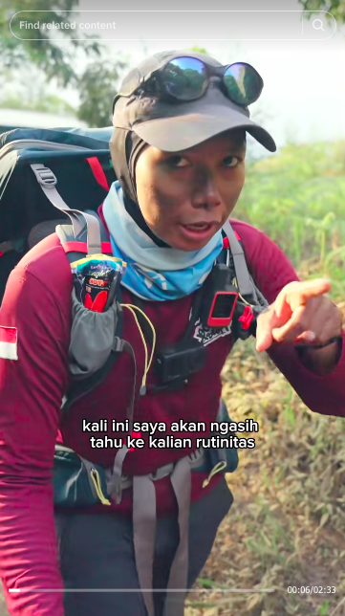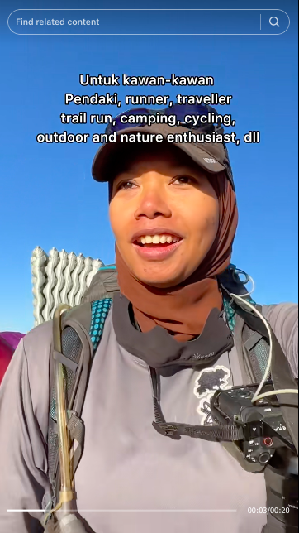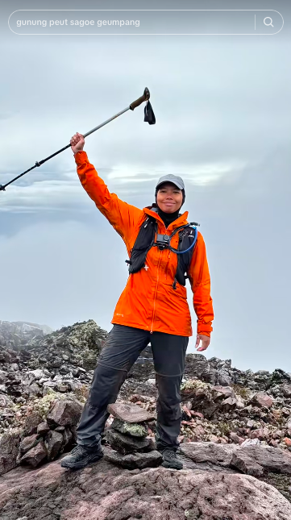
Figure 5. Furky's consistency in wearing the hijab despite extreme conditions
In all her content, Furky Syahroni consistently wears a hijab and rejects the notion that the hijab hinders extreme activities. She emphasizes that removing the hijab for the sake of climbing comfort is not a rational choice, as the hijab has become an inherent identity and spiritual principle (Syahroni, 2019a). Here, the hijab serves not only as a religious symbol but also as a representation of the moral strength and courage of modern Muslim women.
Furky's attitude demonstrates the integration of religiosity and courage in the digital space. This narrative aligns with the concept of Muslim women's digital agency, which utilizes media to build a positive image, educate audiences, and affirm spiritual values ​​within modern practices (Zhao & Abidin, 2021). Thus, the spirituality she promotes is not passive, but relatively active and productive in shaping a new identity for Muslim women on social media (Inhorn et al., 2020).
In his personal blog, Furky interprets every climb as a spiritual journey that connects humans with God and nature (Syahroni, 2019b). She cites gratitude as the essence of climbing, where each step toward the summit reflects life's struggles. His experience facing a storm on Mount Arjuno, including the mystical events he experienced, demonstrates a spiritual awareness that inner strength and faith are the primary assets for every climber. Thus, the climbing experience symbolizes the balance among the physical, mental, and spiritual.
Digital Media as a Space for Resistance and Gender Education
These three themes demonstrate that @furkyrs' TikTok content is not merely personal entertainment but also an arena for the production of complex social meanings. Through climbing, education, and spirituality, Furky Syahroni constructs the image of women as active subjects capable of controlling their own narratives in the digital space. He asserts that social media can be a space for resistance against patriarchal gender structures.
Theoretically, the results of this study support Stuart Hall’s view of media as a system of representation that shapes social reality Hall's (Davis, 2004). Furky's representation of women is not a product of traditional mass media construction, but instead emerges from personal agency, utilizing algorithms and interactive audiences to expand influence. From a contemporary digital communications perspective, this research reinforces the argument that female creators can now leverage algorithmic awareness to negotiate visibility and champion authentic narratives on digital platforms (Obreja, 2024).
This research demonstrates that TikTok has the potential to be an educational and reflective medium, not just a means of quick entertainment. Figures like Furky Syahroni demonstrate that the public can widely accept content that combines moral, intellectual, and spiritual values. With 191,000 followers and positive interactions on every post, the @furkyrs account demonstrates how female representation can inspire across generations and cultures.
Furky Syahroni's presence on TikTok demonstrates that social media can serve as a new space for women's representation, affirming their roles and contributions in society. Song et al. (2025) note that social media is now an effective means of information and education, especially for the younger generation. In this context, the @furkyrs account serves as a public learning space where ecological education, courage, and women's morality are visually displayed and inspiring.
Although TikTok is often criticized for its negative impact on users' concentration and ethics (Palevi, 2024; Zahrotun Nahla et al., 2024), Furky demonstrates that the platform can be used productively. She transforms an entertainment space into an educational one, where women have the autonomy to determine the messages and values ​​they disseminate. In this regard, Furky's representation demonstrates that social media is not merely a narcissistic arena, but also a vehicle for moral and social communication.
Furky's success in attracting 191,000 followers on TikTok demonstrates how digital algorithms can be strategically used to spread positive messages. Through content that emphasizes a spirit of independence and a love of nature, she has successfully inspired many young women to transcend social and geographical boundaries bravely. In line with Hall's (1997) theory of representation, media not only reflect reality but also shape it. Thus, @furkyrs' content creates a new social reality of empowered, religious, and progressive Indonesian women.

CONCLUSION
This study concludes that the representation of women in the climbing content of the TikTok account @furkyrs demonstrates the transformation of Indonesian women's identity from a passive image to an active, independent, and spiritual figure. Furky Syahroni utilizes social media to demonstrate women's resilience and courage in a previously male-dominated space for extreme activities. Through her climbing documentation, she constructs a narrative of gender equality rooted in personal experience, ecological awareness, and religious values, reinforcing women's image as moral and social agents.
Theoretically, this study reinforces Stuart Hall's thinking on representation and Judith Butler's on gender performativity, which asserts that women's identities are constructed through repeated actions and expressions in the digital public sphere. Social media, particularly TikTok, has proven to be a participatory space that offers women opportunities to articulate their identities and aspirations without the constraints of space, class, or culture. Furky's content blends visual aesthetics, educational messages, and symbols of courage, forming a new discourse on women's roles in the digital age.
This study recommends that similar studies be developed using digital ethnographic approaches and multimodal analysis to understand the interplay between gender, ecology, and digital culture in Indonesia. Collaboration among academics, content creators, and educational institutions is also needed to expand digital literacy with a gender-equality and environmental-sustainability perspective. This way, social media can further serve as a platform for empowerment, self-reflection, and social learning for Indonesia's young women.

REFERENCES
Akou, H. M. (2010). Interpreting Islam through the Internet: Making sense of hijab. Contemporary Islam, 4(3), 331–346. https://doi.org/10.1007/S11562-010-0135-6
Arjuna, B., Mulyadi, B. S., Asardan, M. H., Adristina, N., Sekarwangi, N., Ardana, R. A. Z., Hanafi, R., & Khaerani, S. (2024). Pengaruh Algoritma Rekomendasi terhadap Personalisasi Konten Digital di TikTok pada Mahasiswa Sistem Informasi UNNES. Jurnal Potensial, 3(1), 117–127.
Bhandari, A., & Bimo, S. (2022). Why’s Everyone on TikTok Now? The Algorithmized Self and the Future of Self-Making on Social Media. Social Media and Society, 8(1). https://doi.org/10.1177/20563051221086241
Braun, V., & Clarke, V. (2021). To saturate or not to saturate? Questioning data saturation as a useful concept for thematic analysis and sample-size rationales. Qualitative Research in Sport, Exercise and Health, 13(2), 201–216. https://doi.org/10.1080/2159676X.2019.1704846
Braun, V., & Clarke, V. (2022). Thematic analysis : a practical guide. 338.
Brownell, S., & Wasserstrom, J. N. (2003). Introduction: Theorizing Femininities and Masculinities. In Chinese Femininities/Chinese Masculinities (pp. 1–17). University of California Press. https://doi.org/https://doi.org/10.1525/9780520935303-003
Butler, J. (1988). Performative Acts and Gender Constitution: An Essay in Phenomenology and Feminist Theory. Theatre Journal, 40(4), 519–531.
Davis, H. (2004). Understanding Stuart Hall. SAGE Publications Ltd. https://www.perlego.com/book/862122/understanding-stuart-hall-pdf
Dewantoro, A. Z., Achmad, Z. A., & Arviani, H. (2025). Tan Skin Branding on TikTok Account @skinofmeid: Challenge to Dominant Beauty Narratives. Translitera : Jurnal Kajian Komunikasi Dan Studi Media, 14(1), 107–121. https://doi.org/10.35457/TRANSLITERA.V14I1.4520
Duffy, B. E., & Hund, E. (2015). “Having it All” on Social Media: Entrepreneurial Femininity and Self-Branding Among Fashion Bloggers. Social Media and Society, 1(2). https://doi.org/10.1177/2056305115604337;PAGE:STRING:ARTICLE/CHAPTER
Eizmendi-Iraola, M., & Peña-Fernández, S. (2023). Gender Stereotypes Make Women Invisible: The Presence of Female Scientists in the Media. Social Sciences, 12(1). https://doi.org/10.3390/SOCSCI12010030
Evolvi, G. (2019). The veil and its materiality: Muslim women’s digital narratives about the burkini ban. Journal of Contemporary Religion, 34(3), 469–487. https://doi.org/10.1080/13537903.2019.1658936
Friska, F., Arni, A., & Riyadi, I. (2025). Pengaruh Intensitas Konten Tiktok Terhadap Kesehatan Mental Mahasiswa Generasi Z (Studi Kuantitatif pada FISIP Universitas Muhammadiyah Makassar). Jurnal Komunikasi Dan Organisasi (J-KO), 7(2), 77–88.
Gaard, G. (2015). Ecofeminism and climate change. Women’s Studies International Forum, 49, 20–33. https://doi.org/10.1016/J.WSIF.2015.02.004
Guest, G., Namey, E., & Chen, M. (2020). A simple method to assess and report thematic saturation in qualitative research. PLoS ONE, 15(5). https://doi.org/10.1371/JOURNAL.PONE.0232076
Hall, S. (1997). Introduction. In S. Hall (Ed.), Representation: Cultural Representations and Signifying Practices (pp. 1–13). Sage Publications and The Open University. https://psycnet.apa.org/record/1997-36930-000
Harsa, R. (2024). Gue Salut Banget Sama Pendaki Wanita Ini - Furky Syahroni | Podcast BBM - YouTube. YouTube @rikasharsaofficial. https://www.youtube.com/watch?v=Gq6s635RkwY
Hewitt, J. R., & McEvilly, N. (2022). ‘I didn’t realise the variety of people that are climbers’: a sociological exploration of young women’s propensities to engage in indoor rock climbing. Leisure Studies, 41(4), 559–572. https://doi.org/10.1080/02614367.2021.2006280;WGROUP:STRING:PUBLICATION
Hotait, N., & El-Sayed, F. (2025). Beyond the hijab: Performing religious identity on TikTok. Social Compass, 72(2 Special Issue), 204–220. https://doi.org/10.1177/00377686251340897
Ibtasam, S., Razaq, L., Ayub, M., Webster, J. R., Ahmed, S. I., & Anderson, R. (2019). “My cousin bought the phone for me. I never go to mobile shops.”: The role of family in women’s technological inclusion in Islamic culture. Proceedings of the ACM on Human-Computer Interaction, 3(CSCW). https://doi.org/10.1145/3359148
Inhorn, M. C., Birenbaum-Carmeli, D., Vale, M. D., & Patrizio, P. (2020). Abrahamic traditions and egg freezing: Religious Women’s experiences in local moral worlds. Social Science and Medicine, 253. https://doi.org/10.1016/J.SOCSCIMED.2020.112976
Jenkins, H. (2018). Fandom, Negotiation, and Participatory Culture. In P. Booth (Ed.), A Companion to Media Fandom and Fan Studies. https://doi.org/doi.org/10.1002/9781119237211.ch1
Jumarnies, J., Citra, M., Maria, N., Widiana, S., Wati, S. R., & Utamidewi, W. (2024). Sensation Seeking Bagi Pendaki Wanita. Jurnal Review Pendidikan, Psikologi, Dan Pengajaran, 7(3), 7688–7695.
Kemp, S. (2024). Digital 2024: Indonesia. In datareportal.com. https://datareportal.com/reports/digital-2024-indonesia
Khelsea, Y. O., Achmad, Z. A., Tranggono, D., & Claretta, D. (2021). Etnografi Virtual Perilaku Impulsive Buying Remaja Muslimah Penggemar K-Pop di Surabaya. Jurnal Komunikasi Islam, 11(02), 264–289. https://doi.org/10.15642/JKI.2021.11.02.264-289
Lee, J. J., & Lee, J. (2023). #StopAsianHate on TikTok: Asian/American Women’s Space-Making for Spearheading Counter-Narratives and Forming an Ad Hoc Asian Community. Social Media and Society, 9(1). https://doi.org/10.1177/20563051231157598
Li, E. P. H., Prasad, A., Smith, C., Gutierrez, A., Lewis, E., & Brown, B. (2019). Visualizing community pride: engaging community through photo- and video-voice methods. Qualitative Research in Organization and Management, 14(4), 377–392. https://doi.org/10.1108/QROM-03-2018-1621
Lincoln, Y. S., & Guba, E. G. (2013). The Constructivist Credo (Vol. 1). Left Coast Press, Inc.
Malafitri, N., Zuhri, S., & Achmad, Z. A. (2022). Analisis Resepsi Generasi Z Surabaya Terhadap Standar Kecantikan pada Laki-Laki dalam Iklan MS Glow for Men. Representamen, 8(1), 40–55. http://jurnal.untag-sby.ac.id/index.php/representamen/article/view/6346
Maulana, R. A. (2023). Relasi Kuasa Antara Orangtua dan Anak Perempuan Pendaki Gunung (Studi Kasus: Komunitas Pendaki Gunung (KPG) Regional Depok) [Fakultas Ilmu Sosial dan Ilmu Politik, Universitas Islam Negeri Syarif Hidayatullah Jakarta]. https://repository.uinjkt.ac.id/dspace/handle/123456789/75277
Morgenroth, T., & Ryan, M. K. (2018). Gender Trouble in Social Psychology: How Can Butler’s Work Inform Experimental Social Psychologists’ Conceptualization of Gender? Frontiers in Psychology, 8(1320), 1–9. https://doi.org/10.3389/fpsyg.2018.01320
Mudianto, C. D. P., Aini, H. N., & Achmad, Z. A. (2025). Reizuka Ari’s Narrative Strategies and Their Impact on Teenage Girls’ Consumption on TikTok. Lentera: Journal of Gender and Children Studies, 5(1), 403–424. https://journal.unesa.ac.id/index.php/JOFC/article/view/40349/13550
Nahla, Z., Setiawan, B., & Nabila, A. F. (2024). Dampak Tiktok Terhadap Penurunan Etika Generasi Muda. CENDEKIA: Jurnal Ilmu Sosial, Bahasa Dan Pendidikan, 4(2), 136–148.
Nalio, O. E., Octavianti, M., & Nurfadila, F. (2024). Kredibilitas Beauty Influencer dalam Membentuk Minat Beli Followers. Sintesa: Jurnal Ilmiah Kajian Komunikasi, 3(2), 84–102.
Nowell, L. S., Norris, J. M., White, D. E., & Moules, N. J. (2017). Thematic Analysis: Striving to Meet the Trustworthiness Criteria. International Journal of Qualitative Methods, 16(1), 1–13. https://doi.org/10.1177/1609406917733847
Nurchasanah, N., & Basit, A. (2025). Muslim Women in the Digital Age: Between Representation and Reality in the Islamic Digital Media Landscape. International Journal of Social Science and Human Research, 08(06). https://doi.org/10.47191/IJSSHR/V8-I6-50
Obreja, D. M. (2024). Bridging awareness and resistance: Using algorithmic knowledge against controversial content. Big Data & Society, 11(4), 1–13. https://doi.org/10.1177/20539517241296046
Oktaviana, M., Achmad, Z. A., Arviani, H., & Kusnarto, K. (2021). Budaya komunikasi virtual di Twitter dan Tiktok: Perluasan makna kata estetik. Satwika: Kajian Ilmu Budaya Dan Perubahan Sosial, 5(2), 173–186. https://doi.org/10.22219/satwika.v5i2.17560
Permadani, F. D., & Jannah, M. (2022). Relationship Between Sensation Seeking and Risk-Taking Behavior on Mountain Climber. JUARA: Jurnal Olahraga, 7(2), 342–354. https://doi.org/10.33222/juara.v7i2.1661
Rysan, R. M., Alamiyah, S. S., Claretta, D., & Achmad, Z. A. (2021). Etnografi virtual kritik satire video YouTube’s Got Talent di kanal Skinnyindonesian24. Translitera: Jurnal Kajian Komunikasi Dan Studi Media, 10(2), 44–60.
Sastha, H. B. (2007). Mountain climbing for everybody: panduan mendaki gunung. Hikmah. https://books.google.co.id/books?id=6uA6WaTPnBAC&printsec=frontcover&hl=id#v=onepage&q&f=false
Song, S., Adnan, H. M., & Ibrahim, M. S. (2025). The impact of functionality-focused social media images on positive body image: an experimental study among young Chinese women. Frontiers in Communication, 10. https://doi.org/10.3389/FCOMM.2025.1623759/FULL
Steinke, J., Gilbert, C., Coletti, A., Levin, S. H., Suk, J., & Oeldorf-Hirsch, A. (2024). Women in STEM on TikTok: Advancing Visibility and Voice Through STEM Identity Expression. Social Media and Society, 10(3), 1–16. https://doi.org/10.1177/20563051241274675
Steinmetz, K. F. (2012). Message received: Virtual ethnography in online message boards. International Journal of Qualitative Methods, 11(1), 26–39. https://doi.org/10.1177/160940691201100103
Syahroni, F. (2019a). @furkyrs. Instagram. https://www.instagram.com/p/B34Z8DRnVy2/
Syahroni, F. (2019b). Bertemu Penunggu Gunung Arjuno. Www.Furkysyahroni.Com. https://www.furkysyahroni.com/2019/02/bertemu-penunggu-gunung-arjuno.html#google_vignette
Syahroni, F. (2019c). Persiapan dan Biaya Pendakian ke Gunung Kilimanjaro di Afrika. Www.Furkysyahroni.Com. https://www.furkysyahroni.com/2019/10/persiapan-dan-biaya-pendakian-ke-gunung.html#google_vignette
Syahroni, F. (2020). Pendakian Kilimanjaro - Solo Backpacker ke Gunung Tertinggi di Afrika - YouTube. YouTube @FurkyTM. https://www.youtube.com/watch?v=TMzQkNjBj24
Taylor, S. H., & Brisini, K. S. C. (2024). Parenting the TikTok algorithm: An algorithm awareness as process approach to online risks and opportunities. Computers in Human Behavior, 150, 107975. https://doi.org/10.1016/J.CHB.2023.107975
Tifferet, S., & Vilnai-Yavetz, I. (2018). Self-presentation in LinkedIn portraits: Common features, gender, and occupational differences. Computers in Human Behavior, 80, 33–48. https://doi.org/10.1016/j.chb.2017.10.013
Utami, H. P. (2020). Pencarian Sensasi Pada Pengalaman Perempuan Pendaki Gunung (Studi Pada Pendaki Perempuan di Komunitas Wanita dan Gunung). Narasi: Jurnal Literasi, Media, & Budaya, 1(2), 76–87. https://journals.itb.ac.id/index.php/narasi/article/view/14407
Zahra, B. L., & Achmad, Z. A. (2025). Digital Dramaturgy and Young Women’s Personal Branding: A Qualitative Study of @anindythaarsa’s TikTok Content. Metacommunication: Journal of Communication Studies, 10(2), 183–202. https://ppjp.ulm.ac.id/journal/index.php/MC/article/view/23701
Zhao, X. A., & Abidin, C. (2021). Tiktok’s ‘fox eye’ trend and everyday activism: gen z agency in an audiovisual narrative case study. #AoIR2020: AoIR Selected Papers of Internet Research. https://doi.org/10.5210/spir.v2021i0.12267

